Suboccipital craniotomy
- post-op hemostasis may be an issue with the sitting position
- air embolism: opening to air occurs in a non-collapsible vein (diploic vein or a dural sinus) when there is negative pressure in the vein (head
elevated above the heart); air in vein can become trapped in the right atrium of the heart impairing venous return and causing hypotension
- TLC is recommended to aspirate air and precordial doppler to monitor for air
- rise in end-tidal nitrogen and a fall in the end tidal pCO2
Safe entry into fourth ventricle floor
- suprafacial triangle
Lateral oblique (park bench)
- margin of the transverse sinus is two finger breadths above the mastoid notch (just above the superior nuchal line)
- inio-meatal line approximates the location of the transverse sinus
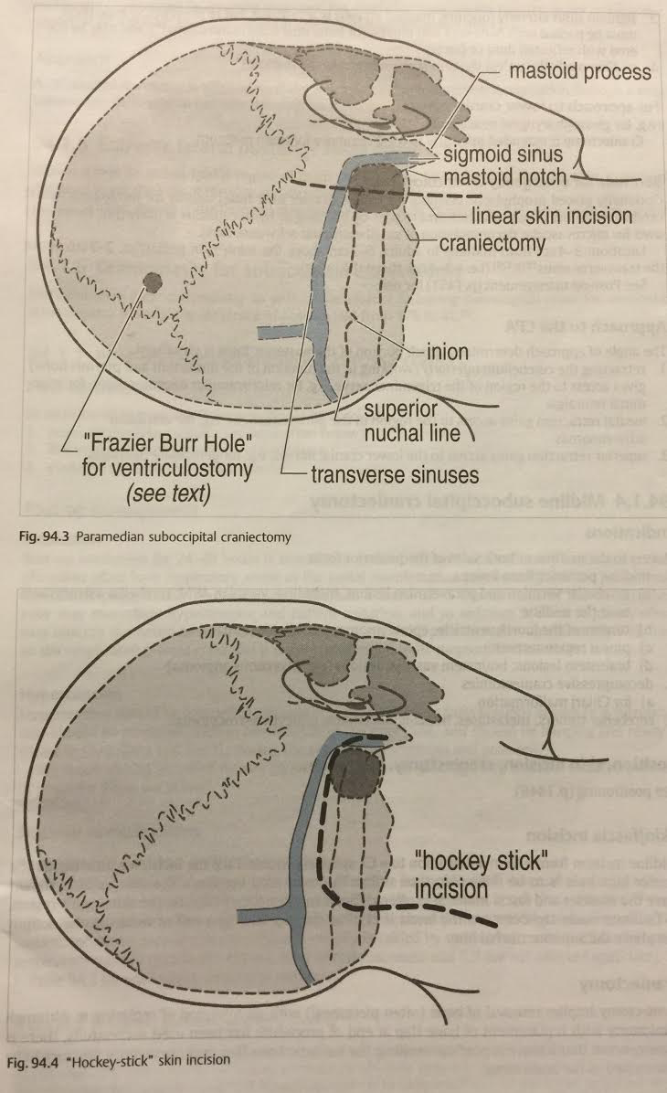
Pterional craniotomy
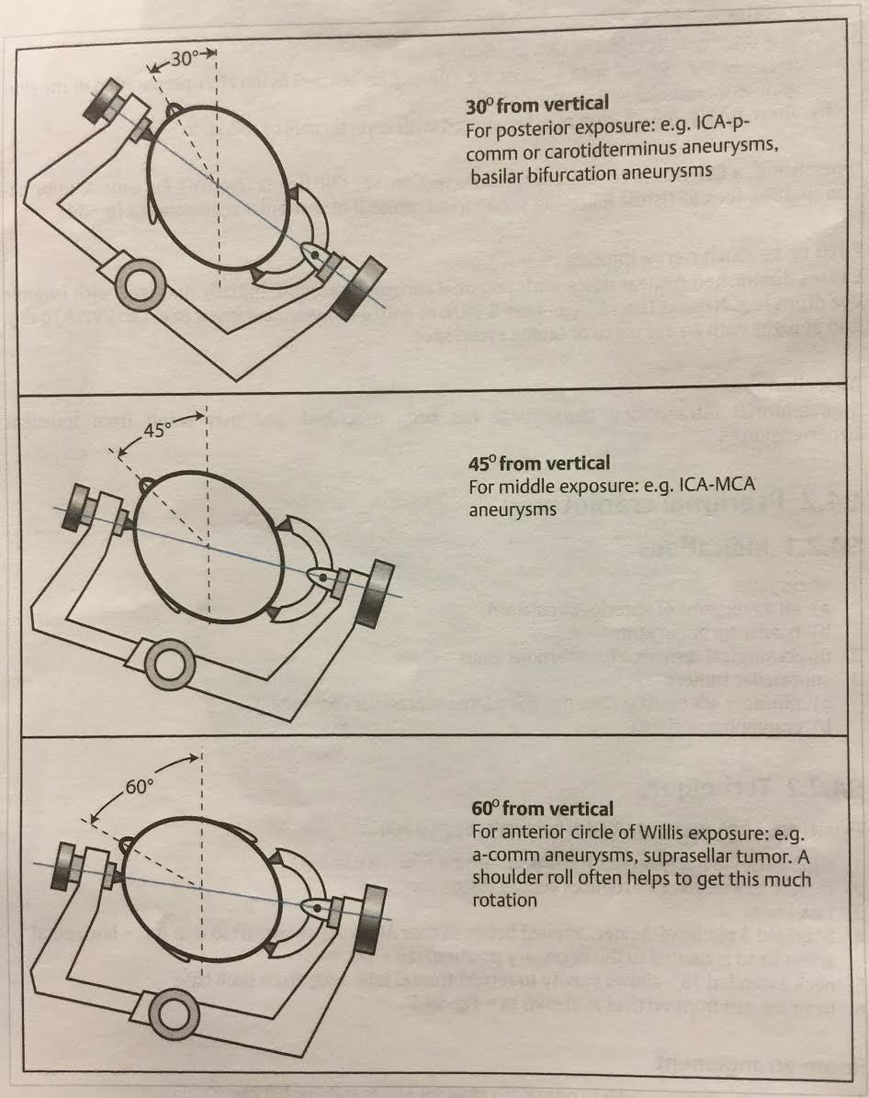
- carotid-ophth aneurysm: flex neck slightly, instead of extend (also, prep the neck!!!)
- prep the neck for PComm and carotid ophthalmic aneurysms
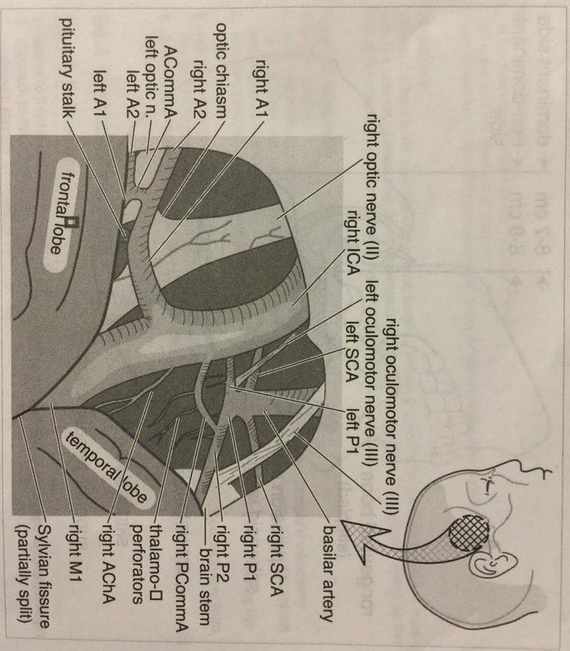
Temporal craniotomy
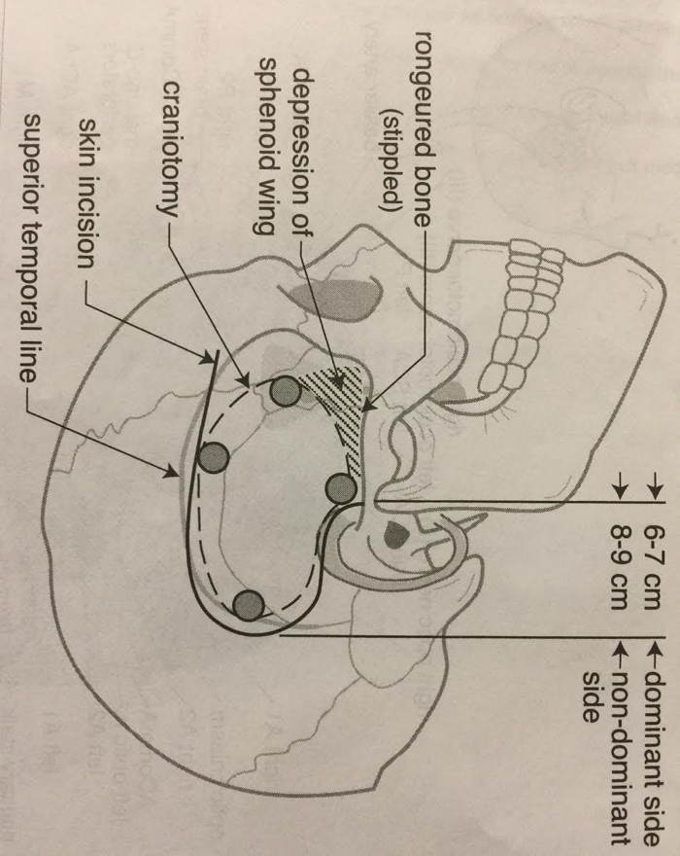
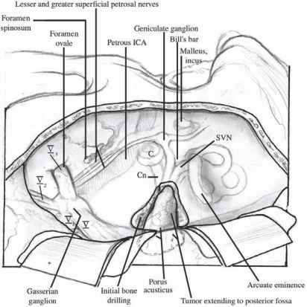
Middle fossa craniotomy
- good for hearing preservation
- do with ENT
- heat damages the facial nerve
- cutting burr cuts aggressively with the least amount of heat
- diamond burr generates a lot of heat (MUST irrigate A LOT!)
- coarse diamond is a hybrid
- 80% as efficient as a cutter with 40% less heat than diamond
- use a coarse diamond burr with A LOT of irrigation
- make a small, controlled burr hole
- use an elevator to move temporalis muscle (not Bovie) to maintain the
blood supply (the main blood supply is on the underside of the muscle)

Frontal craniotomies
- Souttar incision (bicoronal)
Petrosal craniotomy
- lesions of the petrous apex (petroclival meningioma)
- lesions of the clivus (chordoma) with both posterior fossa and supratentorial components
- can reach as low as the IAC (below, consider retrosigmoid or far lateral)
- includes a combined temporal craniotomy with a posterior fossa craniectomy
- supine position with ipsilateral shoulder roll
- elevate thorax 10 degrees
- head positioned to place petrous base at highest point of field
- head rotated 40-60⁰ from vertical
- head abducted towards contralateral shoulder
- neck extended 15⁰ (allows gravity to retract frontal lobe away from the skull base)
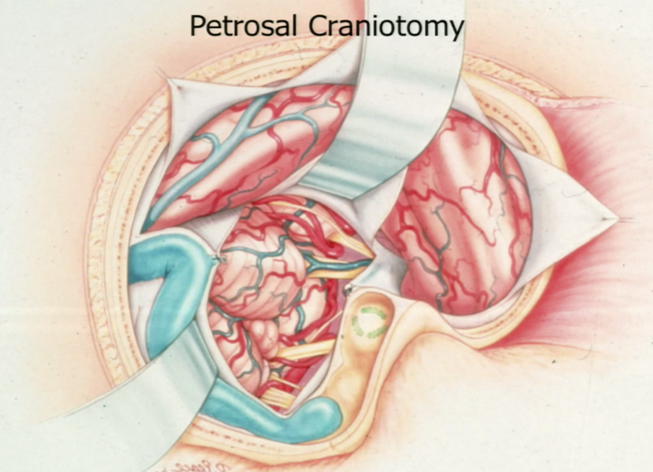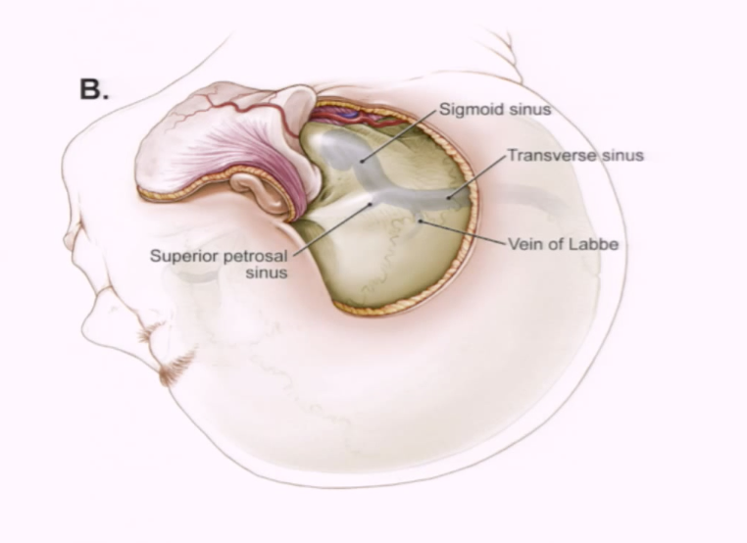
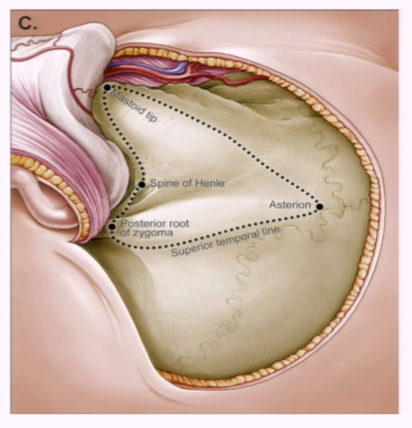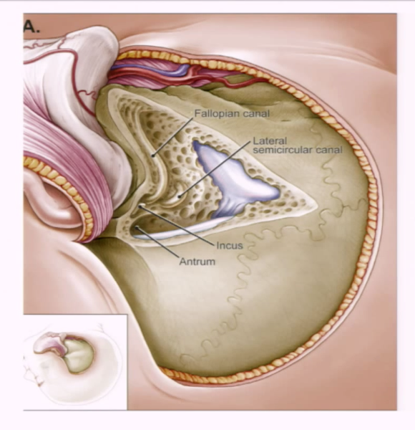
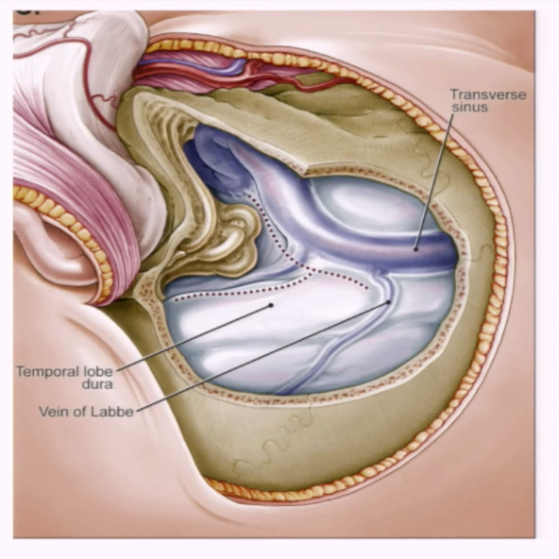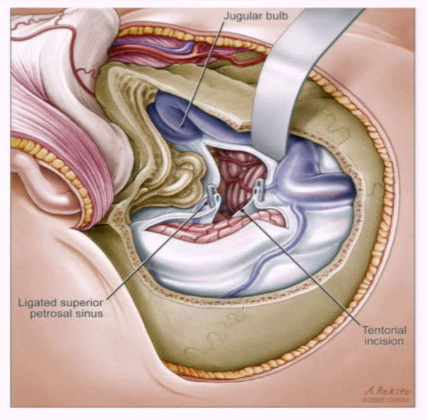
The petrosal approach is also referred to as the combined suprainfratentorial approach because it combines both supratentorial and infratentorial exposures to give wide anterior access to the CPA and ventral brain stem.
The petrosal approach includes a combined temporal craniotomy with a posterior fossa craniectomy–craniotomy for supratentorial and infratentorial exposure. Crucial to this approach is sectioning of the tentorium. With the addition of an extensive petrous resection, the anterior surface of the brain stem can be approached to the level of the inferior one third of the clivus. The lowest portion of the clivus is often obscured by the jugular tubercle. The petrosal approach provides access to lesions in the CPA and petroclival junction (upper two thirds of the clivus), such as meningiomas, trigeminal schwannomas, epidermoids, or chondrosarcomas.
Vascular pathologies such as aneurysms of the middle third of the basilar artery can be accessed. For lesions of the lower third of the clivus and the foramen magnum, the far lateral transcondylar approach provides better access.
Not only the posterior fossa structures but also the supratentorial ventrolateral brain stem can be exposed through this approach. The main advantage of this approach in comparison with pterional or orbitozygomatic approaches is the ability to attack the tumor from an inferior to a superior direction. This is especially important for tumors with significant superior extension.
Surgical Approach
The patient is placed in a lateral position. The incision begins approximately 1 cm anterior to the ear and is directed posteriorly in a gentle curve to the postauricular area approximately 2 cm posterior to the mastoid process. The temporalis fascia and muscle are elevated and reflected anteriorly on a pedicle.
A mastoidectomy is first accomplished with preservation of the labyrinth and exposure of the mastoid segment of the facial nerve. A combined temporo-occipital bone flap is then raised (Fig. 47-5). The transverse sinus and SS were previously identified during the mastoidectomy. This gives exposure along the middle fossa floor, transverse sinus, SS, and suboccipital dura. The dura can then be opened on the inferior aspect of the temporal lobe and anterior or posterior to the SS. After opening the dura over the temporal lobe and the presigmoid dura, the SPS is clipped and divided. The tentorium can be divided in three directions (Fig. 47-6). The first cut is done posteriorly along the transverse sinus to allow for retraction of the transverse sinus–SS junction posteriorly, thus enlarging the presigmoid corridor. The second cut is aimed medially toward the free edge to identify and protect the trochlear nerve. The third cut is parallel to the petrous pyramid and the SPS. This allows resection of the lateral tentorial leaflet and a view of the supratentorial and infratentorial compartments. Ipsilateral cranial nerves IV through X are well visualized (Fig. 47-7). A retractor can be placed to retract the temporal lobe superiorly, and another one can be placed to retract the transverse sinus and SS posteriorly. If the surgeon decides to work through the retrosigmoid corridor, a cerebellar retractor can be placed. Care must be taken to avoid injury to the inferior anastomotic vein. In certain cases, the presigmoid avenue is limited and ligation and division of the SS can provide maximum anterior exposure of the CPA.
Care is taken to avoid damage to the vein of Labbé. The tentorium is cut to the free edge, which enables retraction of the SS posteriorly, creating a presigmoid working corridor. The approach is then directed toward the crural and ambient cisterns. Opening the arachnoid exposes the tumor anterior and superior to the basilar artery, inferior to chiasm, and medial to cranial nerves III and IV. As mentioned previously, this approach allows retrochiasmatic tumor resection with minimal brain retraction.
Wound closure begins with reapproximation of the dura. A dural defect usually remains after suturing. Any opened air cells are waxed. The mastoid antrum is sealed with fascia or muscle, and an autologous fat graft is used to fill the petrosectomy defect. Alternatively or additionally, the posterior temporalis vascularized flap can be used to cover the petrosectomy defect and prevent CSF leakage. The inner table from the craniotomy can be shaped and anchored with miniplates for a more cosmetic mastoid appearance. Spinal drainage can be used for several days after surgery, depending on preference.
Complications and Disadvantages
Typical complications as described earlier for any intracranial approach may be encountered with the petrosal approach. In addition, there is potential for injury to the sinuses and for significant blood loss and air embolism if that occurs. Specific to this approach is the potential for injury to the inferior anastomotic vein, which provides significant venous drainage to the temporal lobe. Hence, edema and venous infarction are a possibility. During drilling of the petrous apex, injury to the semicircular canals (especially the posterior one) and facial nerve may occur.
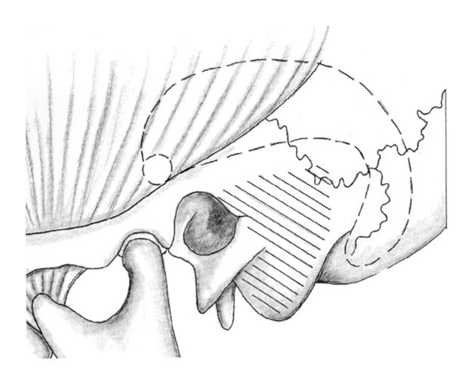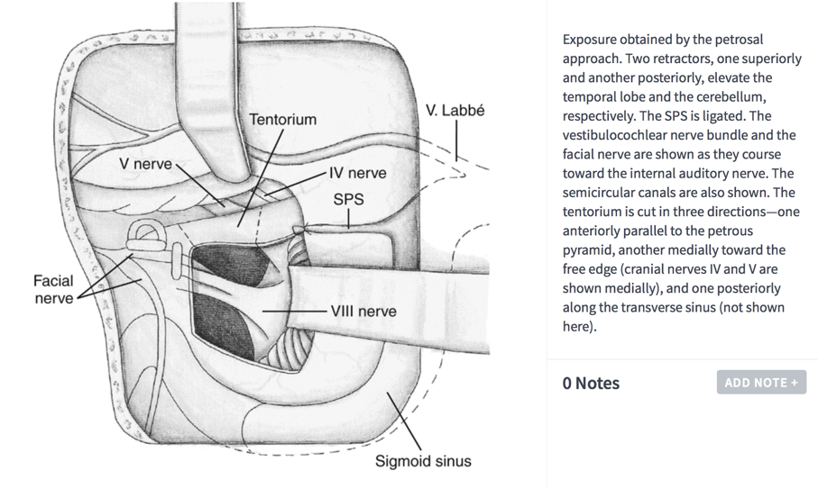
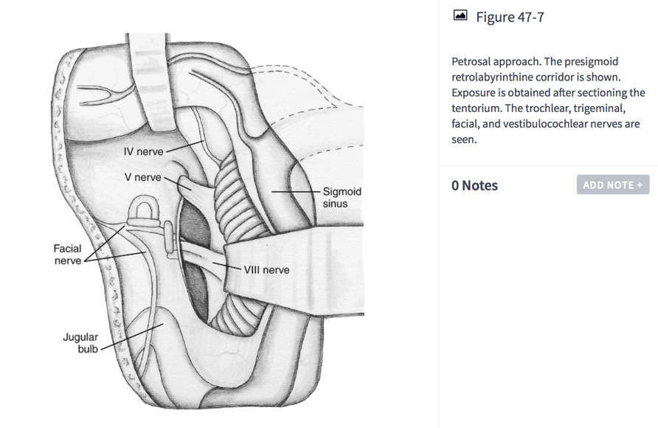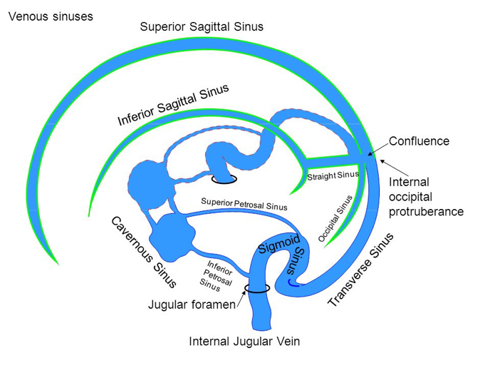
Approaches to the third ventricle
- transcortical
- hydrocephalus needs to be present
- higher seizure risk
- transcallosal
- can be done in the absence of hydrocephalus
- risk of bilateral forniceal injury
- supine with neck flexed
- inverted U incision or souttar skin incision
- NB: SSS if often to the right of the sagittal suture
- craniotomy is:
- 2/3 anterior to the coronal suture
- 1/3 posterior to the coronal suture
- open septum pellucidum if trapped ventricle
- disconnection syndrome avoided if:
- callosotomy < 2.5cm in length from 1-2 cm
behind the tip of the genu
- choroid plexus passes forward in the choroidal fissure to
the foramen of Monro (medial)
- converges with thalamostriate vein (lateral)
- septal vein approaches FOM from anterior
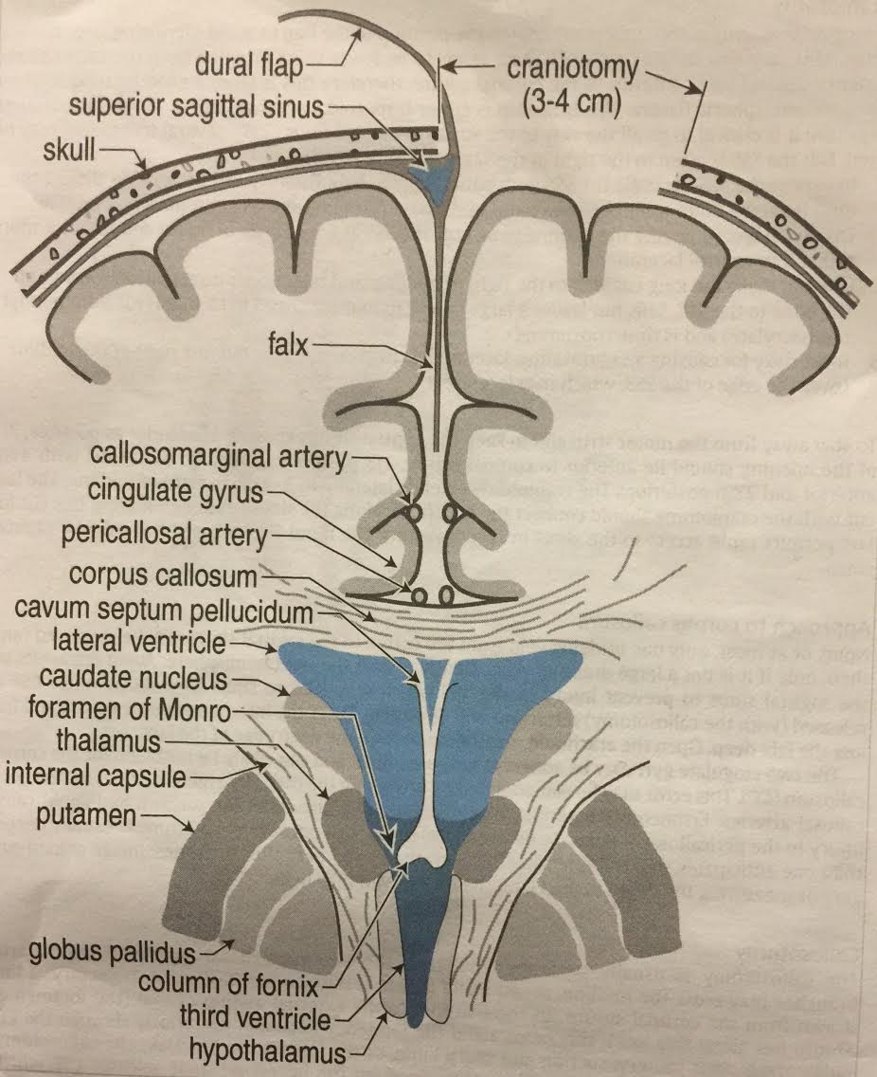

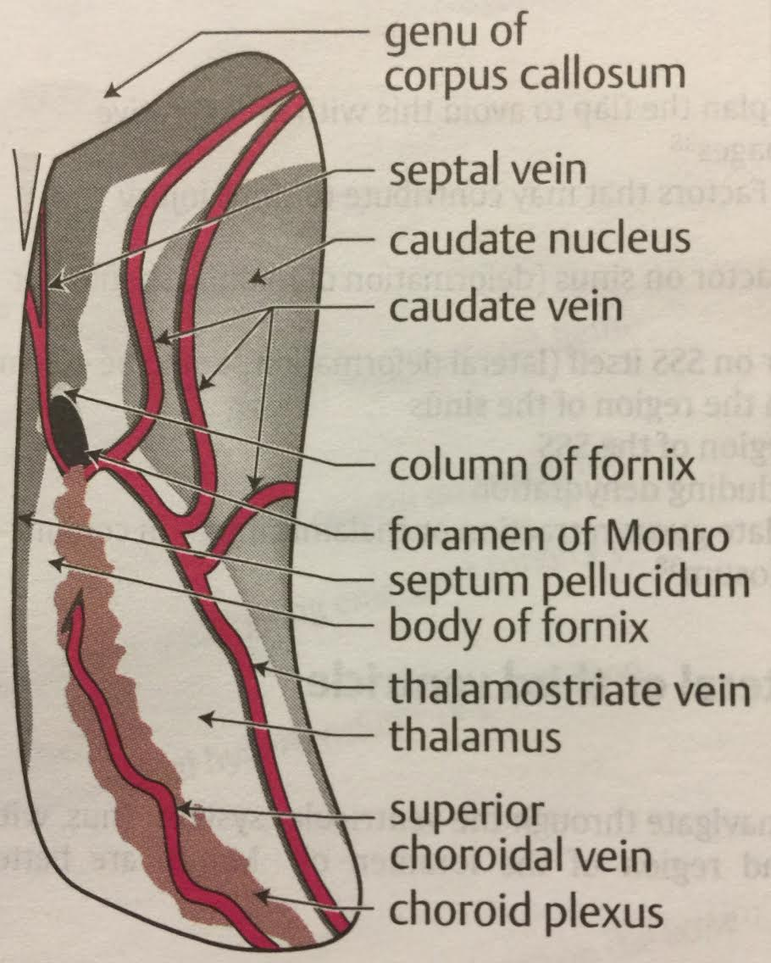 Right ventricle view
Decompressive craniectomy
- diameter 12-15cm
- “T” incision: less risk of flap ischemia
- avoid opening frontal sinus, if possible (be prepared to cranialize if opened)
- rongeur bone to expose floor of the middle fossa
- Gelfilm (absorbable gelatin film) placed between dural substitute and flap

Orbitozygomatic craniotomy
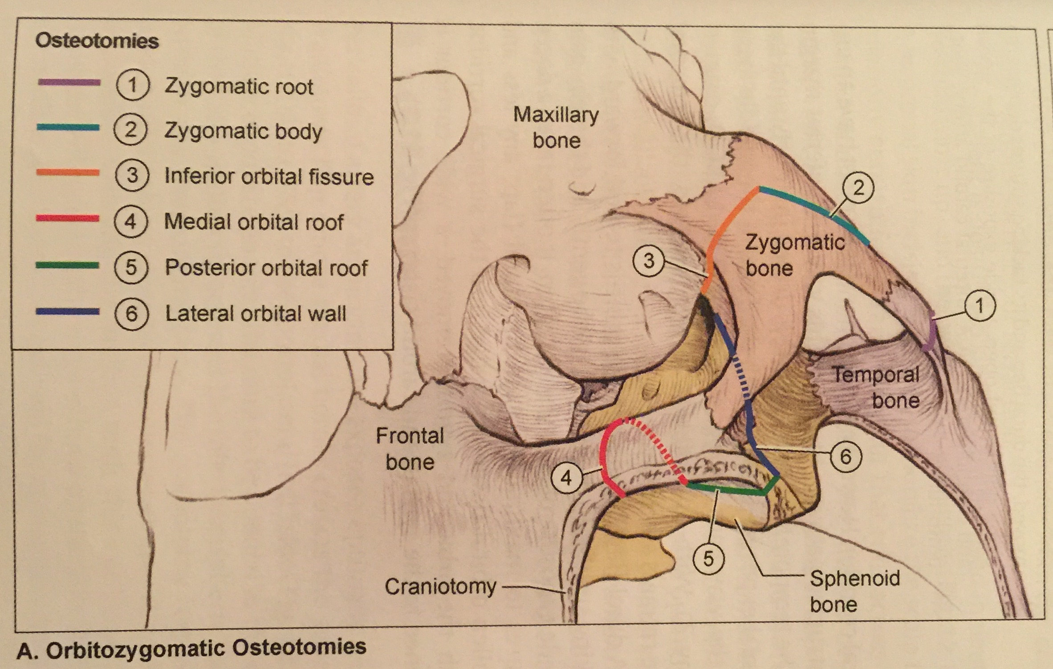
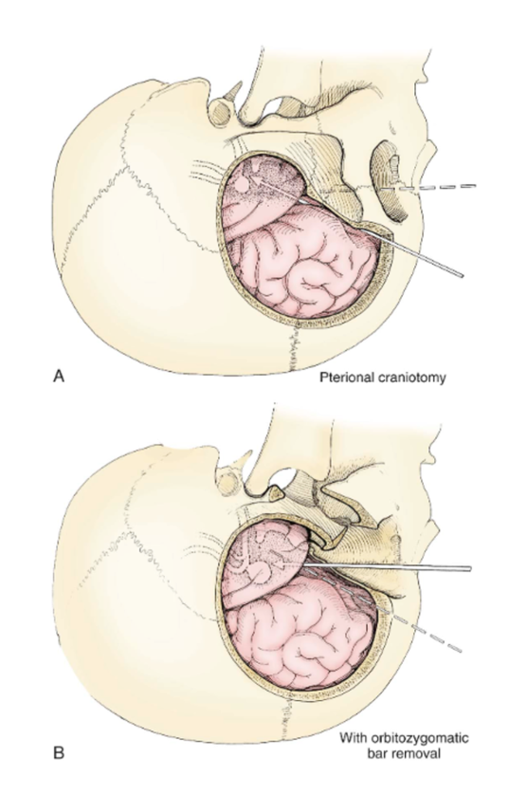
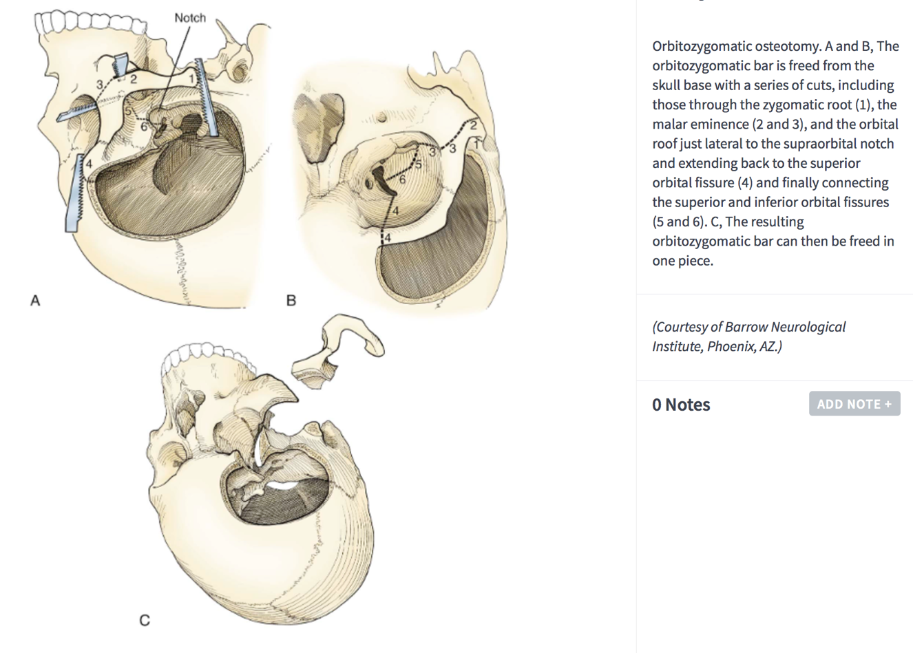

Far lateral craniotomy
- access to lower 1/3 of clivus
- foramen magnum meningioma
- clival chordoma
- glomus jugulare tumor
- PICA aneurysm
- how much condyle can you remove? ½
- ¾ prone position (dangle arm or axillary roll)
- flex, tilt to opposite direction, turn head towards shoulder, tape shoulder forward
- lumbar drain or open cisterna magna
- facial nerve monitoring
- S-shaped incision (above ear down to C2) – less muscle in the way
- extreme far lateral craniotomy: transposition of the vertebral artery – bone work is the same
Midline infratentorial-supracerebellar
- cannot be used if the angle of the tentorium is too steep
- good for tumors under splenium into third ventricle
- sitting or concorde position (precordial Doppler and CVP line for treatment of air embolism) – keep CVP and BP up
- use monitoring (SSEP/MEP) in cases where neck flexion occurs and where hypotension may occur
- incision is made higher in order to expose periosteum for harvest (dural closure)
- use neuro-navigation
- expose above sinus (gives you a bit of extra space to elevate sinus)
- make burr holes on each side of the sinus you are crossing (transvers sinuses, sagittal sinus)
- do not take craniotomy to the foramen magnum (it’s nice to have bone to support the cerebellum)
- the dural opening doesn’t need to be too big
- open cisterna magna to withdraw CSF
- basal veins of Rosenthal coming into vein of Galen should be visualized
- reposition scope to look down (you need to change your angle after opening – the tendency is to be too high and you can injure Galen)
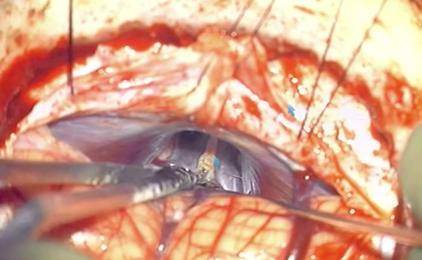
- ok to coagulate the precentral cerebellar vein
- even if you can’t resect the entire tumor, always open the third ventricle to relieve the hydrocephalus
Interhemispheric occipital, transtentorial
- occipital lobe is retracted laterally and the tentorium is incised 1cm lateral to the straight sinus
- good for tumors extending down into posterior fossa
- be careful not to injury the straight sinus
- approach from side where most tumor is
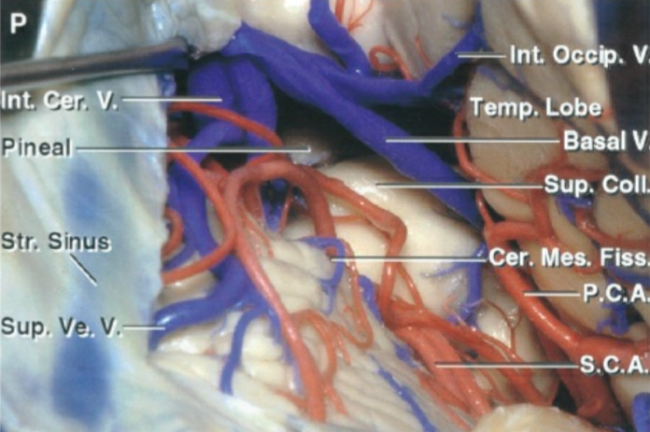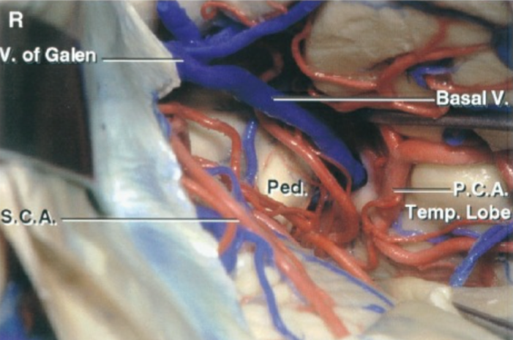
- three-quarter prone or lateral position with the affected side down
- some form of cerebrospinal fluid drainage in advance (either lumbar drain or an external ventricular drain)
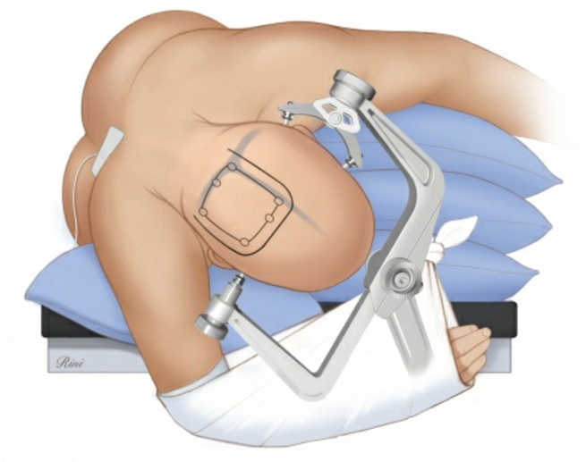

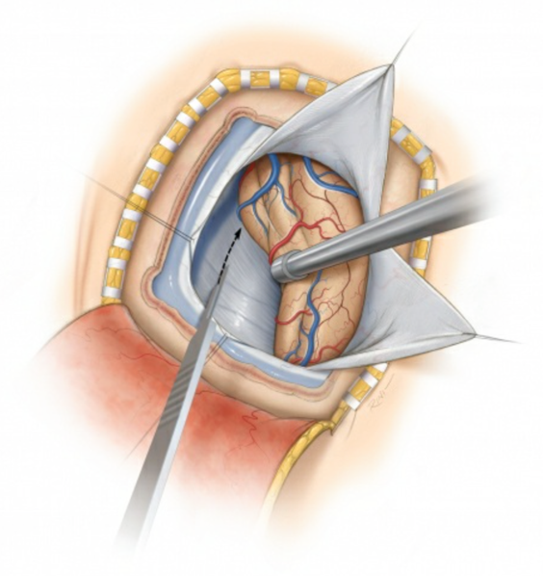
- interhemispheric dissection exposes the straight sinus so that the
tentorium can be divided adjacent to it (~1cm away from it)
- small, non-significant parasagittal vein may have to be sacrificed
- inferior sagittal sinus and falx may be divided to facilitate further
transfalcine exposure
- portion of the tentorium is resected to allow adequate exposure of
the lesion
- the trochlear nerve is mobilized from the tentorial edge before the
edge is manipulated
- the tentorium is transected in the posterior to anterior direction
- initial portion of the incision is created just anterior to the junction of the torcula and the straight sinus
- incision is extended to the level of the incisura
- retention sutures can mobilize the tentorium laterally and posteriorly, obviating the need for transecting a window in the tentorium
- bleeding from the tentorium is controlled via bipolar coagulation and thrombin soaked gelfoam packing of the venous lakes within the
leaflets of the tentorium

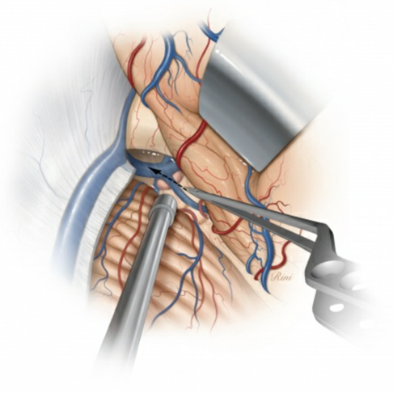
- arachnoid bands overlying the tumor and the quadrigeminal
cisterns can be seen from a supraposterior perspective
- these bands are dissected
- the tumor and the adjacent cerebrovascular structures, including
the deep diencephalic veins (basal veins and the vein of Galen)
are identified early to keep them out of harm's way
- fixed retractor blade "holds" the occipital lobe, but does not
retract it
- precentral cerebellar vein is coagulated, allowing the vermis to be
mobilized away from the operative corridor

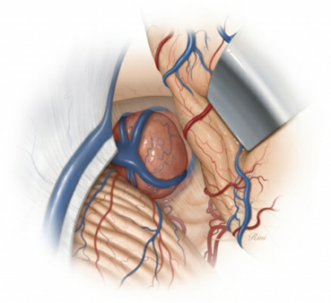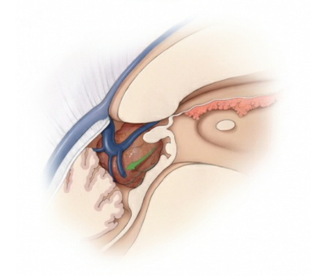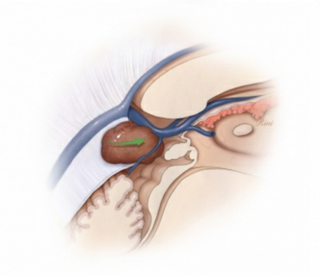
- displacement of the deep veins posteriorly complicates the use of the infratentorial supracerebellar approach
- if the deep veins are displaced anteriorly the infratentorial supracerebellar approach is favored
- various para- and intervenous corridors are used for piecemeal tumor removal
- tumor adherent to the veins is subtotally removed
- this approach is favored if the deep veins are displaced posteriorly and caudally
Transsphenoidal
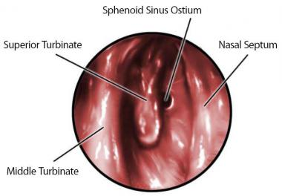

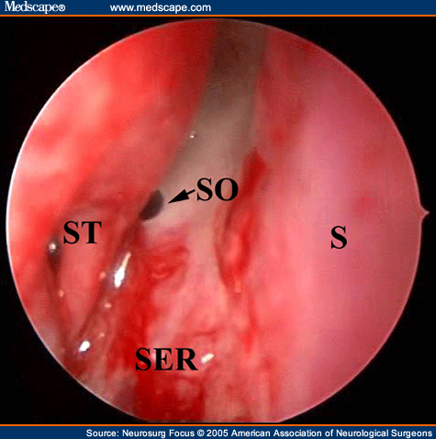
Endoscopic view of the right sphenoid ostium (SO). The sphenoid ostium (arrow) can be found at the inferior third portion of the superior turbinate (ST) and provides an important landmark for the level of the sphenoid sinus. SER = sphenoethomoid recess.
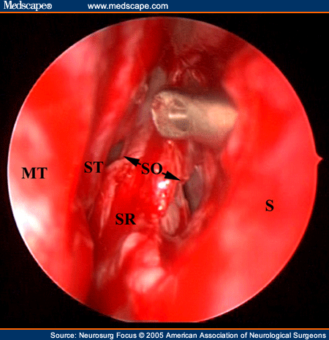
Endoscopic view following the posterior septectomy but prior to the anterior sphenoidotomy. Both sphenoid ostia (arrows) are visible with the endoscope in the right nasal cavity. An instrument placed through the left nostril can be seen above both ostia. SR= sphenoid rostrum.
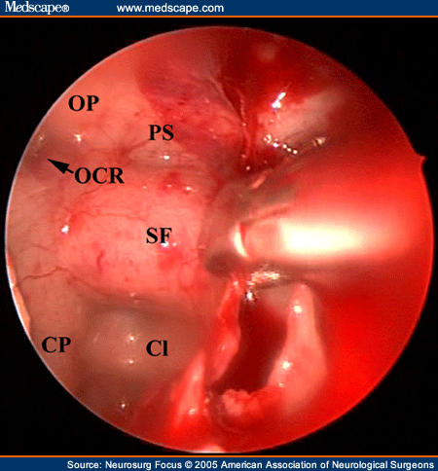
Endoscopic view of the sphenoid sinus as the intersphenoid sinus septum is being removed. After the anterior sphenoidotomy is performed, the intersphenoid sinus septae are removed to expose the intrasphenoidal anatomy. Evident is the panoramic view of the sphenoid anatomy with the optic and carotid protuberances (OP and CP, respectively), opticocarotid recess (OCR; arrow), clivus (Cl), planum sphenoidale (PS), and sellar impression. SF = sellar floor.

Approaches to the skull base
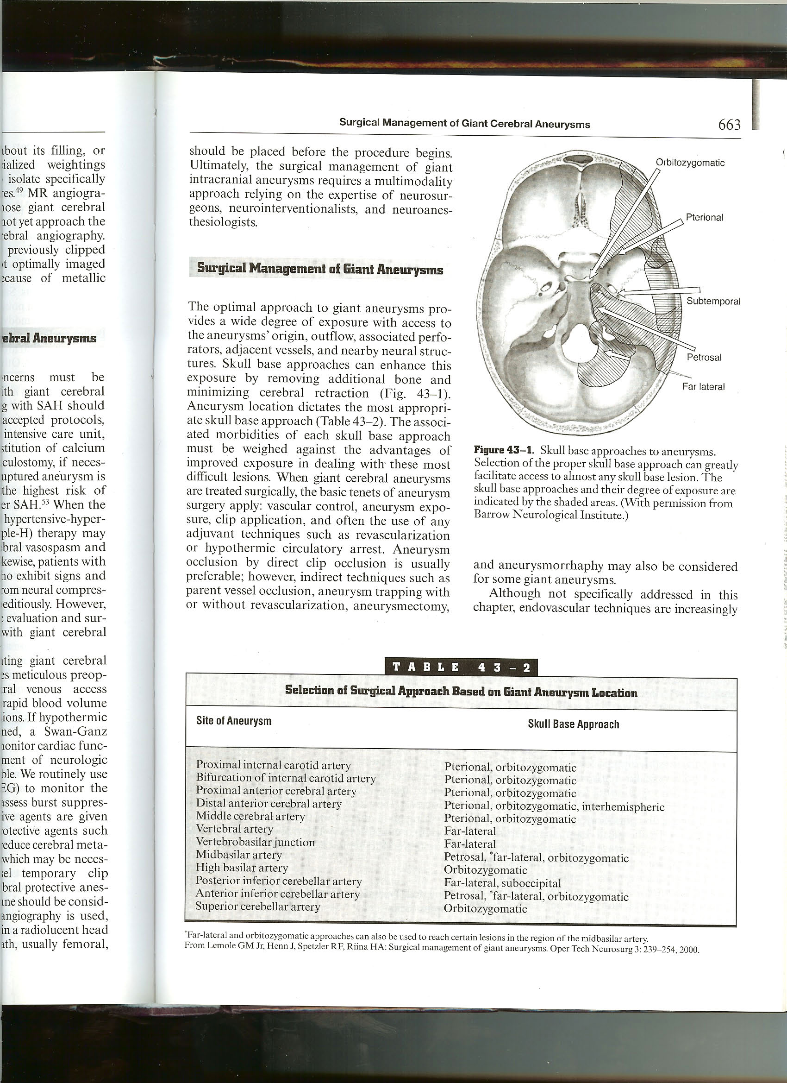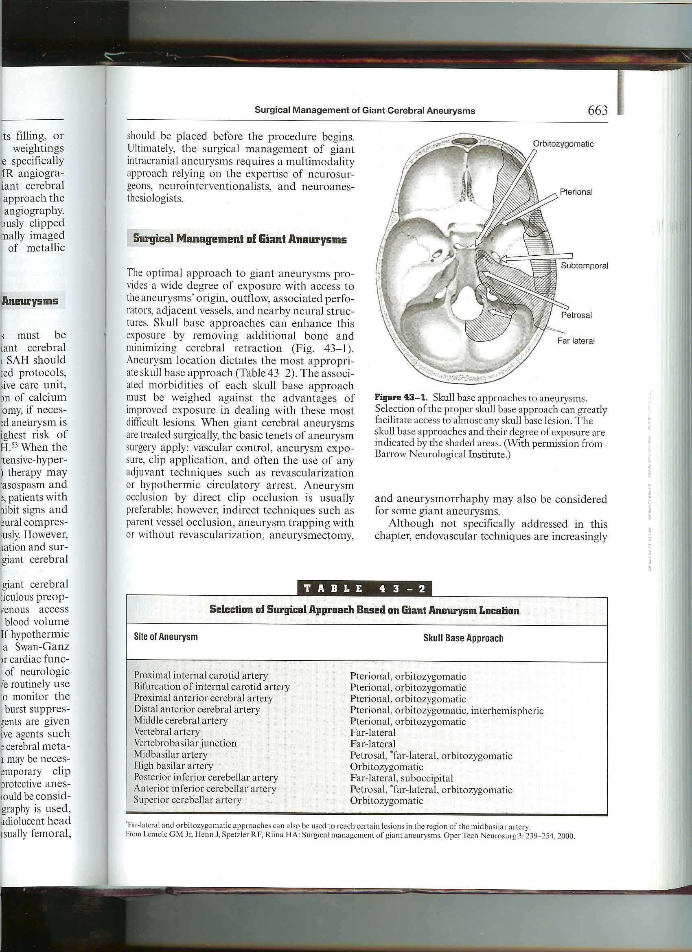
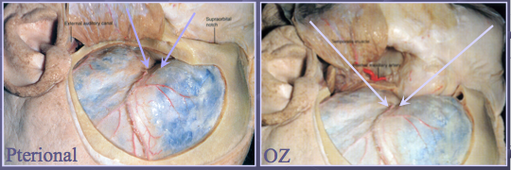
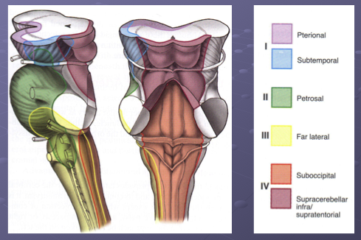

AWAKE CRANIOTOMY
- for polyglots, it is important to map at least the two languages most important to the patient
- fMRI or magnetoencephalography are used to localize language
- the sensitivity and specificity of fMRI in detecting essential language sites localized by electrical cortical stimulation mapping is 80-85%
- prerequisites:
- patient must be cooperative
- patient should not be claustrophobic
- language needs to be nearly intact
- no underlying pulmonary pathology that would preclude awake procedure
- the patient is not intubated
- anesthesia should be IV, not inhaled
- remifentanil for pain and dexmedetomidine and/or propofol for anesthesia
- preoperative loading dose of AED to be given the day before surgery
- given because electrical stimulation is likely to cause seizures
- given the day before in order to avoid excessive somnolence after loading dose
- fosphenytoin (18 mg/kg load), or keppra (15 mg/kg load) if allergy to dilantin
- steroid should be given
- mannitol on an individual basis (low dose to avoid n/v)
- head is pinned after 0.25% bupivacaine block is performed
- care is taken not to inject near facial nerve (can cause droop that affects speech integrity)
- after the craniotomy flap is elevated, the dura is also infiltrated with local anesthetic
- the patient is awoken and a neurophysiologist or neuropsychologist presents stimuli to the patient while the surgeon proceeds CSM
- an Ojemann stimulator is used
- stimulation currents range from 1 to 10 mA
- mapping is performed at 10 mA or at 1 mA below the potential that results in persistent after-discharges or overt seizures
- concurrent electrocorticography is performed to monitor for after-discharges and seizures (place a strip on the brain to detect seizures)
- tasks used during cortical stimulation mapping:
- object naming
- repetition of spoken phrases
- spontaneous speech (reciting the alphabet; useful in localizing sites of speech arrest)
- auditory naming (“what does a king wear on his head?”)
- CSM carries a risk of producing seizures which may limit the mapping process or lead to postponement of the planned resection
- seizures can be controlled by brain surface irrigation with ice-cold saline
- complications: hemorrhage, infection, CSF leak, stroke, postoperative seizures (AED for 2-4 weeks after surgery), postoperative language
deficit, delayed postoperative language deficit (MRI and EEG should be obtained)

