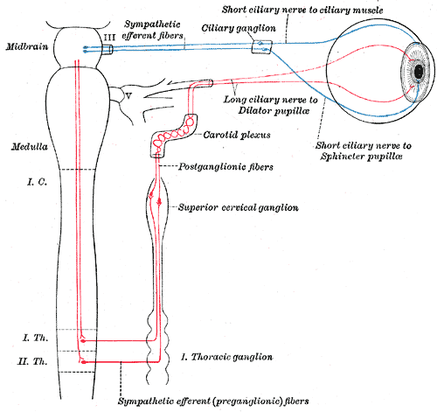**Horner syndrome**

- sympathetic innervation to the eye consists of a 3-neuron arc  
- first-order sympathetic fibers:  
 - arise from the posterolateral hypothalamus  
 - descend uncrossed through the midbrain and pons  
 - terminate in the intermediolateral cell column of the   
 spinal cord at the level of C8-T2  
- second-order   
 - preganglionic pupillomotor fibers  
 - exit the spinal cord at the level of T1  
 - enter the cervical sympathetic chain  
 - run in close proximity to the pulmonary apex and   
 subclavian artery  
 - ascend through the sympathetic chain  
 - synapse in the superior cervical ganglion at the level   
 of the bifurcation of the common carotid artery (C3-4)  
 - post-ganglionic pupillomotor fibers  
 - exit the superior cervical ganglion  
 - ascend along the ICA  
 - shortly after the post-ganglionic fibers leave the superior cervical ganglion, vasomotor and sudomotor   
 fibers branch off, travelling along the ECA to   
 innervate the blood vessels and sweat glands of the   
 face  
- third-order pupillomotor fibers  
 - ascend along the ICA  
 - enter the cavernous sinus  
 - fibers leave the carotid plexus briefly to join CN VI in the   
 cavernous sinus and enter the orbit via the SOF along with V1   
 via the long ciliary nerves  
 - long ciliary nerves innervate the iris dilator and Muller muscle

Horner syndrome may develop from lesions at any point along the sympathetic pathway  
  
Abnormalities found in all patients, regardless of level of interruption:   
- mild to moderate ptosis (Muller muscle)  
- slight elevation of the lower lid (Muller muscle)  
- miosis  
- dilation lag