WHO tumor classification
A. Tumors of neuroepithelial tissue
B. Tumors of cranial and paraspinal nerves
C. Tumors of the meninges
D. Lymphomas and hematopoietic neoplasms
E. Germ cell tumors
F. Tumors of the sellar region
G. Metastatic tumor

A. NEUROEPITHELIAL TUMORS
I. Astrocytes (astrocytic tumors)
II. Oligodendrocytes (oligodendroglial tumors)
III. Oligoastrocytes (mixed gliomas)
IV. Ependymocytes (ependymal tumors)
V. Choroid plexus tumors
VI. Other neuroepithelial tumors
VII. Neuronal and mixed neuronal-glial tumors
VIII. Pinealocytes (pineal parenchymal tumors)
IX. Embryonal tumors
B. TUMORS OF CRANIAL AND PARASPINAL NERVES
I. Schwannoma (neurilemmoma, neurinoma, vestibular schwannoma aka acoustic neuroma)
II. Neurofibroma
III. Perineurioma
IV. Malignant peripheral nerve sheath tumor
C. TUMORS OF THE MENINGES
I. Tumors of meningothelial cells (meningiomas)
II. Mesenchymal, non-meningothelial tumors
III. Primary melanocytic lesions
IV. Other neoplasms related to the meninges (hemangioblastoma)
D. LYMPHOMAS AND HEMATOPOIETIC NEOPLASMS
I. Malignant lymphoma (primary CNS lymphoma – PCNSL)
II. Plasmacytoma
III. Granulocytic sarcoma
E. GERM CELL TUMORS
I. Germinoma
II. Embryonal carcinoma
III. Endodermal sinus tumor (yolk sac tumor)
IV. Choriocarcinoma
V. Teratoma
VI. Mixed germ cell tumors
F. TUMORS OF THE SELLAR REGION
I. Craniopharyngioma
II. Adenohypophyseal cells (pituitary adenoma)
III. Neurohypophysis and infundibulum
IV. Pituitary carcinoma
V. Spindle cell oncocytoma of the adenohypophysis
G. METASTATIC TUMORS
I. Lung cancer (esp. small cell)
II. Breast
III. Melanoma
IV. Renal cell
V. Lymphoma
VI. GI
H. LOCAL EXTENSIONS FROM REGIONAL TUMORS
I. Paraganglioma (glomus jugulare tumor)
II. Notochord (chordoma)
III. Carcinoma
I. CYSTS AND TUMOR-LIKE LESIONS
I. Rathke’s cleft cyst
II. Ectodermal rests (epidermoid, cholesteatoma)
III. Dermoid
IV. Colloid cyst of the third ventricle
V. Neurenteric/enterogenous cyst
VI. Neuroglial cyst
VII. Hypothalamic neuronal hamartoma
VIII. Nasal glial heterotopia
IX. Plasma cell granuloma
J. UNCLASSIFIED TUMORS

Intraventricular tumor differential diagnosis
- CENTRAL MS
- choroid plexus papilloma, choroid plexus carcinoma, colloid cyst, cavernoma
- ependymoma, epidermoid/dermoid
- neurocytoma
- teratoma, tuber
- “rule out” infection
- astrocytoma, AVM, aneurysm, abscess
- lipoma, lymphoma
- menigioma, metastasis
- subependymoma, subependymal giant cell astrocytoma
Brain tumors that respond favorably to chemotherapy
- oligodendroglioma
- gliomas lacking MGMT activity (the cytotoxic effect of Temozolomide is by alkylating DNA at various sites – some tumors can repair this
damage via a protein coded for by MGMT gene) = MGMT methylation deactivates MGMT (no ability to repair damage)
Tumor markers
- CEA: leptomeningeal spread of lung cancer, breast cancer, malignant melanoma, and bladder cancer
ASTROCYTOMA
- subependymal giant cell astrocytoma (tuberous sclerosis, WHO I)
- WHO I: JPA (PCA), SEGA, desmoplastic infantile astrocytoma
- WHO II: diffuse low grade glioma, pleomorphic xanthoastrocytoma (PXA), pilomyxoid astrocytoma, gemistocytic
- WHO III: anaplastic
- WHO IV: glioblastoma
- gemistocytic and PXA are unique because their grade does not conform to their prognosis
- PXA have high-grade features on pathology, but 10-year survival is 70%
- gemistocytic is prone to progression to WHO IV
Pilocytic astrocytoma
- WHO I
- often cystic with mural nodule
- common locations: cerebellum, optic nerve/chiasm (optic glioma), hypothalamus
- dorsally exophytic brainstem glioma
- Rosenthal fibers
- little or no surrounding edema, most enhance, well circumscribed, cystic component with nodule (may be solid), occasionally calcify
- drop mets are rate with pilocytic astrocytoma
- treatment: surgical resection (natural history is slow growth)
- remove only nodule (cyst wall only needs to be removed if strongly enhancing)
- radiation is not recommended
- patients should be followed with serial scans
- reoperation is recommended for recurrence
- radiation is only recommended for non-resectable recurrence (chemotherapy is preferable to XRT in younger pts)
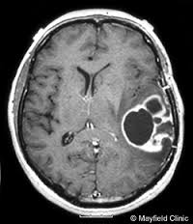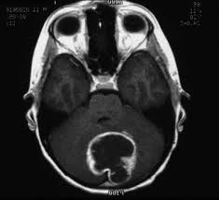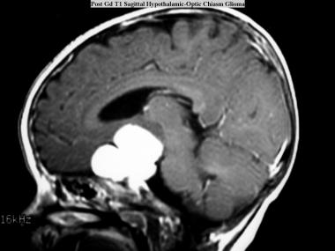
Optic glioma
- incidence is high in neurofibromatosis
- if multicentric in both optic nerves, sparing the chiasm, almost only seen in NF-1
- optic chiasm: more common in sporadic cases
- present with painless proptosis
- chemotherapy and XRT in chiasmal tumors (45 Gy given in 25 fractions of 1.8 Gy)

Hypothalamic glioma
- WHO I
- pilocytic astrocytomas of the hypothalamus
- cachexia, over-alertness, euphoria, hypoglycemia, failure to thrive, macrocephaly
- if complete resection is not possible, chemotherapy and XRT as above in optic glioma

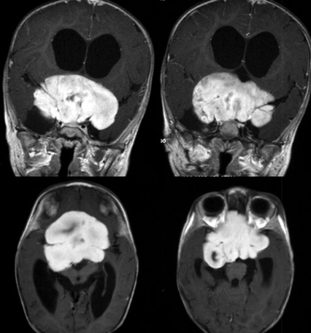

Low grade astrocytoma
- WHO II
- fibrillary is the most common histologic type
- occur in children and young adults
- calcification rare
- anaplasia is absent
- enhancement is a poor prognosticator
- may progress to higher grade
- tend to undergo malignant transformation if diagnosed after age 45
- genetic markers that correlate with higher degree of malignant transformation: IDH mutation, LOH on Chr 10&17, TP53 mutation
- treatment: surgery (intraoperative mapping and awake craniotomy may be necessary)
- radiation therapy: 54 Gy in fractions of 1.8 Gy (can be deferred until progression in radical resections)
- following incomplete resections, RT significantly prolongs PFS and disease specific survival
- chemotherapy: usually reserved for tumor progression (Temozolomide may be used in progressive WHO II astrocytomas)
Pilomyxoid astrocytoma (PMA)
- WHO II
- related to pilocytic, but more aggressive and greater tendency to recur and spread in CSF

Tectal glioma
- low grade astrocytoma
- projects from the quadrigeminal plate
- present with hydrocephalus
- rarely enhance
- follow with serial scans every 6-12 months
- treat HCP with VP shunt or ETV
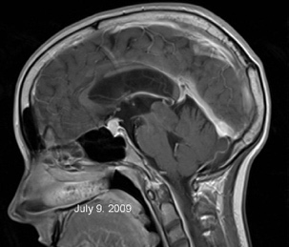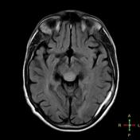

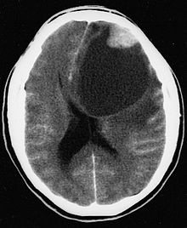
PPleomorphic xanthoastrocytoma (PXA)
- WHO II
- 90% supratentorial, superficial location
- usually occur in young children < 18 years of age
- mural nodule with cystic component
- meninges involved in > 67%
- may undergo malignant transformation
- calcification is rare
- treatment: maximal safe resection
- XRT or chemo for grade III

Anaplastic astrocytoma
- WHO III
- treatment: surgery with a goal of cytoreduction + external beam radiation + temozolomide
- excision of 97% or more of the tumor is associated with increased survival time
- 5-aminolevulinic-acid (5-ALA) guided resection
Glioblastoma
- WHO IV
- infratentorial glioblastoma is rare and usually presents with subarachnoid dissemination of a supratentorial GBM
- neovascularization with endothelial proliferation, necrosis, pseudo-palisading around area of necrosis
- loss of MGMT expression makes alkylating agents (Temozolomide) more effective
- MGMT promoter region methylation significantly increases survival time
- IDH1 and IDH2 mutations are associated with better overall survival, progression-free survival and chemosensitivity
- primary versus secondary
- 4 subtypes: I. Classical, II. Mesenchymal, III. Proneural, IV. Neural
- treatment: surgery with a goal of cytoreduction + external beam radiation + temozolomide
- excision of 97% or more of the tumor is associated with increased survival time
- 5-aminolevulinic-acid (5-ALA) guided resection
- not considered good candidates for surgery:
- extensive dominant lobe GBM
- bilateral involvement (butterfly gliomas)
- elderly patients
- Karnofsky score < 70
- multicentric gliomas
- Stupp regimen
- concomitant chemoradiation is started within 6 weeks after histologic diagnosis of glioblastoma
- temozolomide
- 75 mg/m²/day every day until the end of radiation therapy
- 4 weeks later, six cycles of adjuvant chemotherapy starts
- temozolomide x 5 days, repeated Q28days (150 mg/m²/day up to 200 mg/m²/day)
- may cause myelosuppression (decreases neutrophil count and platelet count)
- prophylaxis for pneumocystic carinii pneumonia should be given (Bactrim)
- fractionated focal irradiation at a dose of 2 Gy per fraction once daily 5 days/wk x 6 weeks (total dose 60 Gy with 2-3 cm margin)
- boost to the enhancing volume to bring the total to 60 Gy
- temozolomide is given concurrently (during radiation) and as an adjuvant
- Gliadel wafers
- no survival benefit in recurrent disease
- side effects: seizures, edema, healing abnormalities, infection
- pseudoprogression: radiation necrosis following chemoradiation may give the appearance of recurrence
- perform MR perfusion (pseudoprogression will have decreased perfusion – will look dark)
- occurs within 90 days after receiving radiation
- treat with a course of steroids (not all patients required steroids; only those with symptomatic pseudoprogression)
- recurrent GBM: surgery in patients with a Karnovsky score ≥ 70; Avastin
Gliomatosis cerebri
- WHO IV
- diffuse, infiltrating astrocytoma that invades almost all of the cerebral hemispheres and brainstem
- usually mixed low and high grades
- biopsy only (Stupp protocol?)
Meningeal gliomatosis
- dissemination of glioma throughout the CSF
- similar to carcinomatous meningitis
- may present with cranial neuropathies, radiculopathies, myelopathy, dementia, communicating hydrocephalus
OLIGODENDROGLIAL TUMORS (Oligodendroglioma)
- frequently present with seizures
- “fried egg” cytoplasm
- split up into oligodendroglioma (WHO grade II) and anaplastic oligodendroglioma (WHO grade III)
- CSF metastasis may occur
- calcification common
- treatment:
- surgery for mass effect (surgery is not always performed for high grade if not accessible due to chemo response)
- chemotherapy for all (with or without surgery) – allelic loss of chromosome 1p and 19q respond better to chemotherapy
- XRT only for anaplastic transformation (Stupp protocol)
OLIGOASTROCYTIC TUMORS
- Oligoastrocytoma (WHO grade II)
- Anaplastic oligoastrocytoma (WHO grade III) – difficult to differentiate from glioblastoma; slightly better survival
- 90% of grade II oligodendrogliomas have the 1p19q codeletion
- 50-70% of anaplastic oligodendrogliomas have the 1p19q codeletion
EPENDYMAL TUMORS
- treatment:
- maximal possible resection (extent of resection determines outcome)
- 2 weeks post-op: LP to look for drop mets (or do this preop)
- XRT to follow surgery (very radiosensitive)
- hold XRT for age < 3 years
- cranial: 59 Gy to tumor bed + 1 cm margins
- spinal: 30 Gy
- chemotherapy is not very effective (may be considered in patients < 3 years due to inability to radiate)
Ependymoma
- WHO grade II
- posterior fossa in pediatrics
- usually benign tumors
- intraspinal in adults
- CSF seeding is common (scan neuraxis)
- usually circumscribed but may be invasive
- types:
- papillary (classic lesion)
- brain and spinal cord
- metastasis in 30%
- can form pseudorosettes or true rosettes
- cellular
- clear cell
- tanycytic (rare)
Myxopapillary ependymoma
- WHO grade I
- occurs in filum terminale
- papillary

Subependymoma
- WHO I
- not enhancing
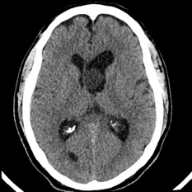

NEURONAL AND MIXED NEURONAL-GLIAL TUMORS

Desmoplastic infantile astrocytoma/ganglioglioma
- WHO I
- DIG
- favorable prognosis
- large hemispheric tumors
- treatment: GTR (chemotherapy if subtotal resection)
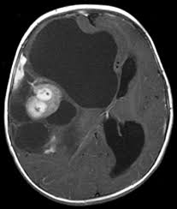

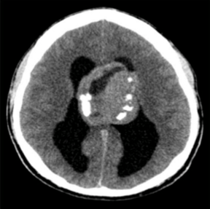
Central neurocytoma
- WHO II
- GTR can be curative
- if MIB-1 > 2.4%, increased risk of recurrence (consider post-op SRS
to reduce risk of recurrence)
- attach to septum pellucidum
- may also be extraventricular
- 25-50% calcify
- moderate to strong contrast enhancement

Dysembryoplastic neuroepithelial tumors (DNET)
- WHO grade I glioma
- usually present with seizures
- treatment: GTR; adjuvant treatment with chemo and radiation
is of no benefit
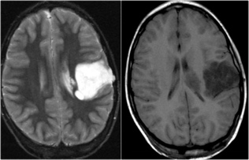

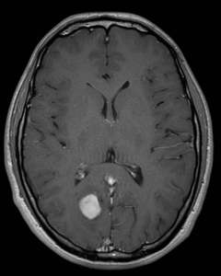
Ganglioglioma
- ganglion cells (neurons) and glial cells
- can occur anywhere
- slow growth, calcify
- white matter mass
- well-circumscribed
- present with seizures
- treatment: GTR, if possible; re-resect recurrence
- 10-year survival 84%
Paraganglioma
- aka glomus tumor
- slow growing, benign
- contain secretory granules on EM and may secrete catecholamines with risk of life-threatening HTN and/or cardiac arrhythmias
- designation is based on site:
- carotid bifurcation: carotid body tumor
- may be bilateral
- painless, slow growing mass in the upper neck; may also cause ICA stenosis → TIA/stroke
- angiogram shows blood supply (from ECA), splaying of bifurcation
- resection shows high complication rate
- superior vagal ganglion (jugular foramen): glomus jugulare
- adrenal medulla & sympathetic chain: pheochromocytoma
- sporadic or part of von Hippel-Lindau
- 24 hour urine collection: total catecholamines and metanephrine
- if elevation found, clonidine suppression test (fall in serum catecholamines in normal response; no change in pheo)
- glomus tympanicum
- imaging: post-gad MRI shows jugular foramen lesion that takes up contrast brightly and is noted to have a “speckled pattern”
suggestive of flow voids depicting high vascularity
- CT would demonstrate an enlarged jugular foramen (indicating the presence of a lesion in the petrous bone)
- angiogram: fed by ECA branches (ascending pharyngeal, occipital, internal maxillary) or vertebrobasilar system
- CT chest, abdomen, pelvis
- serum and urine catecholamines and urine VMA
Norepinephrine epinephrine
- conversion requires an enzyme present in the adrenal medulla ∴high epinephrine level raises suspicion for pheochromcytoma
- Glomus jugulare tumors (when chemically active) produce norepinephrine
- inheritance pattern:
- most are sporadic
- some are transmitted in an autosomal dominant manner with evidence of imprinting
- chromosome 11q
- mutation transmitted in an autosomal dominant pattern with variable penetrance only from the father
- children of men who had a glomus tumor, developed lesions at a rate consistent with AD inheritance (50%)
- children of women with glomus tumors did not have this type of lesion
- nevertheless, these tumors could arise in members of subsequent generations as long as the affected parent was the
father. That is to say, a man whose mother had a familial glomus tumor would not have a glomus tumor, but tumors
could develop in his children in an autosomal-dominant fashion. This is an example of genomic imprinting: in some
fashion, the responsible gene from an affected mother is inactivated but can be reactivated later if one of her sons
inherits the altered gene.
- treatment: embolization and surgical resection (α− and β−blockade must be given before surgery to counteract catecholamine release
that can occur with surgical manipulation)
- IOM (CN VII, IX, X, XI, XII, BAER, SSEP)
- alpha must be given before beta blockade! (phenoxybenzamine and propranolol)
- radiation may be used for poor surgical candidates (35 Gy in 15 fractions)
- density of sustentacular cells and intensity of immunohistochemical staining of the chief and sustentacular cells is inversely
proportional to tumor aggressiveness
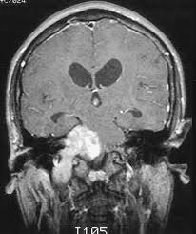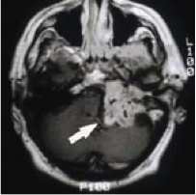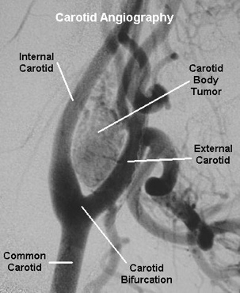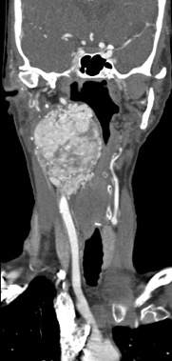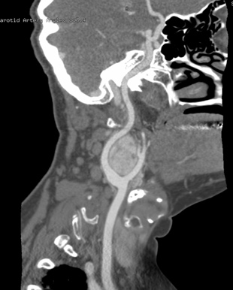

Neuroblastoma
- tumors arising from the sympathetic ganglion
- may occur anywhere in the sympathetic nervous system (most common: adrenal gland, cervical and thoracic sympathetic ganglia)
- become very large before detection
- dumbbell pattern
- neuroblastoma: most aggressive
- ganglioneuroblastoma
- ganglioneuroma
- olfactory neuroblastoma = esthesioneuroblastoma
- catecholamine precursors (homovanillic acid, vanillylmandelic acid may be seen in urine)
- periorbital neuroblastoma may present with racoon’s eyes
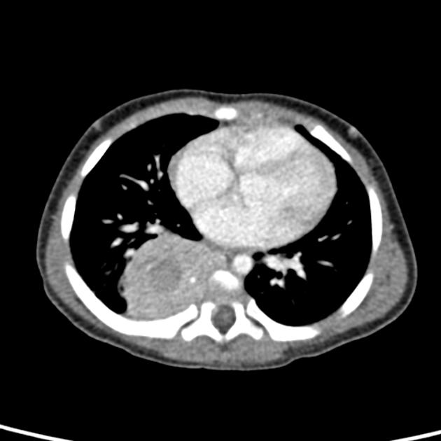

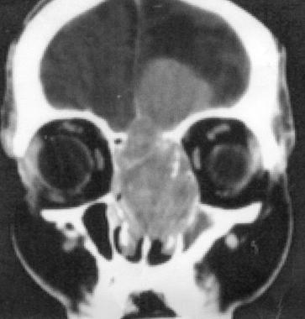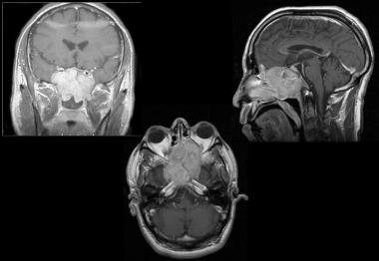

Esthesioneuroblastoma
- arise from olfactory neuroepithelium
- surgical treatment with post op radiation (55 Gy)

CHOROID PLEXUS TUMORS
- all types may produce drop mets
- infratentorial in adults
- supratentorial in children
- enhancing with projecting “fronds”
- hydrocephalus is common secondary to overproduction of CSF

Choroid plexus papilloma
- WHO I
- no role for chemotherapy and radiation
- resect recurrence
- 5-year survival 84%
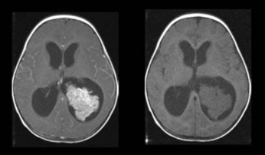

Atypical choroid plexus papilloma
- WHO II
Choroid plexus carcinoma
- WHO III
- chemotherapy may be given in some patients
PINEAL REGION AND EMBRYONAL TUMORS
- ALL PINEAL REGION TUMORS SHOULD HAVE MRI OF ENTIRE NEURAXIS AND CSF SENT FOR MARKERS
- metastasize easily through the CSF (scan neuraxis)
- drop mets may result in radiculopathy and/or myelopathy
- over the age of 40, a pineal region tumor is most likely a meningioma or a glioma
- other tumors: meningioma, metastasis, astrocytoma
- treatment:
- germinoma may be treated with XRT + chemo
- all other malignant tumors should be resected with XRT to follow
- if there is evidence of CSF seeding, craniospinal XRT should be done with a boost to the tumor bed
- XRT is avoided in children < 3 years
- NB: malignant germ cell tumors with evidence of metastasis do not benefit from surgery on the primary tumor

Pineal cysts
- < 2 cm lesions should be followed clinically
- shunt for hydrocephalus may not treat gaze disturbance (from
pressure on tectal plate)
Germinoma (GCT)
- malignant germ cell tumor
- radiosensitive
- treatment: XRT + chemo
- metastasize easily through the CSF (scan neuraxis)
- positive CSF beta-hCG in 50%
- test dose of radiation (5 Gy) to see if tumor shrinks
Embryonal carcinoma (GCT)
- malignant, non-germinomatous germ cell tumor
- radioresistant
- metastasize easily through the CSF (scan neural axis)
Choriocarcinoma (GCT)
- malignant, non-germinomatous germ cell tumor
- radioresistant
- metastasize easily through the CSF (scan neural axis)
- positive CSF beta-hCG
Endodermal sinus tumor (yolk-sac carcinoma) (GCT)
- malignant, non-germinomatous germ cell tumor
- radioresistant
- metastasize easily through the CSF (scan neural axis)
Teratoma (GCT)
- mature or immature
- benign or malignant

Tumor | Beta-hCG | AFP | PLAP (placental alkaline phosphatase)
Germinoma | 10-50% positive | - | Positive
Choriocarcinoma | 100% positive | - | -
Embryonal carcinoma | +/- | Positive | -
Yolk sac carcinoma | - | Positive | -
Immature teratoma | - | Positive | -
Mature teratoma | - | - | -

Pineocytoma
- WHO I
- well-differentiated, arising from pineal epithelium
- radiosensitive
- surgical resection + SRS for any residual

Pineoblastoma
- WHO IV
- malignant
- considered a primitive neuroectodermal tumor (PNET)
- radiosensitive
- radiation and chemo
Papillary
- WHO II/III

- prognosis: depends on histologic diagnosis
- germinoma: 5-year = 97%
- NG-GCT: 5-year with RT = 36%
- pineocytoma: mean survival of 8 years
- pineoblastoma: GTR + RT = 25 months
EMBRYONAL TUMORS
- primitive neuroectodermal tumor (PNET) = embryonal tumors
- all patients need neuraxis imaging due to propensity for CSF dissemination
- prophylactic craniospinal XRT is indicated following removal (cranial XRT is avoided before age 3)
Retinoblastoma
Pineoblastoma
Neuroblastoma
Esthesioneuroblastoma
- olfactory neuroblastoma
- malignant
- grading should be performed in all cases
- combined ENT/neurosurgery treatment
- median overall survival = 7 years
Medulloblastoma
- WHO IV
- small-cell tumor arising in the cerebellar vermis
- evaluate for drop mets
- GTR frequently not possible due to brainstem invasion
- may calcify
- poor prognosis in age < 3 yrs
- 3 types:
- classic: Homer-Wright rosettes, “blue tumor”
- desmoplastic: more common in adults
- large cell: more aggressive than classic; resembles atypical teratoid/rhabdoid tumors of the cerebellum
- medulloblastoma with extensive nodularity
- treatment: highly radiosensitive and moderately chemosensitive
- surgical resection (most likely not able to obtain GTR + craniospinal XRT)
- 35-40 Gy to whole craniospinal axis + 10-15 Gy boost to tumor bed over 6-7 weeks
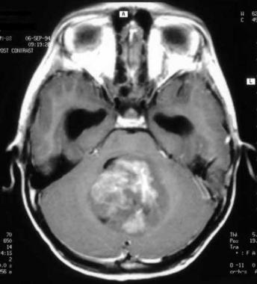
Supratentorial primitive neuroectodermal tumors
- highly malignant
- primarily affect children
- expected 3-year progression-free survival ~ 50%
- Ependymoblastoma: median post-op survival 12-20 months
Atypical teratoid/rhabdoid tumors (AT/RT)
- primarily in infants and children
- 33% have CSF spread at presentation
- most patients die within 1 year of diagnosis
TUMORS OF THE CRANIAL, SPINAL, AND PERIPHERAL NERVES
Vestibular schwannoma
- benign, schwann-cell tumor, arises in inferior division of vestibular nerve
- chromosome 22
- NF-2
- hearing loss, tinnitus, dysequillibrium
- w/u: MRI, audiogram
- definition of serviceable hearing:
- Gardener-Robertson Class I (use phone on that side) or Class II (localize sound)
- pure tone audiogram threshold </= 50 dB
- speech discrimination score >/= 50%
- treatment:
- small tumors (< 15 mm) with good hearing
- observe with MRI and audiogram
- small tumors with serviceable hearing
- SRS or surgery
- medium tumors (15-25 mm) should be treated
- large tumors should be treated
- SRS 12-13 Gy (higher doses lead to facial neuropathy)
- three approaches: middle fossa (intracanalicular tumor), translabyrinthine (no hearing preservation), retrosigmoid
- peel tumor laterally
- facial nerve function: House-Brackmann grades 1-3 are associated with acceptable function
- risk of facial nerve injury is much greater if surgery is done for recurrence of if it follows SRS
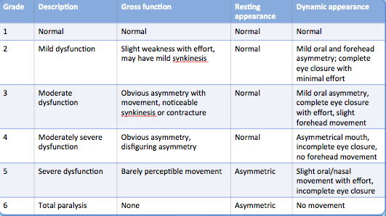
TUMORS OF THE MENINGES
Meningiomas
- planum sphenoidale: arise from flat part of the sphenoid bone;
anterior to chiasmatic sulcus and posterior part of anterior
cranial fossa
- tuberculum sellae
- WHO I
- WHO II: choroid, clear cell, atypical
- WHO III: (“RAP”) rhabdoid, anaplastic, papillary
- PXA may mimic meningiomas since they are peripherally located and have a dural tail
- consider pre-operative embolization
- preop imaging to determine if dural sinus is patent
- it is always preferable to leave residual tumor and consider treating it with radiation than to cause a venous infarct!
- XRT is ineffective as the primary modality of treatment
- treatment of recurrent atypical or anaplastic meningioma with residual disease post-op: XRT with 55-60 Gy
- Simpson grade: I = complete removal, V = simple decompression/biopsy
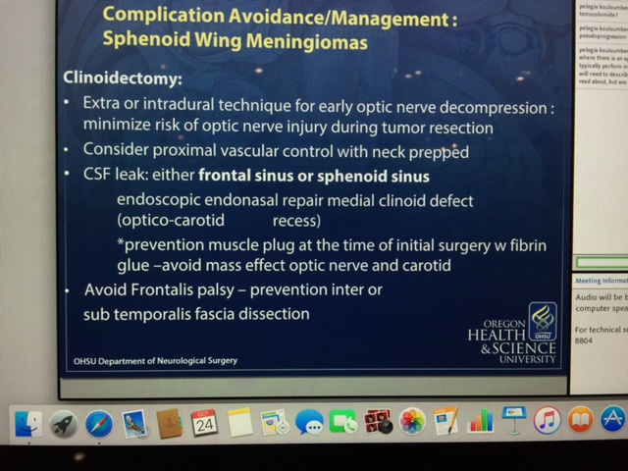

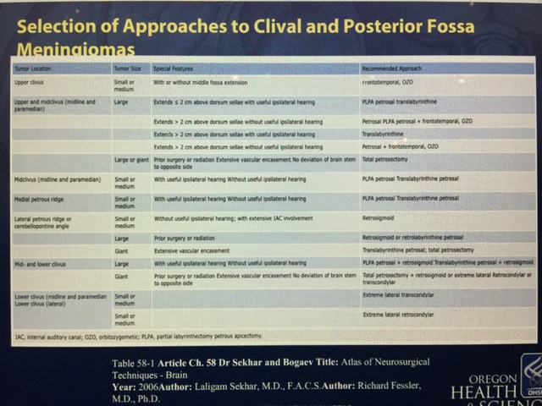

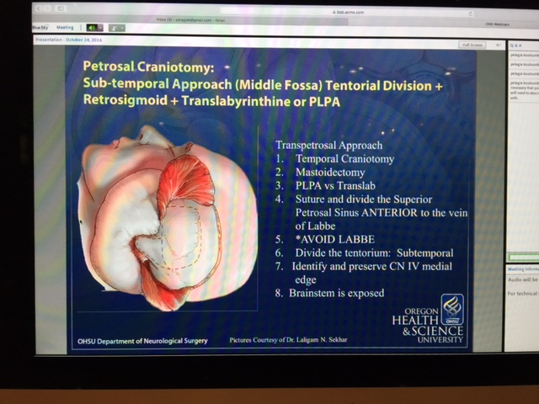
Hemangiopericytoma
- WHO classified as mesenchymal (nonmeningothelial) tumors
- WHO II or III (anaplastic)
- sarcoma arising from pericytes
- may metastasize (spine, lung, long bone, liver, abdominal cavity)
- surgery is primary treatment with XRT to reduce recurrence rate
- chemotherapy is used for metastases or for tumors failing local control measures (salvage therapy)
Primary CNS melanoma
- radiation therapy
Hemangioblastoma
- highly vascular
- sporadic or von Hippel-Lindau
- may be associated with polycythemia
- pre-op embolization may help reduce vascularity
- mural nodule needs to be removed
- no role for XRT
von Hippel-Lindau
- AD
- chromosome 3
- hemangioblastomas of the cerebellum and spinal cord
- pheochromocytoma: must treat pre-op to avoid intraoperative hypertensive crisis
- polycythemia
- renal cell carcinoma, neuroendocrine pancreatic tumor
- retinal angioma
- resect hemangioblastomas as they become symptomatic
- preoperative workup:
- MRI of the brain and spine c/s contrast
- cerebral angiogram to determine if embolization is possible
- ophthalmology exam
- CT abdomen and pelvis (adrenal, renal, pancreas)
- lab work to eval for polycythemia
- 24 hour urine collection for VMA
LYMPHOMAS AND HEMATOPOIETIC NEOPLASMS
CNS lymphoma
- primary or secondary
- homogeneously enhancing grey matter lesions (periventricular) or corpus callosum, esp in AIDS and transplant patients
- may present with multiple CN palsies
- very responsive to steroids (“ghost tumors”)
- treatment: XRT + chemo
- may present with spinal cord compression or carcinomatous meningitis
- evaluation: MRI of entire spine, bone marrow biopsy, eye exam for uveitis/intraocular lymphoma
Multiple myeloma
- neoplasm of a single clone of plasma cells
- hypercalcemia
- bone pain
- Bence-Jones protein in urine, myeloma protein in serum
- multiple “punched-out” lesions
- bone scan usually negative
- MM is very radiosensitive
- solitary plasmacytoma has a 50% 10-year survival
- elimination of M protein following radiation indicates 50-60% chance of remaining free of MM
Plasmacytoma
- neoplasm of single clone of plasma cell
- there must be no other lesions on skeletal survey (not bone scan)
- local XRT provides good local control rates
PITUITARY TUMORS
- mnemonic for suprasellar lesions: SATCHMO
- S: sellar (adenoma), sarcoid
- A: aneurysm
- T: teratoma, tuberculosis
- C: craniopharyngioma, chordoma, cleft cyst
- H: hamartoma, hystiocytosis, hypothalamic glioma
- M: meningioma, metastasis
- O: optic glioma
- most are benign adenomas arising from the adenohypophysis
- microadenoma = < 10mm
- 50% of pituitary tumors causing Cushing’s disease are too small to see on imaging (therefore, endocrinologic testing is required)
- MRI enhancement is very time-dependent
- imaging must be done within 5 minutes of contrast administration to see a discrete microadenoma
- initially, gadolinium enhances the normal pituitary (no blood-brain barrier), but not the pituitary tumor
- after ~ 30 minutes, the tumor enhances the same
- dynamic MRI may improve outcome (contrast in injected while the MRI scanner is running)
- deviation of the pituitary stalk may also indicate the presence of a microadenoma
- normal thickness of the stalk = diameter of basilar
- thickening of the stalk is usually NOT adenoma (lymphoma, autoimmune hypophysitis, granulomatous disease, hypothalamic glioma)
- macroadenomas may produce headache from increased intrasellar pressure
- pituitary apoplexy can present in many ways – always give steroids as there is suppression in the presence of apoplexy
- endocrine panel: TSH, PRL, FSH, LH, IGF-1, ACTH
- prolactinomas are the only pituitary tumors where medical treatment may be tried initially
- SELECTIVE LOSS OF A SINGLE PITUITARY HORMONE TOGETHER WITH THICKENING OF THE PITUITARY STALK IS STRONGLY
SUGGESTIVE OF AUTOIMMUNE/LYMPHOCYTIC HYPOPHYSITIS (treatment is steroids)
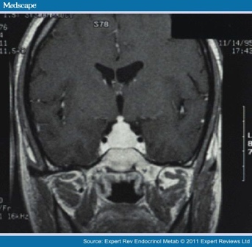 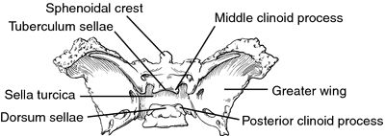
NB: thickening of the stalk is NOT adenoma!
Pituitary adenoma
- 65% are secretory
- prolactin
- amenorrhea-galactorrhea in females
- impotence in males
- stalk effect: pressure on the stalk can decrease inhibitory control over PRL secretion
- most common secretory adenoma
- NB: always check pregnancy test in a female with amenorrhea
- treatment:
- PRL<500 ng/mL in tumors that are not extensively invasive – PRL may be normalized with surgery
- PRL>500 ng/mL – chance of normalizing PRL surgically are very low
- if no progressive deficits, medical treatment first to decrease PRL level
- response should be seen in 4-8 weeks (PRL decrease, size decrease on MRI, and VF improved)
- if no response – surgery followed by reinstitution of medical therapy
- Bromocriptine (Parlodel): start with 1.25mg PO QHS and titrate up
- dose is increased every 3-4 days for macroadenomas causing mass effect (up to 7.5mg TID x 6 mo)
- after 6 months, maintenance dose of 7.5mg daily
- dose is increased every 2-4 weeks for microadenomas
- check PRL level after 4 weeks
- rare side effects that necessitate discontinuation of medication: vasospasm and psychosis
- Cabergoline (Dostinex): 0.25mg PO twice weekly (has 60-100 hour half-life)
- increase dose by 0.25mg Q4weeks – up to 3mg per week
- check PRL level after 4 weeks
- side effects of the medications: headache, n/v, GI complaints, CSF leak (as tumor shrinks), apoplexy
- if PRL level> 50 ng/mL despite medical treatment, consider surgery
- if PRL level 20-50 ng/mL, reassess dose
- if PRL level < 20 ng/mL, maintain dose
- if good response to dopamine agonists, treat for 1-4 years (check PRL yearly)
- if tumor no longer visible on MRI, withdraw therapy with regular serial imaging (recurrence highest in 1st yr)
- GH
- in adults: acromegaly
- workup: endocrine tests, cardiology consult, colonoscopy, IGF-1 levels
- effects: soft tissue, skeletal, cardiomyopathy, colon cancer, peripheral nerve entrapments
- in children: pituitary gigantism (very rare)
Oral glucose tolerance test (OGTT)
- baseline GH level cannot be used as elevated GH may occur with stress and low levels are seen in many acromegalics
- unnecessary in diabetic patients as baseline hyperglycemia has already suppressed GH level
- GH secretion is inhibited by hyperglycemia
- in acromegaly (or gigantism), GH secretion is autonomous and does not suppress with hyperglycemia
- patients should fast 10-16 hours prior to the test (but may drink water)
- blood is drawn at 0, 30, 60, 90, and 120 minutes
- normal subjects with exhibit suppression of GH to undetectable levels (< 0.3 mcg/L) during the test
- paradoxical rise in GH may occur during GTT during normal adolescence
- treatment: aggressive surgical approach
- IGF-1 may take months to normalize after surgery
- medical therapy for elderly or surgical failures: Octreotide (somatostatin analogue)
- 50-100 mcg SQ Q8H (up to 1500 mcg/d)
- ACTH (corticotropin)
- Cushing’s disease (endogenous hypercortisolism)
- Nelson syndrome (in patients with adrenalectomy)
- treatment: aggressive surgical approach
- TSH (thyrotropin)
- secondary (central) hyperthyroidism
- elevated or inappropriately normal TSH (TSH should be undetectable in primary hyperthyroidism)
- anxiety, palpitations, heat intolerance, hyperhidrosis, weight loss, hyperactivity, lid lag, hyper-reflexia, tremor
- treatment: aggressive surgical approach with post-op XRT
- gonadotropins (LH and/or FSH)
- does not produce a clinical syndrome
- 5% are locally invasive
Cushing’s disease v. syndrome v. ectopic ACTH secretion
- Cushing’s disease and ectopic ACTH secretion → Cushing’s syndrome
- Cushing’s syndrome = caused by hypercortisolism
- may be caused by Cushing’s disease
- most common cause is iatrogenic (administration of exogenous steroids)
- symptoms:
- weight gain (centripetal fat: buffalo hump, supraclavicular, moon facies, slender extremities)
- hypertension
- purple striae on flank, breasts, and lower abdomen
- amenorrhea in women and impotence in men
- hyperpigmentation of skin and mucous membranes (ACTH elevation only, not with hypercortisolism from
other causes)
- atrophic, tissue-thin skin, easy bruising, poor wound healing
- depression, emotional lability, dementia
- osteoporosis
- generalized muscle wasting
- sepsis
- hirsutism and acne due to elevation of other adrenal hormones
- Cushing’s disease = endogenous hypercortisolism due to hypersecretion of ACTH by an ACTH-secreting pituitary adenoma (one
cause of Cushing’s syndrome)
- hyperglycemia
- hypokalemic alkalosis
- loss of diurnal variation in cortisol levels
- normal or elevated ACTH levels
- elevated 24-hour urine free-cortisol
- low CRH level
- failure to suppress cortisol with low-dose (1mg) dexamethasone test
Dexamethasone suppression test: determines whether ACTH secretion can be suppressed
- Low dose: 1mg dexamethasone is given at night (11PM) and cortisol is measured at 8AM
- High dose: 8mg dexamethasone is given at night and cortisol is measured at 8AM
- can determine if cause is from pituitary (Cushing’s disease)
- normal result: cortisol should decrease once you receive dexamethasone (<1.8 mcg/dL)
- 1.8-10 mcg/dL = indeterminate; retesting is necessary
- normal AM cortisol = 10-20 mcg/dL
- normal 4pm cortisol = 3-10 mcg/dL
- normal bedtime cortisol = < 5 mcg/dL
- abnormal result: hypercortisolism (Cushing’s syndrome) despite administration of dexamethasone due to
1. adrenal tumor, 2. pituitary tumor, 3. ectopic ACTH-secreting tumor
- adrenal tumors and ectopic ACTH production WILL NOT suppress even with high doses of dexamethasone
(but patients with adrenal tumors will have low levels of ACTH)
Adrenal tumor:
- low dose test results in no decrease in blood cortisol
- ACTH level is low (<5ng/L)
- high dose test in not needed
Cushing syndrome from ectopic ACTH-secreting tumor:
- low dose test results in no decrease in blood cortisol
- ACTH level is high
- high dose test: no decrease in blood cortisol
Cushing’s syndrome caused by pituitary tumor (Cushing’s disease):
- low dose test results in no decrease in blood cortisol
- ACTH level is high
- high dose test: expected decrease in blood cortisol
Corticotrophin-releasing hormone (CRH) stimulation test:
- CD responds to exogenous CRH bolus with even further increased plasma ACTH and cortisol levels
- ectopic ACTH-secreting and adrenal tumors do not
- post-CRH ratio > 3 is consistent with primary Cushing’s disease
Inferior petrosal sinus / cavernous sinus sampling:
- microcatheter to measure ACTH levels on each side at:
- baseline, 2, 5, 10 minutes after stimulation with IV CRH
- simultaneous ACTH levels at each interval
- baseline IPS ACTH: peripheral ACTH ratio > 1.4 = primary Cushing’s disease
- IPS sampling IS NOT indicated if:
- ACTH-dependent Cushing’s disease
- suppression occurs with high-dose dexamethasone test
- visible pituitary adenoma on MRI
- causes of hypercortisolism (ectopic ACTH secretion):
- small-cell lung carcinoma
- thymoma
- carcinoid tumor
- pheochromocytoma
- medullary thyroid cancer
- Pseudo-Cushing’s state
- hypothalamic or ectopic secretion of corticotropin-releasing hormone → hyperplasia of pituitary corticotrophs
Nelson syndrome
- rare, follows total bilateral adrenalectomies performed for Cushing’s disease
- classic triad: hyperpigmentation, abnormally high ACTH, progression of pituitary tumor
- due to continued growth of corticotroph (ACTH-secreting) adenoma cells
- ACTH > 200 ng/L
MEN I
- AD
- pituitary tumors are non-secretory
- pancreatic islet cell tumor (produce gastrin and hence Zollinger-Ellison syndrome)
- parathyroid
Cushing’s disease/syndrome – management
1. If MRI shows macroadenoma → transsphenoidal surgery
2. If MRI is negative → inferior petrosal sinus sampling
- if IPSS is positive → surgery
- if IPSS is negative → look for extra-pituitary source (CT abdomen)
3. If surgery is performed, but biochemical cure is not obtained:
- consider re-exploration
- SRS or medical therapy
- adrenalectomy in appropriate patients
- continued hypercortisolism with:
- non-resectable pituitary tumor
- failure of medical therapy to control symptoms after transsphenoidal surgery
- life-threatening Cushing’s disease
- CD without evidence of pituitary tumor (testing: high-dose DMZ suppression and IPSS)
- if adrenalectomy is performed, follow-up regularly to r/o Nelson’s syndrome
Addison’s disease – adrenal insufficiency (not enough cortisol produced by the adrenal gland)
- can occur after abrupt discontinuation of exogenous corticosteroids
Surgical treatment for pituitary adenoma
- do not replace thyroid hormone until adrenal axis is assessed – if hypoadrenalism is present, can precipitate adrenal crisis
- post-op steroids:
- hydrocortisone 50mg IV/PO BID, then 20mg QAM and 10mg QPM
- monitor for DI: UO > 250 cc/hour x 1-2 hours, urine SG < 1.005, hypernatremia, dilute urine
- keep up with loss
- ddAVP 2-4 mcg SQ/IV Qday
- obtain post-op MRI following surgery 3 months post-op
Pituitary carcinoma
- can metastasize
- most are secretory (ACTH and PRL most common)
- poor prognosis once mets occur (little improvement with surgery, XRT, chemotherapy)
Neurohypophyseal tumors
- pituicytoma
- granular cell tumor
Assessing cortisol reserve
Cosyntropin stimulation test:
- draw a baseline cortisol test (fasting not required, can be done any time of the day)
- give cosyntropin (ACTH analogue) 1 ampule (250 mcg) IM or IV
- check cortisol at 30 minutes and 60 minutes
- normal response: peak cortisol level > 18 mcg/dL AND an increment of > 7 mcg/dL, or a peak > 20 mcg/dL regardless of increment
- subnormal response: indicates adrenal insufficiency
- primary adrenal insufficiency: pituitary ACTH secretion will be elevated
- secondary adrenal insufficiency: chronically reduced ACTH → adrenal atrophy and unresponsiveness
CYSTS AND TUMOR-LIKE LESIONS
Rathke’s cleft cyst
- a lesion with a nodule in the sella is usually a RCC
Colloid cyst
- slow growing, benign, anterior 3rd ventricle
- aka neuroepithelial cysts
- recommend surgery when cyst is > 1 cm in diameter
- hyperintense on T1 and hypointense on T2
Epidermoid cysts
- CPA, 4th ventricle, suprasellar, spinal cord
- aka cholesteatoma
- may produce chemical meningitis
- surgical excision
- radiation has no role
- DWI restriction
Craniopharyngioma
TUMORS AND TUMOR-LIKE LESIONS OF THE SKULL
BENIGN TUMORS
Osteoma
- most common primary bone tumor of the calvaria
- round, sclerotic, well demarcated
- usually arise from outer table of cranium
- hot on nuclear bone scan
- surgery for cosmetic reasons
Hemangioma
- cavernous and capillary
- X-ray with circular lucency with honeycomb or trabecular pattern, sunburst pattern
- hot on bone scan
- gross appearance is a hard, blue-domed mass beneath the pericranium
- radiation considered for inaccessible lesions
Dermoid/Epidermoid
- X-ray with osteolytic lesions with well-defined, sclerotic margins
- surgical excision
- radiation not indicated

Chordoma
- primary malignant tumor
- usually in clivus or sacrum
- high recurrence rate
- physaliphorous cells
- slow growing
- lytic with frequent calcifications
- radioresistant
- wide en bloc resection + proton beam radiation
- median survival is 6.3 years

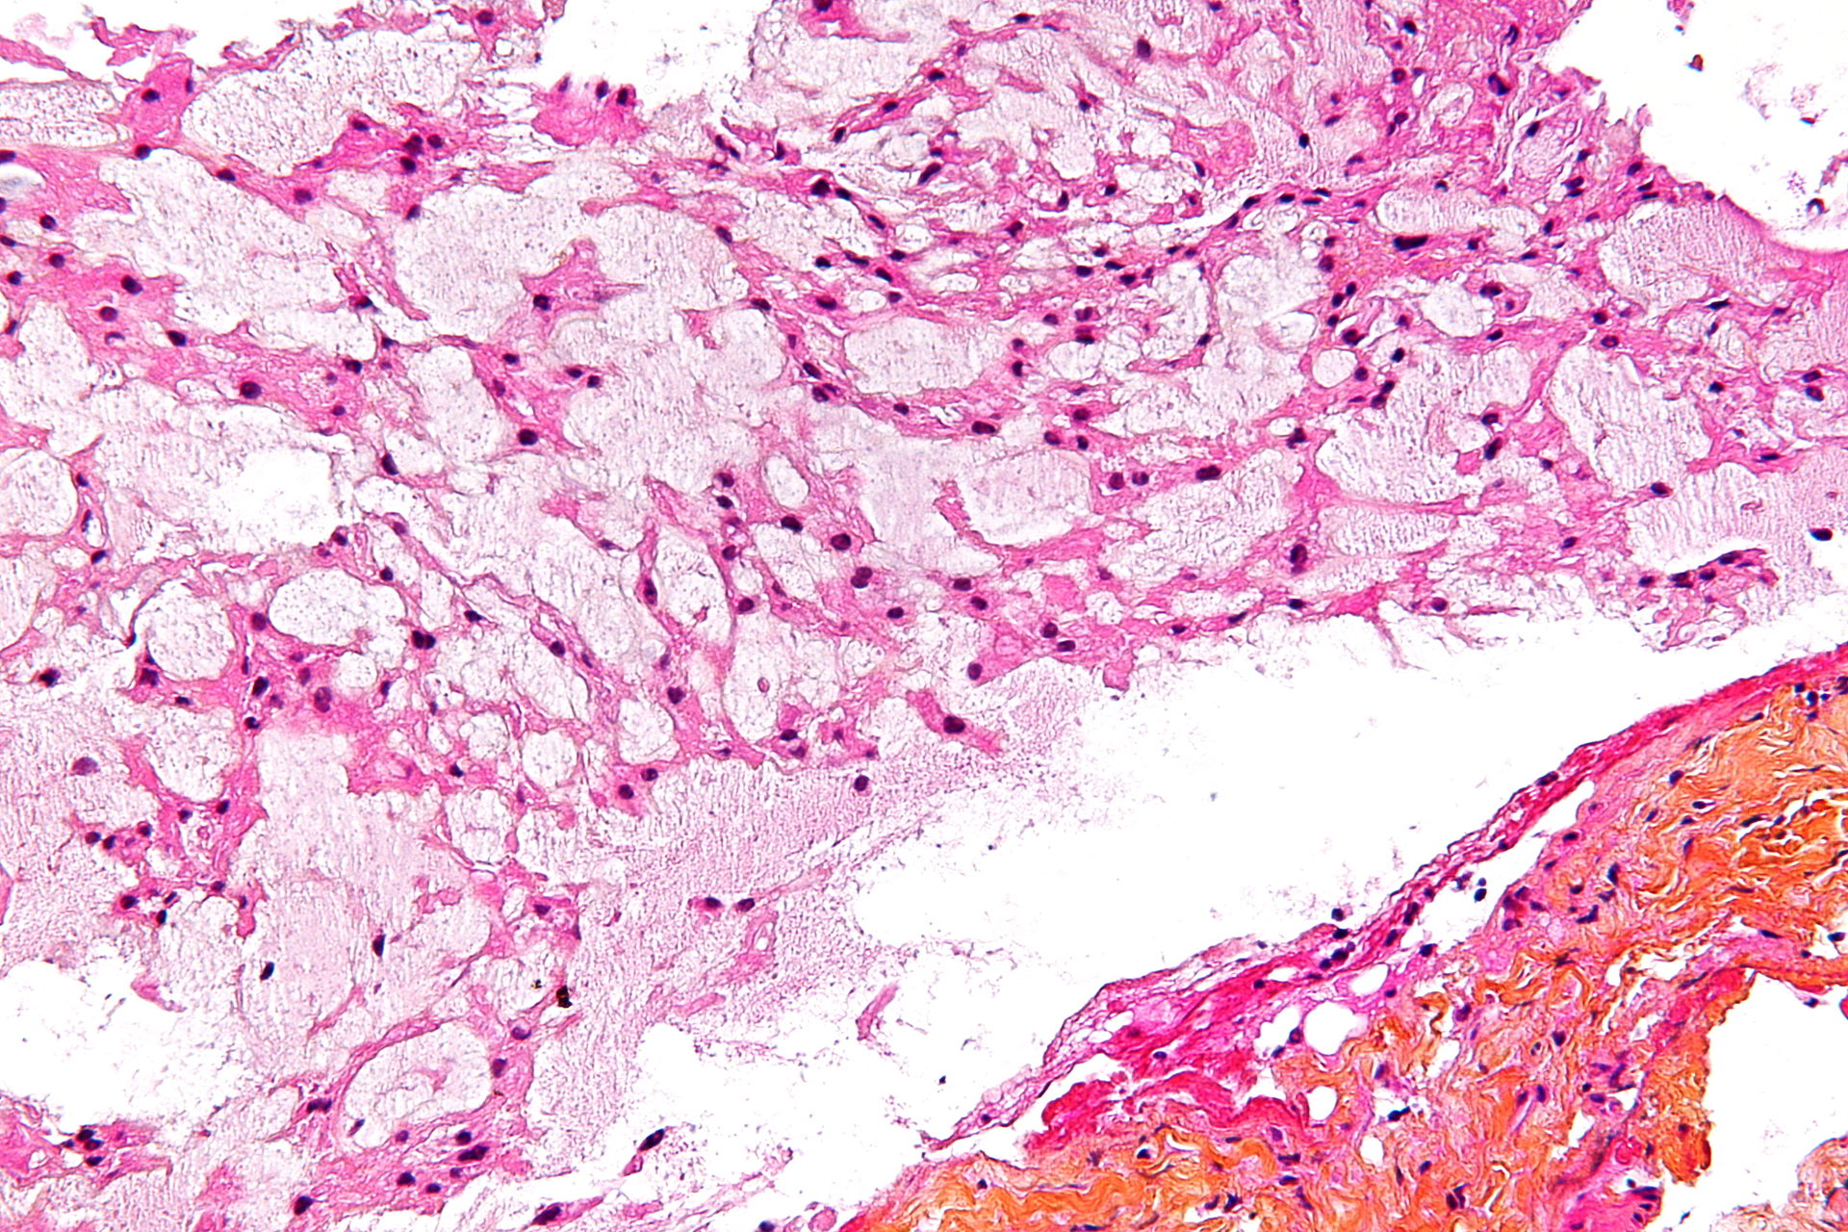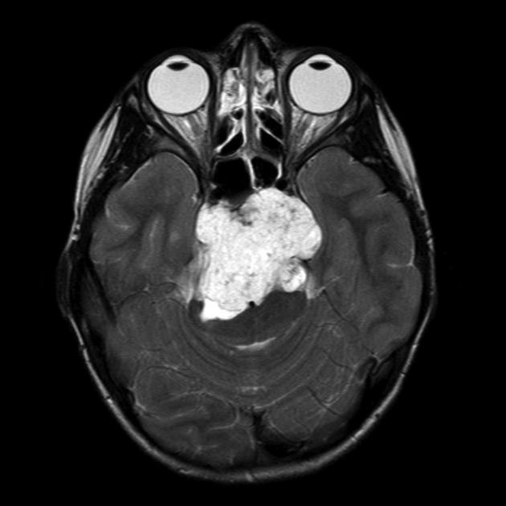

NON-NEOPLASTIC SKULL LESIONS
Osteopetrosis
- congenital
Hyperostosis frontalis interna
Paget’s disease of the skull
- aka osteitis deformans
- osteolysis is followed by repeated attempts at repair, replaced by fibrous tissue and osteoid that may calcify
- possible hemorrhage and necrosis
- hypervascularity of bone
- mostly asymptomatic, incidentally found
- age 50+
- pain from microscopic fracture
- increase in HAT and SHOE size normally seen
- cortical thickening
- inner table is not involved
- bone scan is “hot” due to hypervascularity
- malignant degeneration to osteosarcoma
Fibrous dysplasia
- slow, benign progression of bone being replaced by a weaker fibrous type of bone with poorly formed bony trabeculae
- normal bone is replaced by fibrous connective tissue
- monostotic: most common
- ground glass appearance on X-ray (due to lack of normal cortical and trabecular organization)
- bone scan is “hot” due to constant bone turnover
- if no uptake is seen on bone scan, you can rule out fibrous dysplasia
- thick, sclerotic margin (aka rind of sclerosis) is seen
- seen with McCune-Albright syndrome (polyostotic FD, skin pigmentation, early sexual development, female only, menses at 5-6 yo)
- may degenerate to fibrosarcoma
- polyostotic FD thins out table of the skull, where Paget’s thickens it
- the spine is not commonly involved
Meningioma
Aneurysmal bone cyst
MALIGNANT TUMORS
Metastatic lesions: prostate, breast, lung, kidney, thyroid, lymphoma, multiple myeloma, plasmacytoma
Chondrosarcoma
Osteogenic sarcoma
Fibrosarcoma
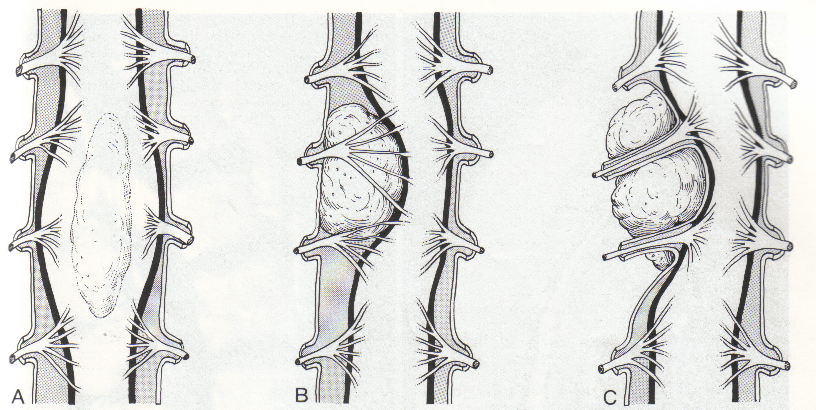
TUMORS OF THE SPINE AND SPINAL CORD
- three compartments: extradural (C), intradural/extramedullary (B), intramedullary (A)

Spinal lymphoma
- may be found in any compartment
EXTRADURAL TUMORS (55%)
- vertebral bodies or epidural space
Metastatic tumors
- comprise the majority of extradural tumors (lung, breast, prostate)
- most are osteolytic
- may be osteoblastic: prostate and breast
- before deciding on surgical plan:
- know the systemic disease status
- if the patient is healthy enough to have surgery (medical/cardiac clearance)
- Karnofsky performance score (KPS)
- radiation is a MUST following surgery for a metastatic lesion!
Osteoid osteoma and Osteoblastoma
- benign
- histologically identical
- </= 1 cm = osteoid osteoma
- > 1 cm = osteoblastoma
- high cure rate with complete excision
- cause night pain relieved by NSAIDs (aspirin)
- treatment: complete excision to avoid recurrence (radiation is not indicated)
- osteoblastoma may undergo sarcomatous change (osteosarcoma)
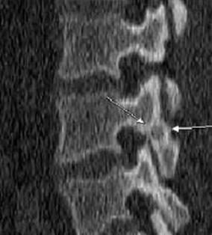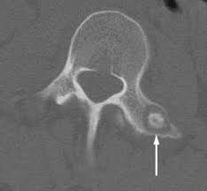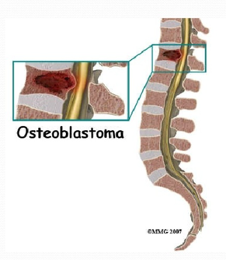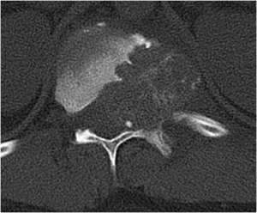
Osteosarcoma
- most common primary bone cancer
- usually in the lumbosacral region, in males,in their 40s
- poor prognosis (median survival = 10 months)
- biopsy can contaminate field
Aneurysmal bone cyst
- painful, expansile osteolytic lesion in patients under 30
- highly vascular honeycomb blood-filled cavities
- involves primarily the posterior elements
- high recurrence rate if not completely resected
- thin peripheral bone rim with internal thin bony ridges
- characteristic MRI appearance with fluid levels
- peripheral enhancement of many small chambers
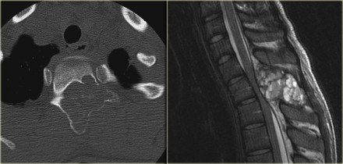

Chondrosarcoma
- malignant tumor of cartilage
- treatment: resection and proton beam radiation
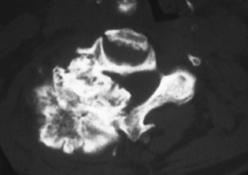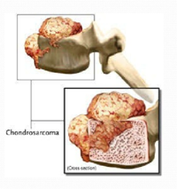
Osteochondroma
- benign

Vertebral hemangioma
- most common primary spine tumor
- benign
- bone scan: no increased uptake unless there is an underlying
compression fracture
- bone scan helps differentiate a hemangioma from a
metastatic lesion (which lights up on bone scan)
- hyperintense on T1 and T2
- less than 1% are symptomatic
- treatment:
- if asymptomatic, no follow-up is needed
- radiation therapy for painful lesions
- radiosensitive and undergo sclerotic obliteration
- 40 Gy (improvement may take months)
- embolization
- vertebroplasty
- surgery for painful lesions that fail other tx or for
lesions causing neurologic deficit
- recurrence 20-30% in 2 years for subtotal resection
- if STR, follow with radiation therapy
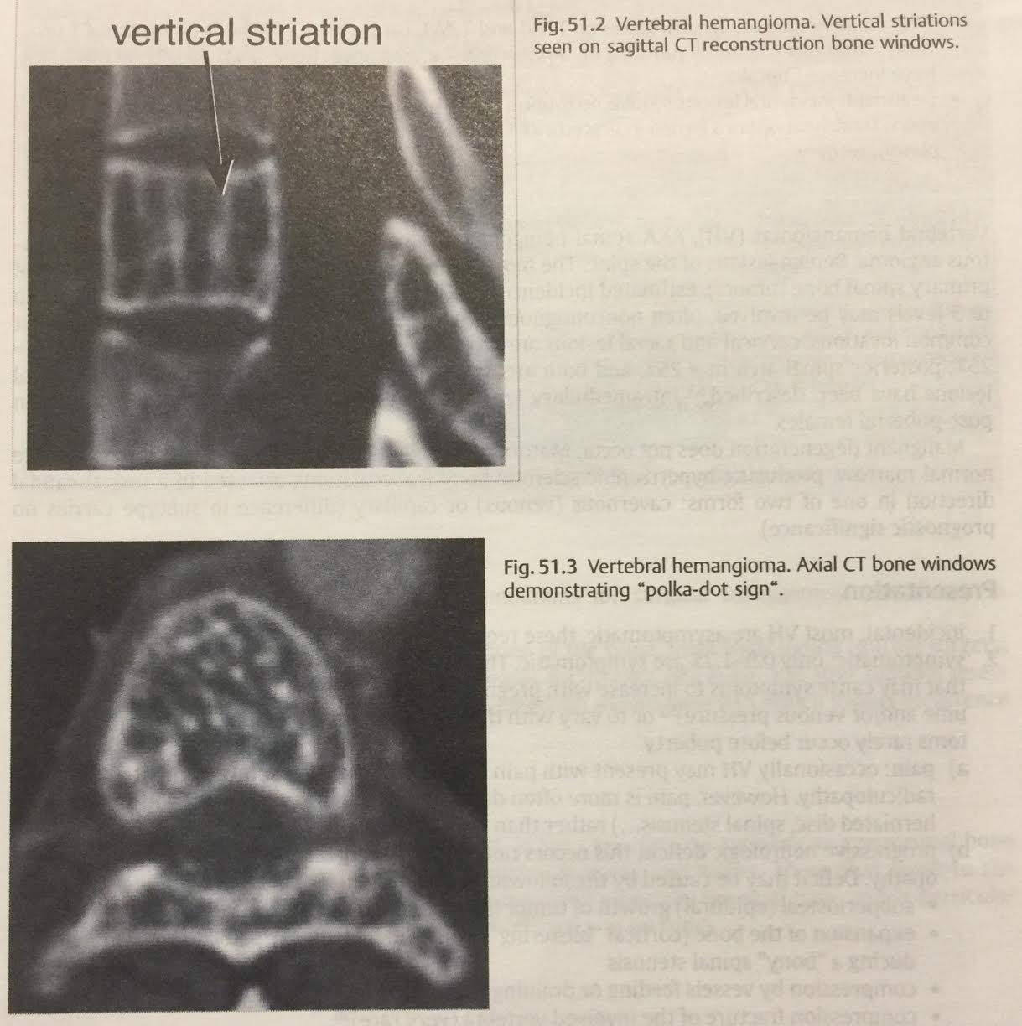

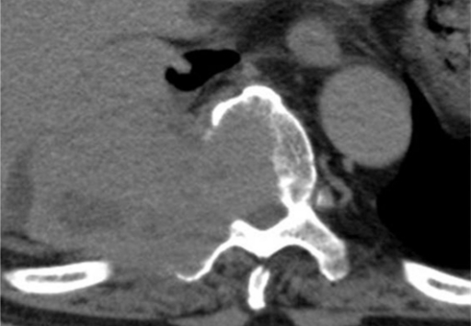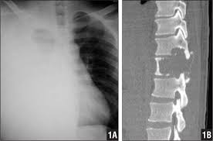
Giant cell tumor
- in the same category as ABC
- occur in skull base and sacrum
- lytic with bony collapse
- benign with pseudomalignant behavior
- recurrence is common
- pulmonary mets can occur
- w/u should include CT of the chest
- treatment: preop embolization with intratumoral curettage
- recurrence rate is low (20%) even with STR
- radiation controversial b/c of malignant degeneration
- radiation reserved for non-resectable recurrence

Plasmacytoma
Multiple myeloma
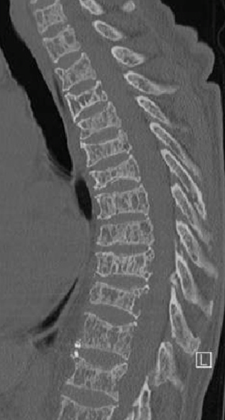
Unifocal Langerhans cell histiocytosis (eosinophilic granuloma)
Ewing’s sarcoma
- malignant tumor
- spine is usually a site of metastasis
- treatment is mostly palliative
- radical excision + radiation (very radiosensitive) + chemotherapy
INTRADURAL EXTRAMEDULLARY SPINAL CORD TUMORS (40%)
Meningioma
Schwannoma
- arise from dorsal roots
- patients usually present with local pain
- deficits occur late
- dumb-bell tumor
Neurofibroma
Lipomas
Metastasis – only 4% involve this compartment

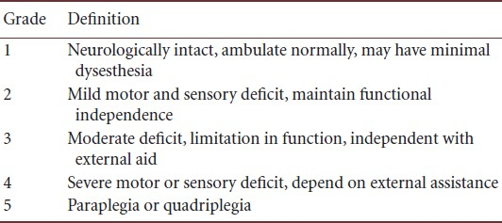
INTRAMEDULLARY SPINAL CORD TUMORS (5%)
- MEP monitoring: tumor removal should be discontinued if the amplitude drops to < 50% of baseline
- Modified McCormick Scale
- considered the standard outcome tool for patients with intradural spinal tumors
- completed by physician in an outpatient setting; not a patient-rated outcome scale
- assesses global functional impairment in terms of neurological function and walking ability

Astrocytoma
- low-grade lesions with an identifiable plane: resection without radiation
- low-grade lesions without a plane: debulking within tumor (no radiation for low-grade lesions)
- high-grade lesions: biopsy + minimal debulking + radiation
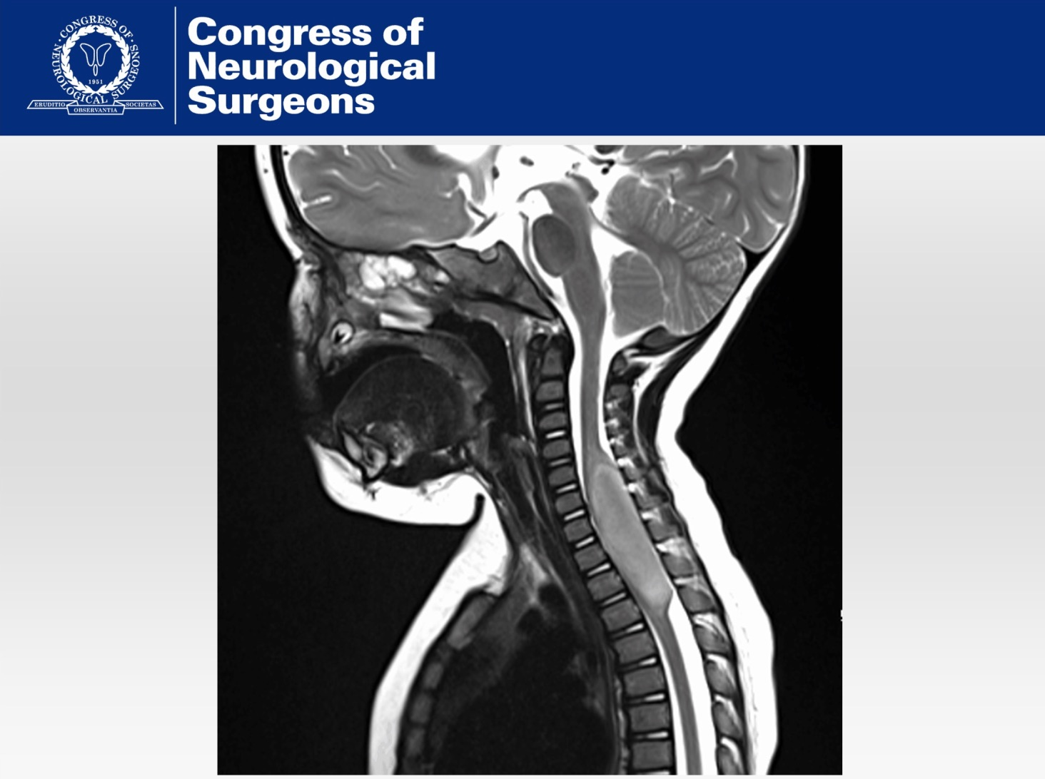
Ependymoma
- more common in adults
- encapsulated and minimally vascular
- attempt at gross total resection (no radiation is recommended)
- typically demonstrate “capping” (area of hemosiderin surrounding tumor)
Glioblastoma
Dermoid
- may be iatrogenic from incompletely excised dermal elements at the time of MM closure
Epidermoid
Teratoma
Lipoma
Hemangioblastoma
- non-infiltrating
- very vascular
- associated with von Hipple-Lindau
Neuroma
Syringomyelia
Lymphoma
Oligodendroglioma
Metastasis
- most spinal mets are extradural
- small-cell lung, breast, malignant melanoma, lymphoma, colon Ca
CEREBRAL METASTASES
- most common type of brain tumor seen clinically
Primary CNS tumor metastasis
- the following primary CNS tumors are known to spread via CSF seeding (drop mets):
- high grade gliomas
- primitive neuroectodermal tumors (esp. medulloblastoma)
- ependymoma
- choroid plexus tumors
- pineal region tumors
- germ cell tumors
- pineocytoma
- pineoblastoma
- rarely: oligodendroglioma, hemangioblastoma, primary CNS melanoma
Metastatic tumors
- even with optimal treatment, median survival of patients with cerebral mets is still only 26-32 weeks
- the specific tumor type, length of time since diagnosis, etc. are not as important prognostically as the Karnofsky Performance Scale
- use of WBRT following surgery did not affect length of survival, but it did increase disease-free interval
- Lung (the most common tumor to metastasize to the brain)
- small cell (aka oat cell)
- very radiosensitive
- prophylactic WBRT is given (25 Gy in 10 fractions)
- surgery for brain mets only if a large, life-threatening lesion is seen
- if multiple SCLC lesions: XRT 30 Gy in 10 fractures + chemotherapy
- non-small cell (adenocarcinoma)
- Melanoma
- classically radioresistant, but SRS is still done
- patients with Karnofsky performance scale score < 70 are poor surgical candidates
- if patients have significant systemic burden, treat that before the cerebral mets
- if systemic disease is controlled and there are 1-4 intracranial lesions that are accessible: OR or SRS
- Renal cell carcinoma
- radioresistant (response to XRT = 10%)
- usually several areas of mets prior to cerebral metastasis
- Esophageal
- solitary brain met with good KPS = surgical treatment has better prognosis
Radiosensitivity of brain metastases to WBXRT
Radiosensitivity | Tumor
Radiosensitive | * small-cell lung ca  * germ-cell tumors  * lymphoma  * leukemia  * multiple myeloma
Moderately sensitive | * breast
Moderately resistant | * colon  * non-small-cell lung ca
Highly resistant | * renal  * malignant melanoma  * sarcoma  * thyroid  * adenocarcinoma

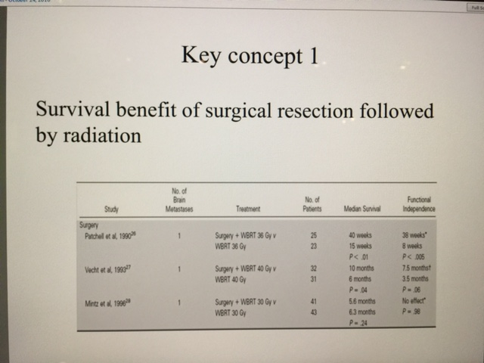
If reasonable: Surgery + WBRT >> median survival than WBRT alone
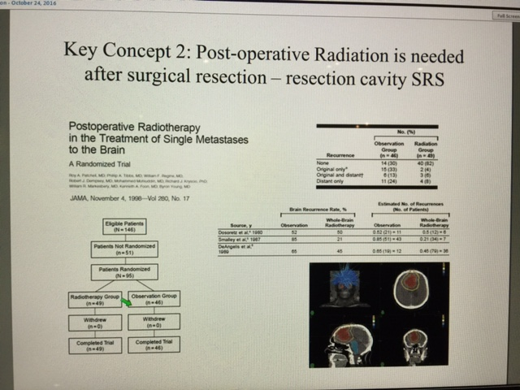
Radiation is a MUST after surgery for a metastatic tumor!

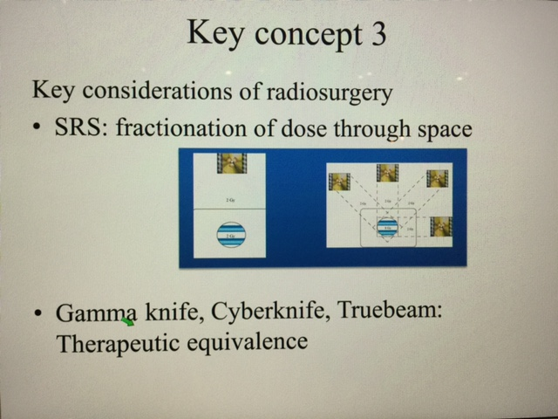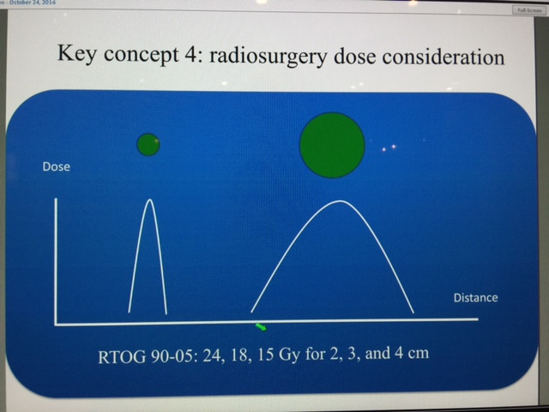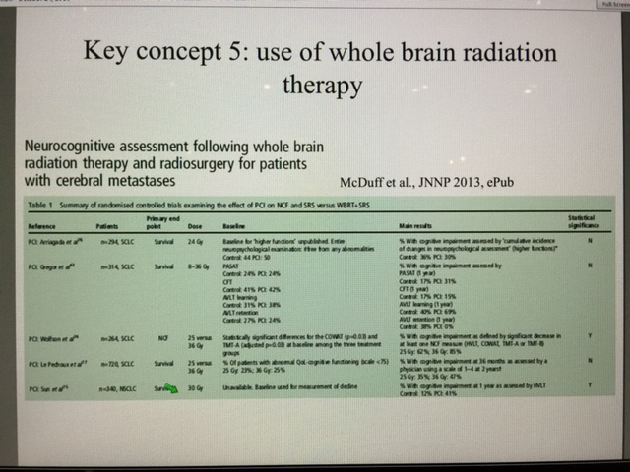
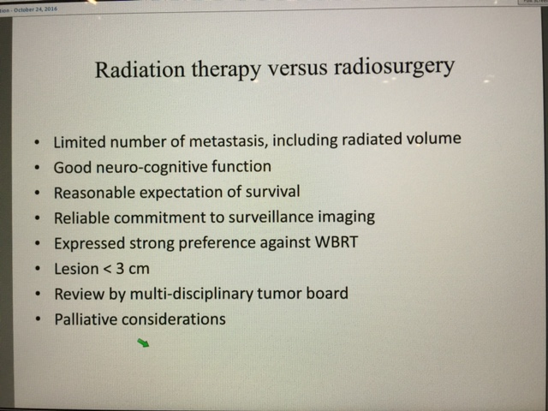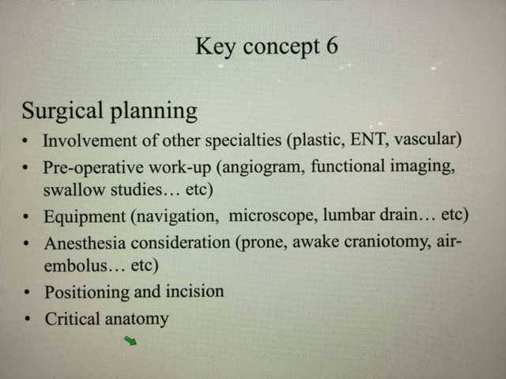
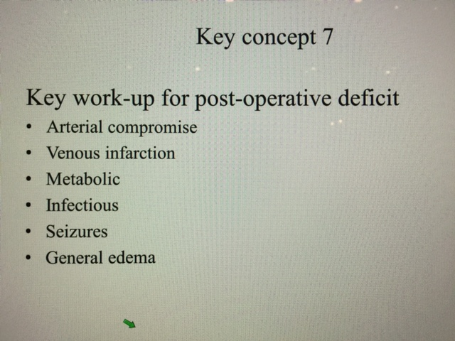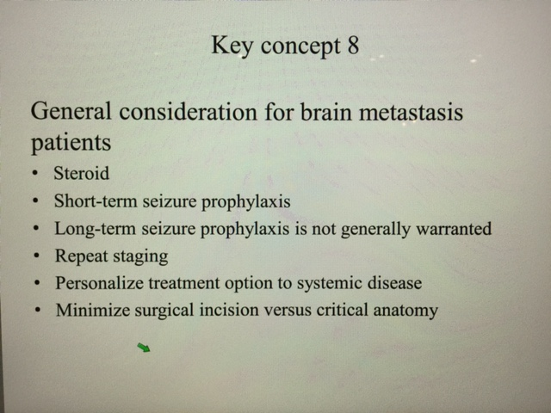
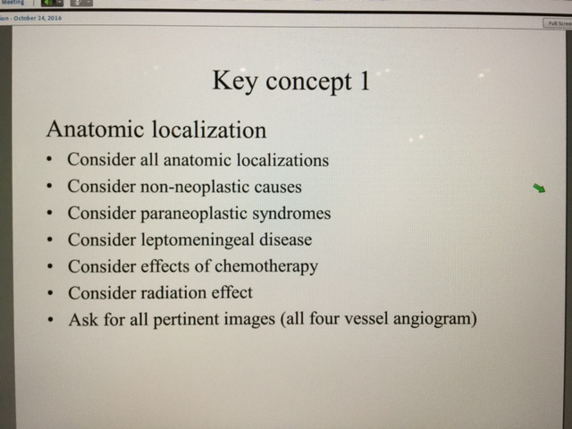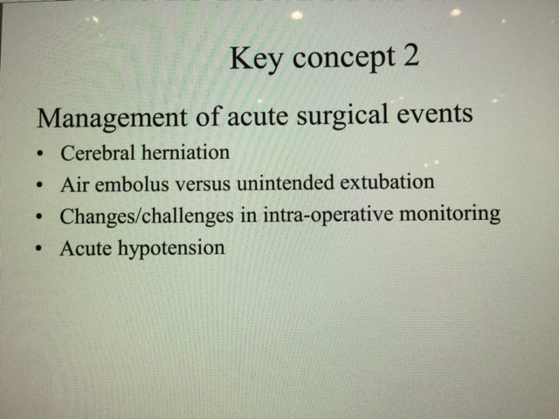
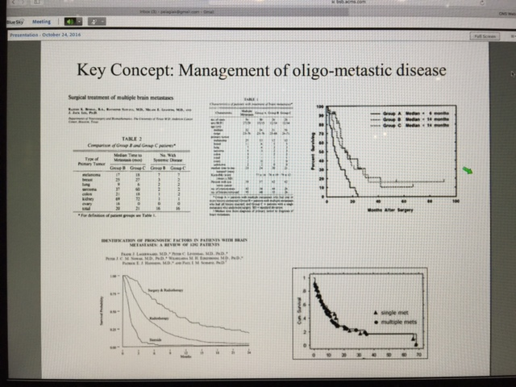 consider surgery for 1-3 metastases if pt is doing well
Carcinomatous meningitis [always remember this as a possible diagnosis in ANY section of the Board Exam!!!]
- breast, lung, melanoma
- LP > 10 cc needed (may need up to 3 specimens before positive result is seen)
- radiation therapy and intrathecal chemotherapy improve survival
- may present with cranial nerve + cerebral + radiculopathy (these poorly localize and that is why you must consider carcinomatosis)
SPINAL EPIDURAL METASTASES
- surgery not helpful for:
- total paralysis > 8 hours
- loss of ambulation > 24 hours
- prognosis < 3-4 months survival
- poor medical condition
- radiosensitive tumor
- bone metastases can sometimes produce hypercalcemia (medical emergency)
- XRT 30-40 Gy in 10 treatments over 7-10 days (ports extending 2 levels above and 2 levels below the lesion)
- no chemotherapy has been found to be helpful with spinal epidural metastatic lesions
Safe entry zone into the pons
- peritrigeminal area in ventro-lateral pons
- fibers are directed horizontally or slightly oblique so myelotomy should be transverse
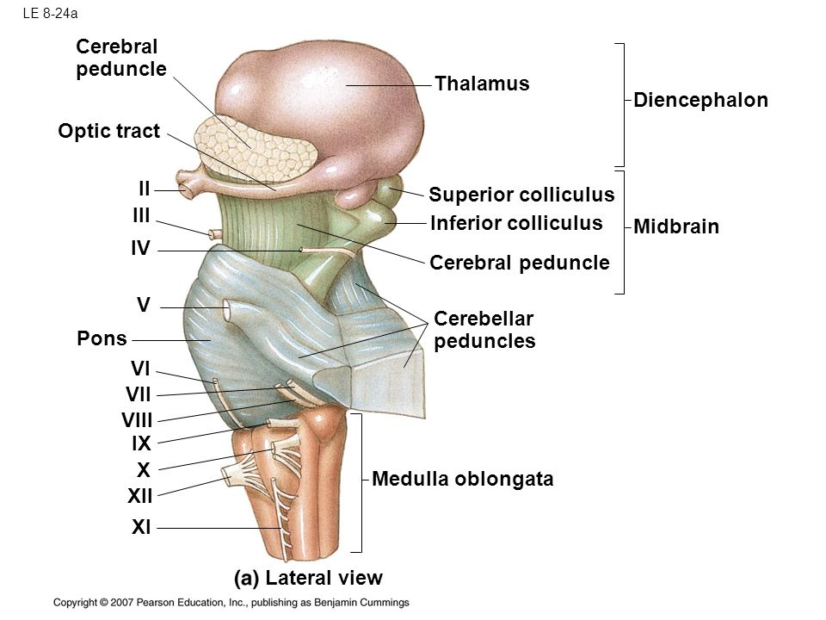

Approaches to clival lesions
