Cerebral perfusion pressure: CPP = MAP – ICP  
CPP would have to drop below 40 in a normal brain before CBF would be impaired  
Elevated ICP (>20 mm Hg) is more detrimental than changes in CPP (> 60 mm Hg)

Monro-Kellie doctrine: the sum of the intracranial volumes (CBV + brain + CSF) is constant. An increase in any one must be offset by an equal decrease in another

Cushing’s triad: hypertension + bradycardia + respiratory irregularity

Indications for ICP monitoring:   
- For salvageable patients with severe TBI (GCS </= 8 after cardiopulmonary resuscitation):  
 - abnormal HCT (EDH, SDH, ICH, contusions, compression of basal cisterns, herniation, or cerebral edema)  
 - normal HCT but with >/= 2 risk factors for intracranial hypertension (age > 40 yrs, SBP < 90 mm Hg, posturing)

1 mm Hg [torr] = 1.36 cm H2O  
1 cm H2O = 0.735 mm Hg [torr]

NB: the maximum expected output from a ventriculostomy would be ~450-700 cc/day in a situation where none of the produced CSF is absorbed by the patient. Commonly, drainage ~75 cc/8H

Ways to confirm monitoring reflects ICP:   
- lowering the HOB towards 0 degrees should increase ICP  
- gentle pressure on both jugular veins simultaneously should cause a gradual increase in ICP over 5-15 seconds

ICP waveforms  
- ICP monitoring waveform has a flow of 3 upstrokes in one wave  
 - P1 (percussion wave): represents arterial pulsation  
 - P2 (tidal wave): represents intracranial compliance  
 - P3 (dicrotic wave): represents aortic valve closure  
- in normal ICP waveforms, P1 should have the highest upstroke, P2 in-between, an P3 should be the lowest  
- if P2 is higher than P1, indicates elevated intracranial pressure  
- Lundberg A waves (aka plateau waves): steep increases in ICP; indicative of early brain herniation  
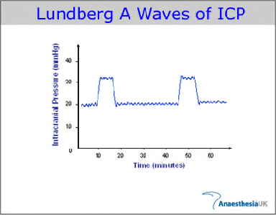  
- Lundberg B waves (aka pressure pulses): unstable ICP, cerebral vasospasm  
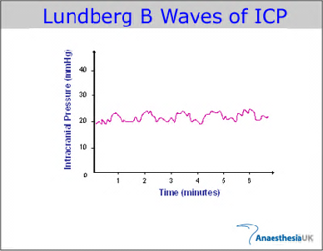  
- Lundberg C waves: may be seen in normal individuals

Jugular venous oxygen monitoring  
- indications include the need for augmented hyperventilation (PCO2 = 20-25) to control ICP  
- SjVO2: normal is >/= 60%; desaturation to < 50% suggests ischemia  
- sustained desaturation should prompt evaluation for:   
 - kinking of jugular vein  
 - anemia  
 - increased ICP  
 - poor catheter position  
 - CPP < 60 mm Hg  
 - vasospasm  
 - surgical lesion  
- high SjVO2 > 75% may indicate hyperemia or infarcted tissue

Brain tissue oxygenation tension monitoring   
- indications include the need for augmented hyperventilation (PCO2 = 20-25) to control ICP  
- monitored with Licox probe  
- likelihood of death increases with longer times of brain tissue oxygenation tension (pBtO2) < 15 mm Hg or even brief drop of pBtO2<6  
- initial pBtO2 < 10 mm Hg for > 30 minutes correlates with increased risk of death or bad outcome  
- probe placement:  
 - TBI: place on least injured side  
 - SAH: place in vascular distribution at greatest risk of vasospasm  
 - ICH: place near site of hemorrhage

CBF  
- normal white matter: 18-25 ml/100g-min  
- normal grey matter: 67-80 ml/100g-min

* ICP>20 mmHg should be treated  
  - avoid excessive use of fluids and pressors to maintain CPP>70mmHg because of risk of ARDS  
  - avoid CPP<50mmHg  
  - jugular venous O2 saturation < 50% or pBtO2 < 15 mmHg are treatment thresholds

|  |  |
| --- | --- |
| General measures: Step | Rationale |
| Elevate HOB 30-45 degrees | Augment venous outflow |
| Avoid neck constriction |  |
| Avoid arterial hypotension (SBP<90mmHg) | Maintain CBF |
| Avoid hypoxia (PO2<60mmHg) | Prevent ischemia |
| Light sedation | Reduce sympathetic tone and HTN |
| Normocarbia | Avoid hyperventilation |
| Non-contrast HCT | r/o surgical lesion |

|  |
| --- |
| Specific measures for IC-HTN: Steps |
| Heavy sedation |
| Drain CSF if EVD present |
| Hypoventilate (PaCO2=30-35mmHg) |
| Mannitol 0.25-1g/kg, then 0.25mg/kg Q6H |
| 10-20cc bolus of 23.4% hypertonic saline |
| Non-contrast HCT to r/o structural lesion |

|  |
| --- |
| Measures to treat acute ICP crisis |
| Check airway, neck position, order STAT HCT |
| Elevate HOB |
| Sedate and paralyze |
| Drain CSF if EVD is present |
| mannitol |
| Hyperventilate with Ambu bag |
| Pentobarbital 100mg slow IV |