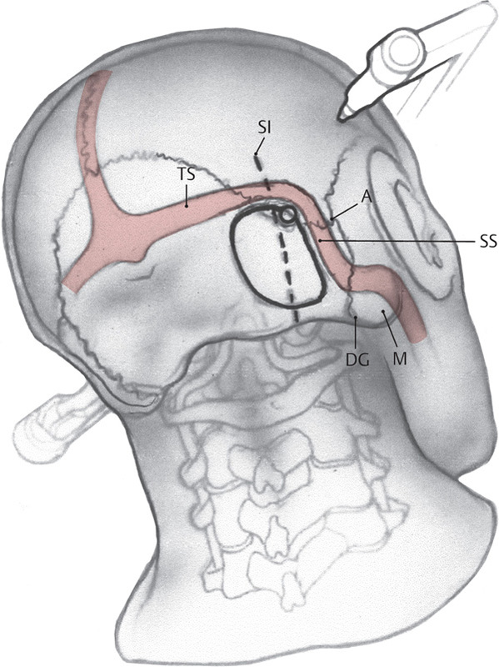**Microvascular decompression for treatment of trigeminal neuralgia**

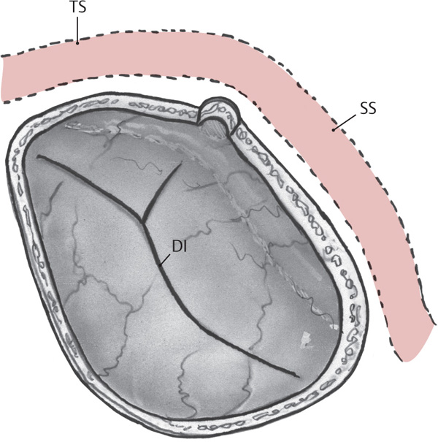- MVD is not the treatment of choice if a patient has trigeminal neuralgia secondary to MS or other lesions  
- Preoperative imaging is reviewed to rule out underlying lesion

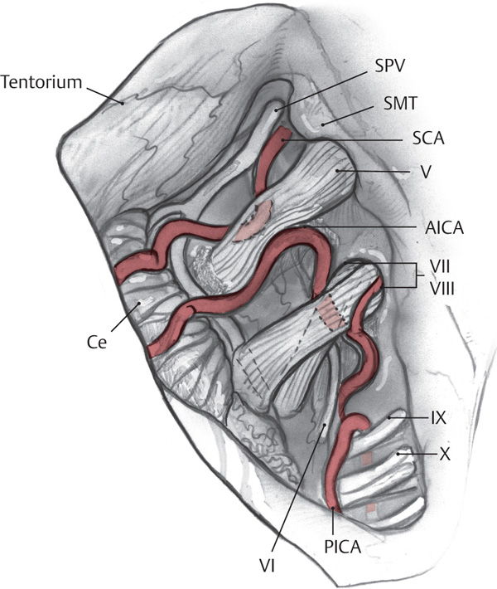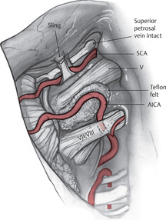- A surgical timeout is performed  
- Preoperative antibiotics are given  
- General anesthesia is administered  
- The patient is positioned in the supine position with a shoulder roll under the ipsilateral shoulder  
- The Mayfield head holder is placed  
- Intraoperative neurophysiologic monitoring should be used: BAER, CN V (masseter), CN VII

- An incision is marked behind the hairline

- Goal is to expose the junction of the transverse and sigmoid sinuses  
- A line from the inion to the root of the zygoma approximates the transverse sinus course   
- The digastric groove can be palpated (over sigmoid sinus)  
- Working at the superolateral angle (where the tentorium meets the petrous bone)

- Wax mastoid cells

- Open dura   
- Microscope is brought into the field  
- If the use of preoperative diuretics and spontaneous egress of CSF upon opening provide sufficient relaxation of the cerebellum leading to adequate exposure of the cerebellopontine angle, use of rigid retractors is discouraged

- Identify the CN VII, CN VIII complex (inferior/posterior to CN V)

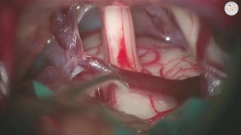

- The greater petrosal vein of Dandy is coagulated if exposure is compromised

- Often, the superior cerebellar artery is seen abutting the nerve (other possibilities: AICA, aberrant trigeminal nerve)

- Dissect the vessel away from the nerve, NOT the nerve away from the vessel

- Shredded Teflon is placed and inserted between the nerve and the vessel  
- If the compression is venous, the vein is coagulated and cut

- Inspect the entire cisternal segment of the nerve from the entry zone to the porus trigeminus

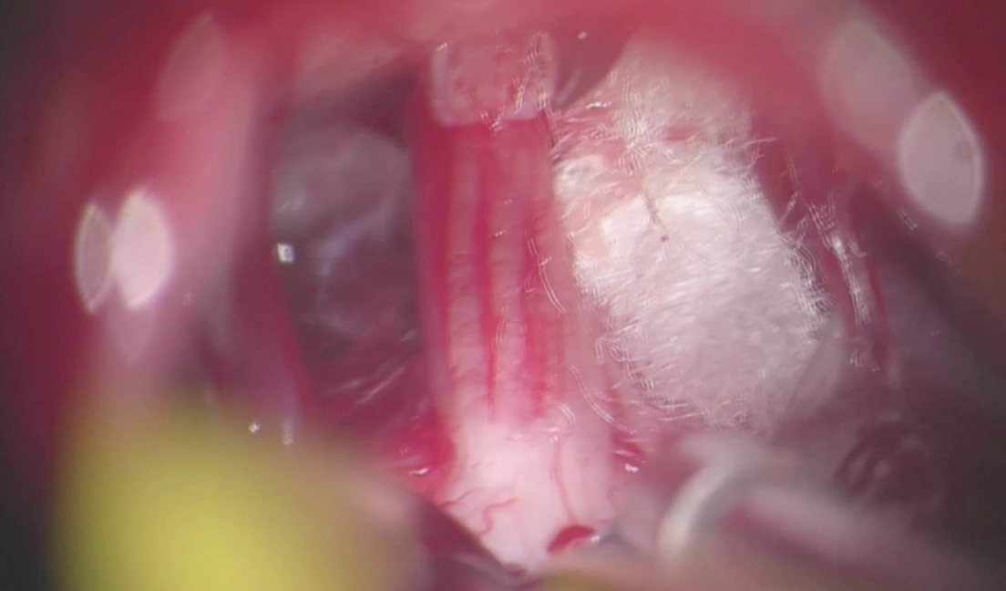

- The mastoid air cells are waxed again, and a water-tight dural   
 closure is performed

- The bone flap is replaced

Postoperative complications:   
- CSF leak (watertight closure is important)  
 - Consider re-exploration or lumbar drain  
- Hearing loss (partial if mastoid cells are not waxed (CSF in mastoid) or complete if no BAER are not used from CN VIII compromise)  
 - Consult ENT; unlikely to require additional intervention  
- Facial numbness (manipulation of the trigeminal nerve)  
- Incomplete relief of TGN (may indicate compression was missed due to inadequate inspection of cisternal segment or pledgets have moved)  
 - Consider re-exploration and re-decompression  
 - If this occurs more than 6 months after MVD, the risk of developing facial numbness is very high; consider one of other interventions