**PERCUTANEOUS TRIGEMINAL BALLOON COMPRESSION**

- Preferred procedure for patients with V1 involvement, dementia or other cognitive impairment, language barrier (does not require patient’s cooperation)  
- This procedure is done under general anesthesia and does not require patient cooperation  
  
NB: needle insertion and/or lesioning may cause HTN  
Prep the cheek of the involved side with Betadine  
Entry point: (under propofol) insert needle (14 gauge) 2.5-3cm lateral to oral commissure  
  
Trajectory:   
- palpate the buccal mucosa with gloved finger inside the mouth (lateral to teeth)  
- with other hand, pass the needle medial to the coronoid process of the mandible, deep to the oral mucosa  
- aim toward the plane intersecting a point 3cm anterior to the EAM and the medial aspect of the pupil when the eye is directed forward  
- do not contaminate the field with the hand that was inside patient’s mouth  
- as insertion progresses, use fluoroscopy to direct the tip towards the intersection of the top of the petrous bone with the clivus (5-10mm below floor of sella along the clivus)  
- upon entering the foramen ovale, the masseter often contracts (jaw briefly closes)  
- remove the stylet, look for CSF to verify location  
- replace stylet with balloon  
- advance into Meckel’s cave under direct radiographic control with the C-arm in lateral projection

Foramen ovale is best seen on a submental X-ray by hyperextending the neck 20 degrees and rotating the head 15-20 degrees away from side of pain  
- aim for balloon placement in the medial foramen ovale  
- after placing the balloon (No. 4 Fogarty catheter balloon), insert the stylet to visualize where the balloon will go  
- use 1ml of Omnipaque 240 to fill the balloon  
- the balloon should assume a pear-shaped appearance   
- during balloon inflation, it is not unusual to see a short period of bradycardia due to trigeminovagal reflex  
- keep the balloon inflated for 90 seconds  
- if the balloon ruptures, replace it and repeat (contrast is harmless)  
  
- post-op care:   
 - ice pack to face   
 - soft diet  
 - if corneal reflex impaired (neuroparalytic keratitis): artificial tears Q2H while awake and lacrilube to eye and tape shut QHS  
- patients are then weaned off carbamazepine as tolerated

Complications:   
- sensory loss is not considered a complication, but an expected effect of nerve destruction  
- extreme numbness perceived as pain is called anesthesia dolorosa  
 - best strategy to deal with AD is to avoid it (do not keep balloon inflated too long or use more than 1 mL of contrast)  
 - treatment: amitriptyline (Elavil, TCA), motor cortex stimulation

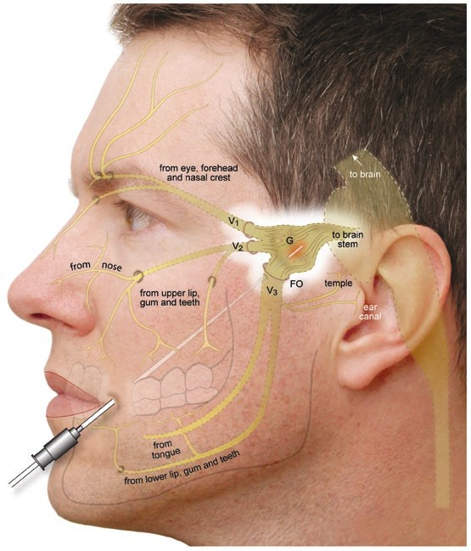* Balloon compression compresses the gasserian ganglion, whereas radiofrequency ablates the roots