Neurosurgical Atlas (Dr. Dennis Spencer – Yale) + Chapter 100 Seizure Surgery (Greenberg)
Categories of patients suitable for seizure surgery
1. Partial seizures
- temporal origin (see below)
- extratemporal origin
2. Symptomatic generalized seizures (Lennox-Gastaut)
3. Unilateral, multifocal epilepsy associated with infantile hemiplegia syndrome
Basic procedures:
1. Resection
2. Disconnection (callosotomy)
3. Hemispherectomy
- anatomic hemispherectomy
- functional hemispherectomy (deafferentation surgery)
4. Multiple subpial transection
- treatment of partial seizures in which the seizure focus is within eloquent cortical regions
5. Vagal nerve stimulation
- offered to non-resective candidates (poor localization or surgical failures)
- 12-year retrospective review: seizure frequency decreased by 26% at 1 year, 30% at 5 years, 52% at 12 years
- results of Vagal Nerve Stimulation Study Group E05 trial: 45% median seizure reduction at 12 months
- indication: refractory partial epilepsy (simple or complex)
- supplanted callosotomy for drop attacks
- FDA approved for implantation over age 12
- the vagus nerve is in the posterior part of the carotid sheath, between the internal jugular vein and the common carotid artery
- CAUTION: differentiate the vagus nerve from the phrenic nerve which traverses the anterior part of the sheath
- placement on the right side is contraindicated because the right vagus nerve innervates the sinoatrial node – stimulation on the right
side may result in asystole
- risk of bradycardia exists even on the left side
- the ideal site for lead implantation on the vagus nerve is in the middle part of the neck proximal to the branches to the cardiac plexus
- side effects: cough, hoarseness, throat pain
- if the VNS becomes infected, cut the wires close to the vagus nerve’s lead implantation site and the leads should be left in place
(attempting to remove the leads from the vagus nerve will result in injury to the nerve)

Corpus callosotomy

- not done very frequently since VNS developed
- this is a palliative procedure
- effective in treating atonic or drop attacks
- 25%: increase in focal seizures, 70%: elimination of seizures, 80% reduction in frequency
- palliative treatment in patients with multiple, poorly localized (unresectable) epileptogentic foci, secondarily generalized tonic-clonic seizures,
drop attacks
- division of the anterior 2/3 of the corpus callosum
- intraoperative EEG: bisynchronous discharges should become asynchronous
- no need to section the anterior commissure
- bifrontal craniotomy using a bicoronal skin incision
- head is flexed
- incision along coronal suture
- 4 x 8 cm craniotomy is made
- pericallosal arteries are identified and the avascular midline plane
- callosotomy may be performed with bipolar, suction, CUSA
- use neuronavigation to stay in the midline
- post-op akinetic mutism (resolves in weeks)
- MRI sagittal cuts to assess extent of division of the corpus callosum
- interhemispheric retraction can lead to supplementary motor cortex injury
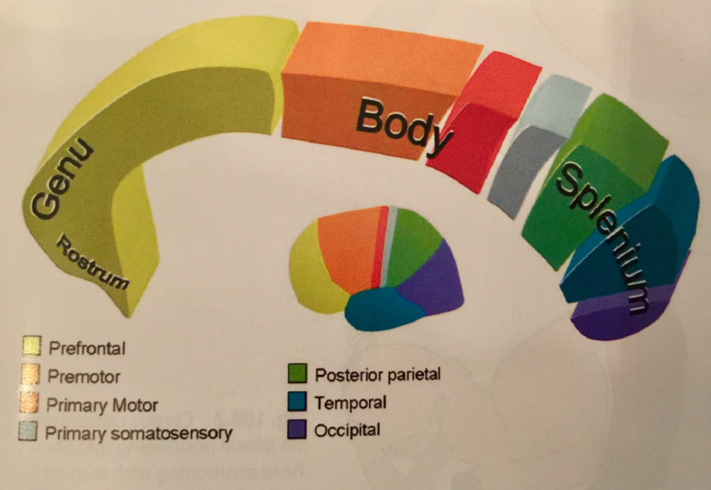

Disconnection syndrome
- In a patient with dominant left hemisphere:
- inability to name objects presented to the left visual hemifield
- left tactile anomia
- left sided dyspraxia
- left pseudohemianopsia
- right sided anomia for smell
- impaired spatial synthesis of right hand resulting in difficulty copying complex figures, decreased spontaneity of speech
- incontinence
- difficulty imitating the hidden other hand
- less risk if anterior commissure is spared
- Alien hand syndrome: non-dominant hand may reach for objects or manipulate items without conscious control

Callosotomy versus VNS:
- callosotomy offers better seizure control (especially drop attacks)
- VNS is reversible
- VNS is less invasive
- VNS has less morbidity
- VNS requires battery changes and closer follow-up
Functional hemispherectomy
- effective for hemispheric epilepsy syndromes
- typical candidate: patient with hemiplegia secondary to a unilaterally damaged hemisphere that is the result of a congenital or acquired lesion
- eg. infantile spasms, hemiconvulsion-hemiplegia-epilepsy syndrome, Sturge-Weber, multilobar cortical dysplasia, hemiplegia from perinatal infarction (porencephalic cyst), Rasmussen syndrome
- preoperative assessment:
- is the patient’s condition medically intractable?
- does the patient’s clinical status justify such an extensive procedure?
- are EEG findings strongly suggestive of a unilateral hemispheric origin of seizure?
- do structural and functional imaging demonstrate unilateral hemispheric damage?
- is the contralateral hemisphere healthy?
- family understanding and support system?
- ideal candidate is a patient with hemiplegia and hemianopsia secondary to unilateral hemispheric damage
- if patient is only hemiparetic with partial hemianospia, surgery will provide good seizure control with the price being impairment
- fMRI, PET (if hypometabolism is in damaged hemisphere, this is a good predictor (if not, warning for more extensive involvement)
- Wada test: verify that the good hemisphere can carry on speech and memory functions satisfactorily after surgical disconnection
- should only be performed on the damaged hemisphere to avoid risk of ischemic injury to the functional hemisphere
- early shift of language function is frequently seen in patients with early severe hemispheric damage
- complete lateralization of speech is acquired by the age of 5 years (shift beyond that is difficult)
- neuropsychological evaluation
- partial anatomical resection and full disconnection of the damage hemisphere
- preserves the anterior frontal, posterior parietal, and occipital lobes
- resection of the paracentral lobule and the anterior 2/3 of the temporal lobe (including mesial structures)
- disconnection of all commissural and projection fibers with a complete callosotomy
- severs the connection with the brainstem and thalamus through frontobasal and occipitoparietal cuts
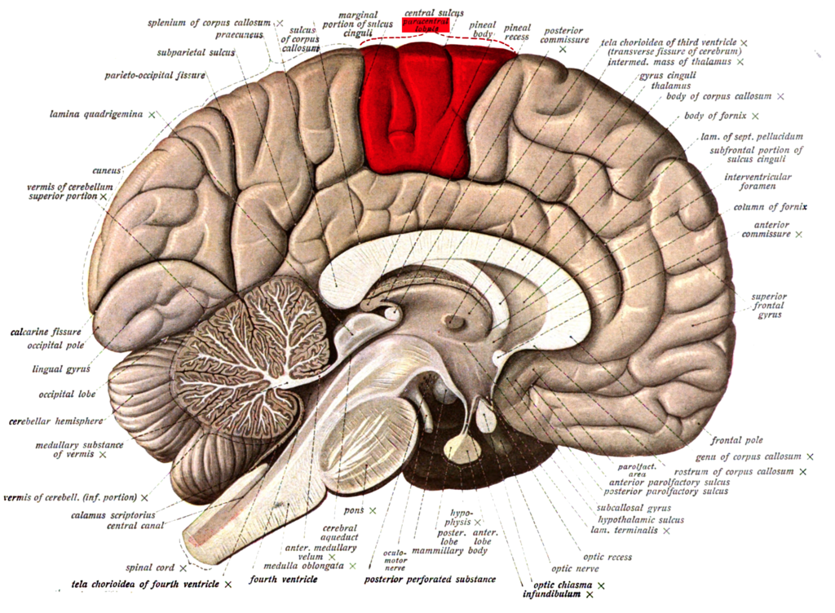

Paracentral lobule
- on the medial surface of the hemisphere - the continuation of the precentral and postcentral gyri

- controls motor and sensory innervations of the contralateral lower extremity

- responsible for control of defecation and urination

- anterior portion is part of the frontal lobe (SMA)

- posterior portion is part of the parietal lobe (deals with somatosensory of the distal limbs)

Multiple subpial transection
- treats epileptogenic zones in functionally critical cortical areas where resective surgery can cause unacceptable neurological deficits
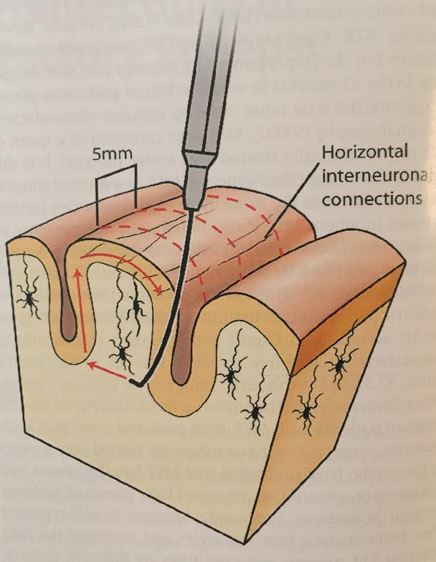
- two main indications:
- focal seizures in eloquent cortex
- Landau-Kleffner syndrome (acquired epileptic aphasia or verbal auditory agnosia )
- aim is selective destruction of horizontal fibers to prevent synchronization and spread of epileptogenic discharges while allowing preservation of the normal cortical functions
- main goal of preoperative evaluation is to define the seizure focus
- surgical technique:
- bipolar electrocautery is used to cauterize a small pial point on the defined epileptogenic focus at the side of the gyrus (5-7 mm deep)
- injury to sulcal vessels should be avoided
- parallel cuts (spaced 5mm apart) are made until the entire proposed epileptogenic zone has been transected
- the efficacy and extent of the procedure are judged intraoperatively by using ECoG (electrocorticography) before and after MST
- transient, post-operative deficits are common
- clinical improvement is usually seen within a week of the procedure
- mild cerebral edema is expected

Temporal lobe epilepsy
- causes:
- sclerosis (gliosis)
- tumor
- vascular (primarily cavernoma: must resect hemosiderin-laden area around cavernoma to achieve seizure control)
- developmental

Case
22 RH male with seizures since age 6 presents to ED with GTC seizure and status

- on trileptal (previously on Topamax, Dilantin, Keppra)

- make sure the patient has tried and failed at least 3 different AED

- coronal cuts on MRI brain c/s contrast with atrophic left hippocampus
- EEG shows left temporal spikes interictally

- Video EEG to capture and localize seizures
- bitemporal spiking: can’t really localize – more information is needed
- rapid generalization: treatable if locus can be found
- make sure EEG shows seizures before proceeding with the rest of the workup (pseudoseizures need to be ruled out)
- - Neuropsych testing done
- Wada test to determine dominant hippocampus
- operative considerations:
- - failure of multiple medications
- - need to have localization of seizures on EEG
- - long history
- - specific type of seizure type and frequency
- - reliable video EEG with correlation of seizure behavior and electrographic behavior and MRI localization

- - treatment: temporal lobectomy with amygdalohippocampectomy

- Mesial temporal lobe epilepsy (MTLE)
- h/o complicated febrile convulsions
- auras
- ipsilateral limb automatisms, contralateral dystonic posturing
- scalp EEG: anterior temporal interictal spikes
- MRI: hippocampal atrophy +/- increased T2 signal
- PET: hypometabolism in the affected area
- failing treatment with 3 AEDs 3% chance of seizure control with medical managment
- evaluation:
- H&P
- video scalp EEG monitoring
- imaging (MRI, PET – may show hypometabolism on side of focus)
- WADA test to look at contralateral memory capacity (angiogram first to assess circulation, then 100mg sodium amobarbital)
- neuropsychological testing
- if concordant MRI substrate + EEG → substrate-directed surgery (MTS, neoplasm, vascular)
- if AVM, invasive ictal monitoring indicated as it can cause remote issues
- if no concordance between MRI + EEG → invasive intracranial recording
- developmental abnormalities require intracranial recordings
- eg. cortical dysplasia: epileptogenic volume is usually much larger than the lesion seen on MRI
- depth electrodes (placed stereotactically) [risks: seizures, hemorrhage]
- subdural grids or strips
- grids are placed with a craniotomy
- also used intra-operatively for functional mapping
- Treatment: anterior temporal lobectomy with amygdalohippocampectomy, selective amygdalohippocampectomy, laser interstitial
thermal therapy (LITT – Visualase; thermal energy is used to induce cell death by damaging DNA and causing protein denaturation)
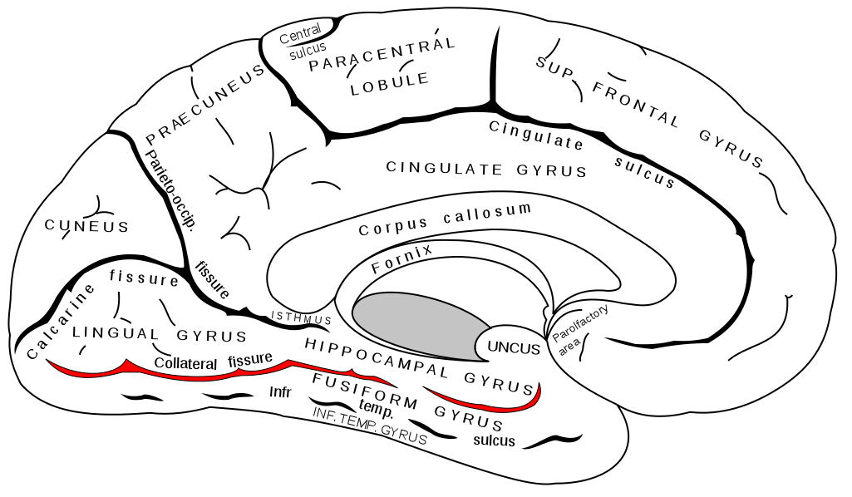
Collateral sulcus: landmark for parahippocampal cortex
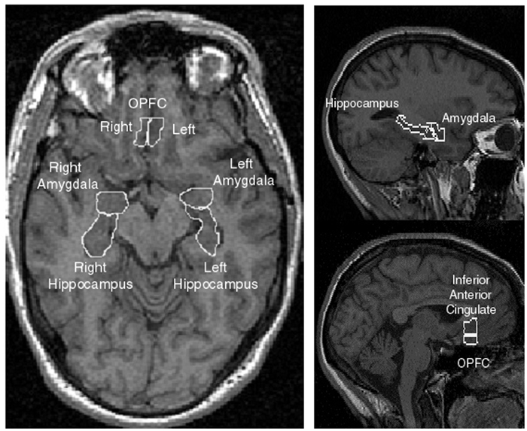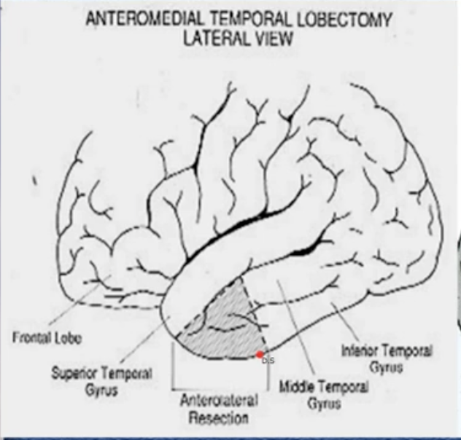

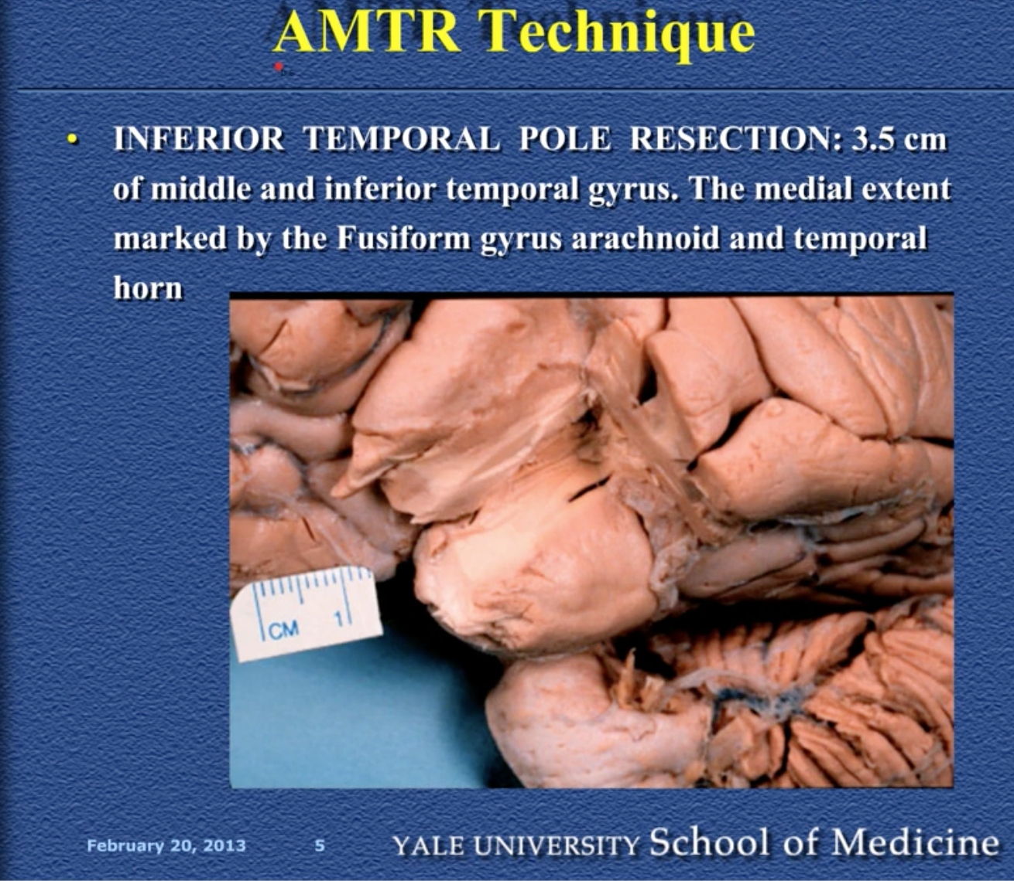

- Selective amygdalohippocampectomy can also be performed via these approaches:
- transcortical: inferior temporal gyrus approach
- transylvian: greater risk of injury to the M1
- subtemporal

Anterior temporal lobectomy with amygdalohippocampectomy
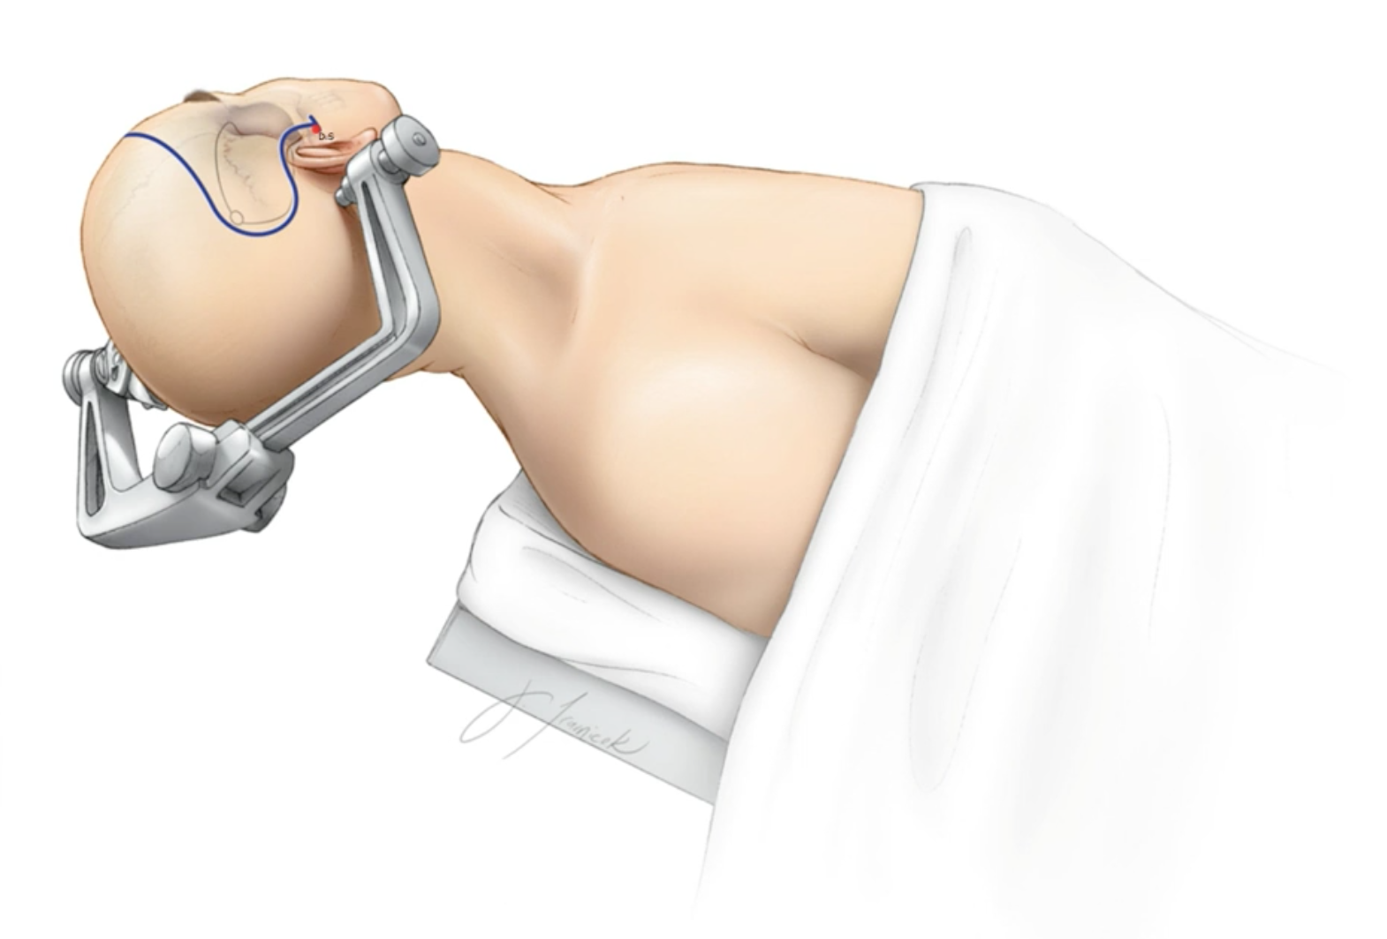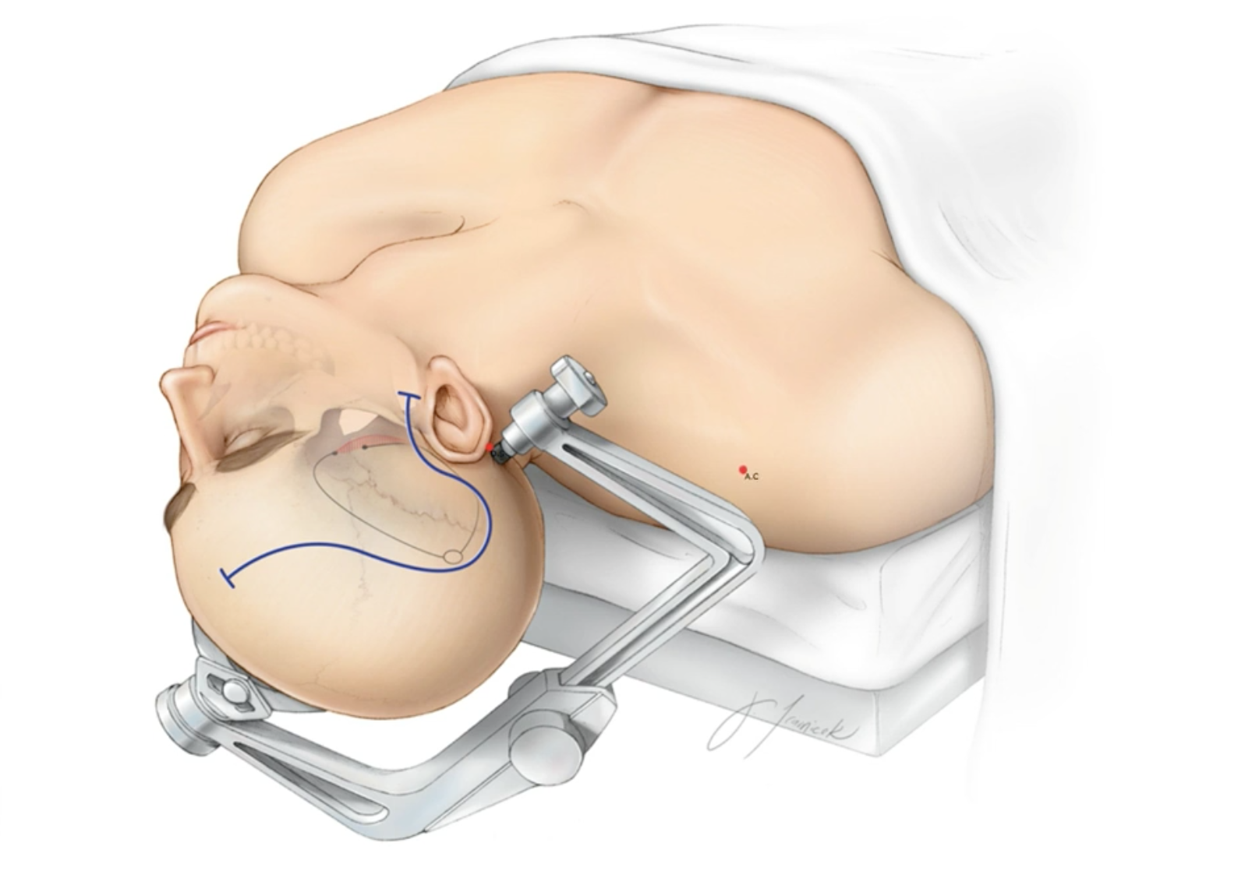
- Patient is positioned supine with a shoulder roll under the ipsilateral shoulder
- the aim is to have the operative field (frontotemporal area) almost horizontal
- Use neuronavigation if it is available
- Rotate head 60⁰, slightly extend to align the hippocampus with microscopic exposure
- This head position places the hippocampus in a horizontal position
- reverse question mark incision from the root of the zygoma just anterior to the ear going back around the pinna and up and parallel to the temporalis line to the hairline
- myocutaneous flap is elevated

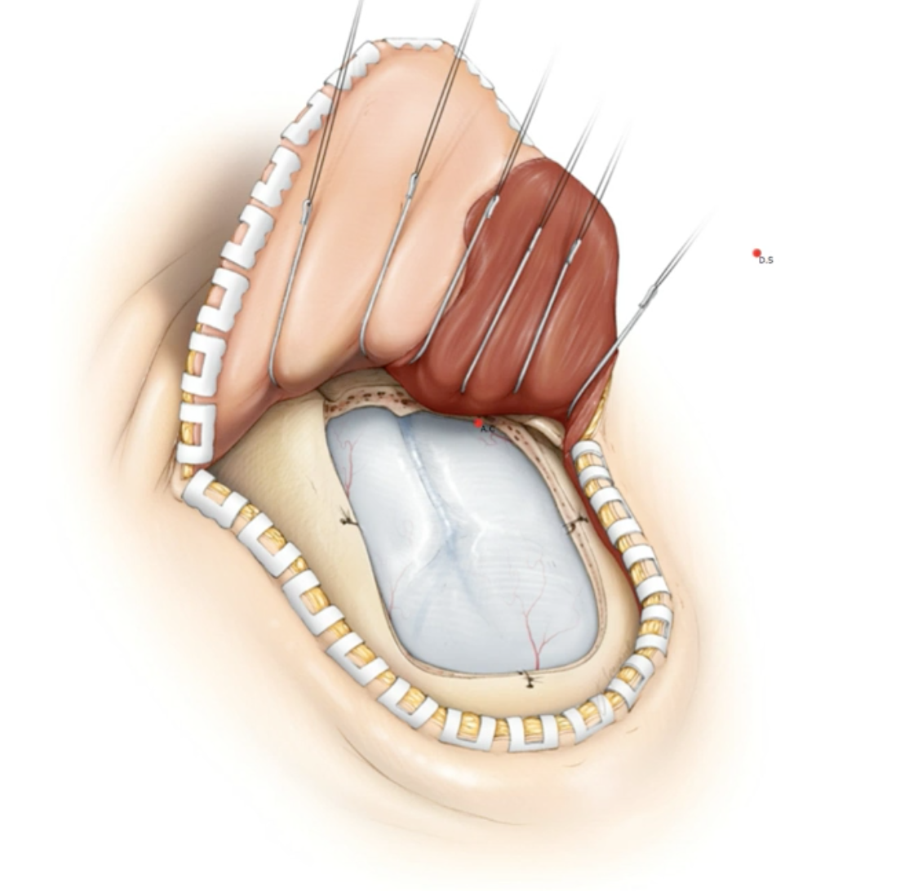

- Craniotomy should create a wide exposure and reach the anteroinferior temporal lobe (expose at least 6.5 cm behind the temporal tip; go all the way down to middle fossa floor)
- Protect the sylvian vein and vein of Labbe
- Make sure to wax any exposed mastoid air cells
- Craniotomy should include the inferior portion of the frontal lobe as you will have a retractor gently retracting the superior temporal gyrus

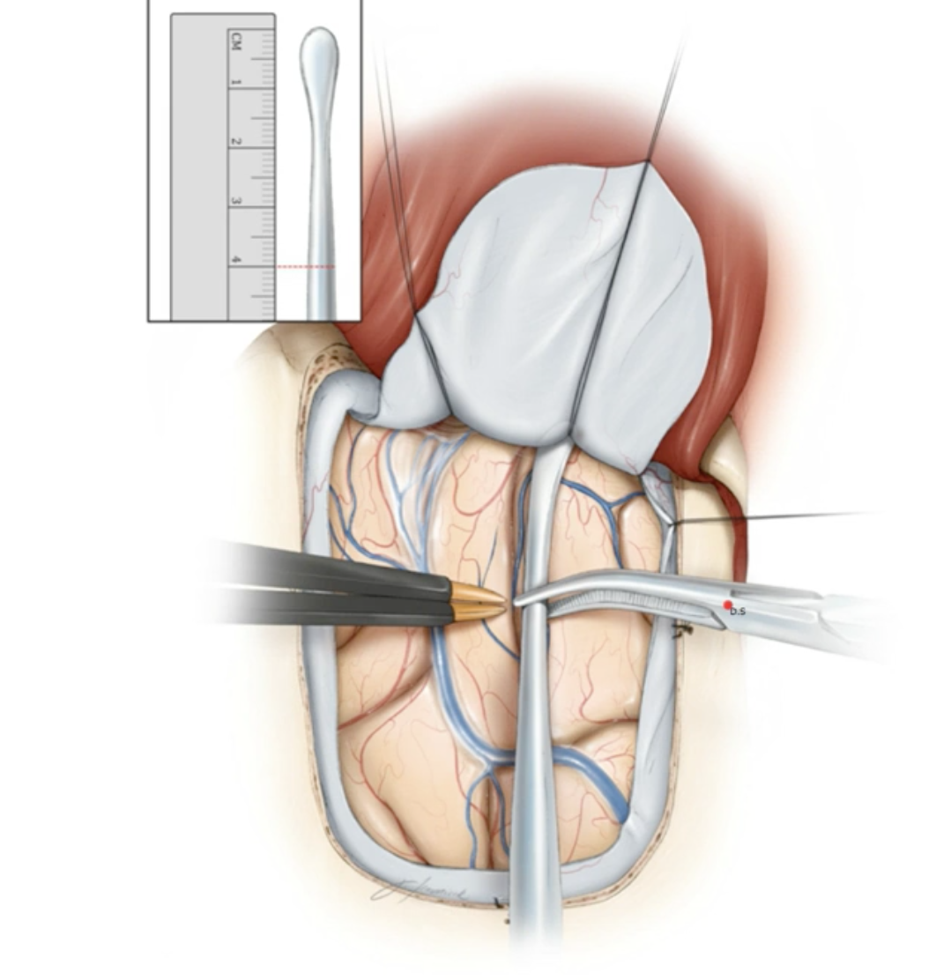

- Measure and plan to remove 4 cm of the anterior temporal lobe (medial and inferior temporal gyri – do not violate the superior temporal gyrus)
- ALWAYS stay subpial to avoid vascular/nerve injury (structures at risk: ICA, MCA, PCA, ACh, CN III, CN IV)
- Preservation of the vein of Labbe is paramount

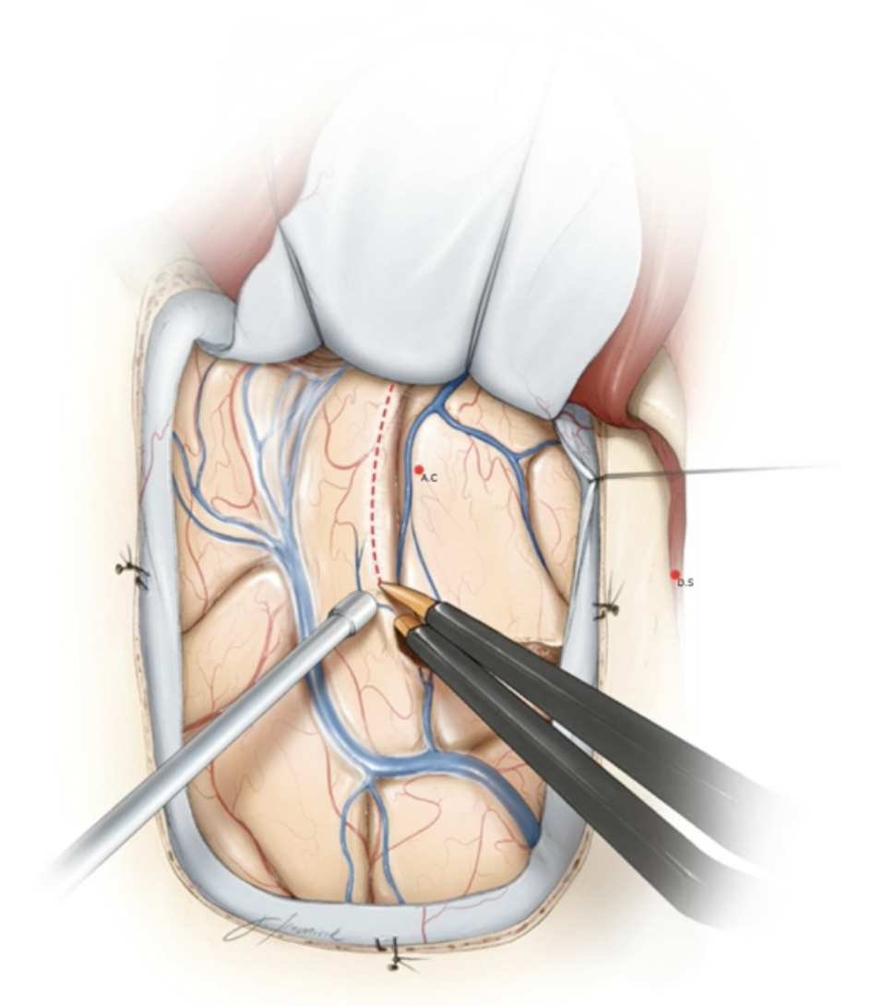

- Start the corticotomy along superior temporal sulcus
- A vertical corticotomy is made along the posterior margin and extended medially until the collateral sulcus is reached
- The temporal pole is removed
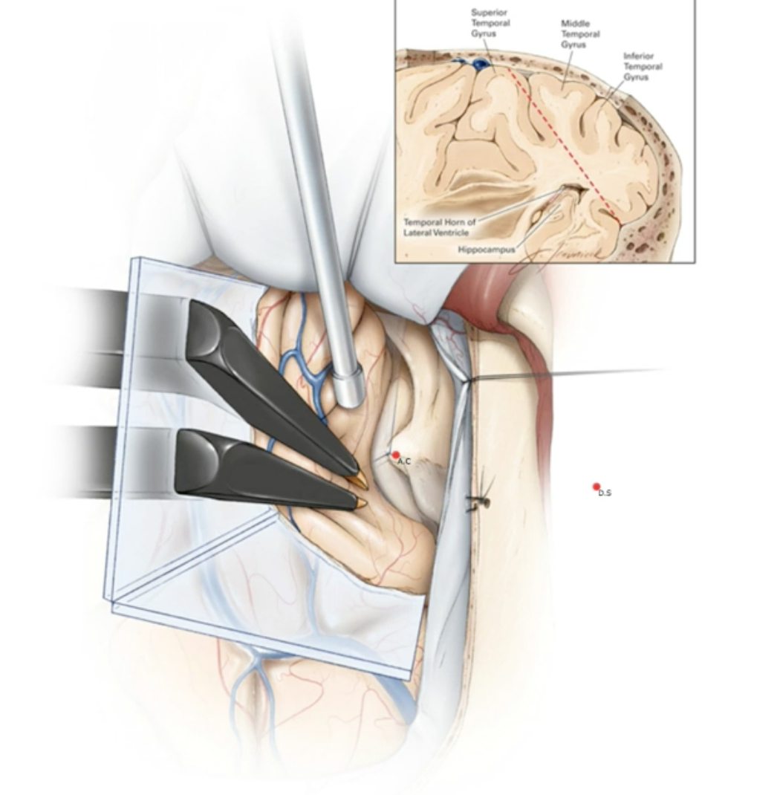

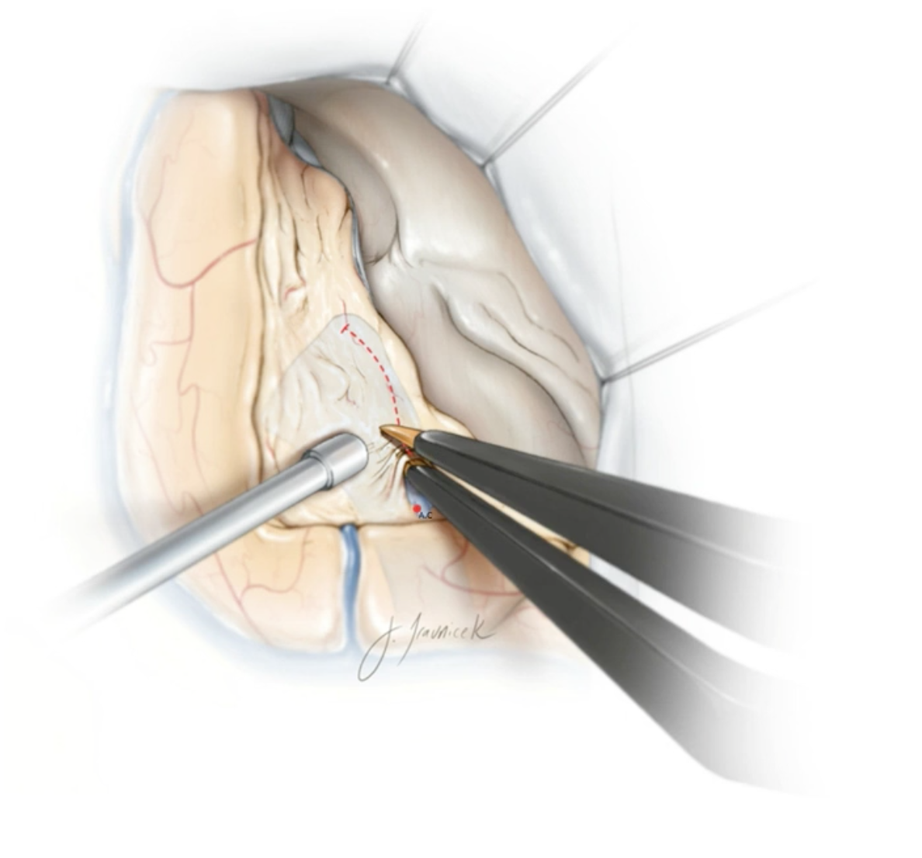
- The middle temporal gyrus can be used as a landmark for the temporal horn

- Open the ventricle

- Do not go too medial into the temporal stem or too medial/inferior into the hippocampus

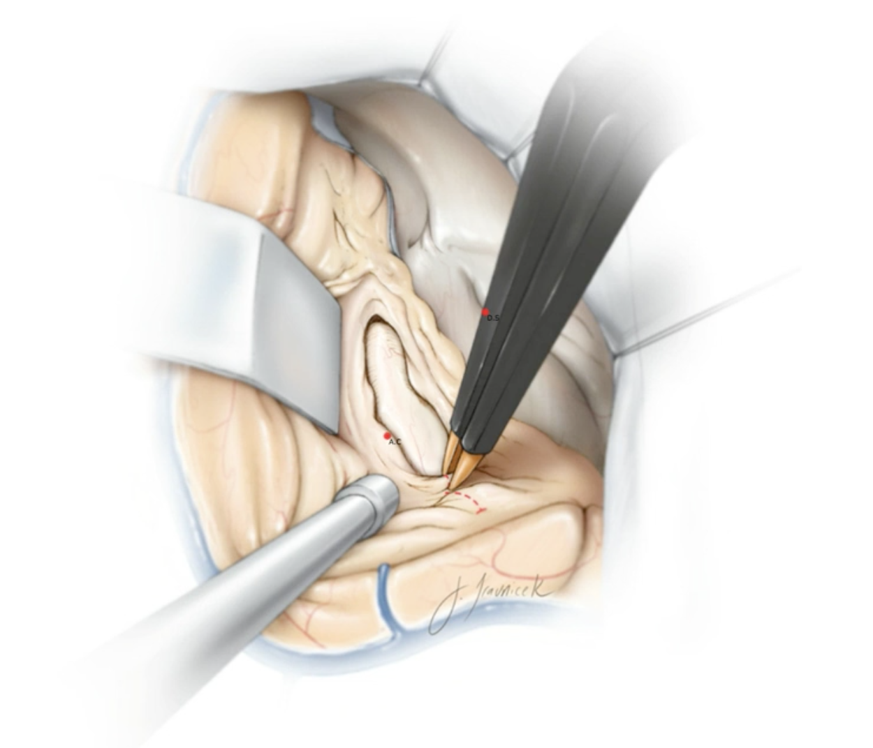

- The temporal horn is always more posterior than expected and only the anterior portion of it may be seen with the amount of temporal lobe removed

- You may encounter venous bleeding close to the ependyma
- Do not coagulate the choroid plexus as this may injure the anterior choroidal artery

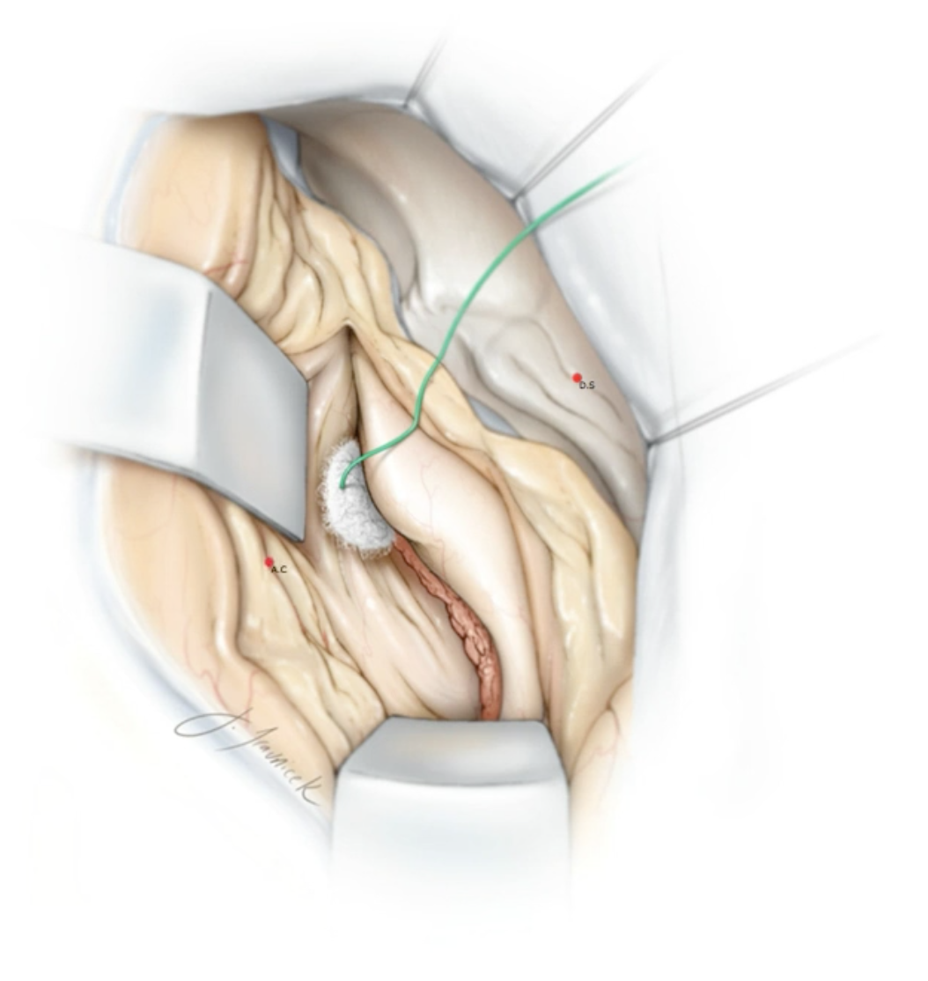

- Place a retractor along the superior temporal gyrus in the temporal horn
- Identify the choroid plexus (choroidal point) and the knee of the MCA superiorly
- The amygdala is between these two structures and can be resected selectively

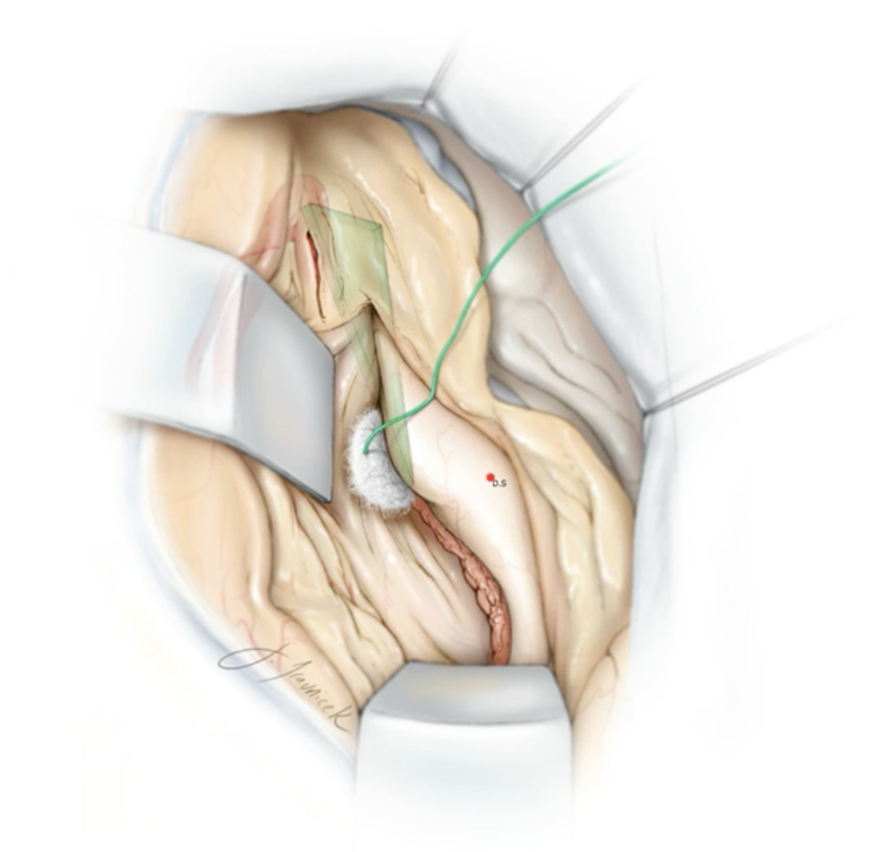

- The M2 defines the border between the amygdala and pallidum
- Therefore, care needs to be taken not to go superior to the M2 as this may injure the basal ganglia
- Avoid the temporal horn roof (Meyer’s loop)
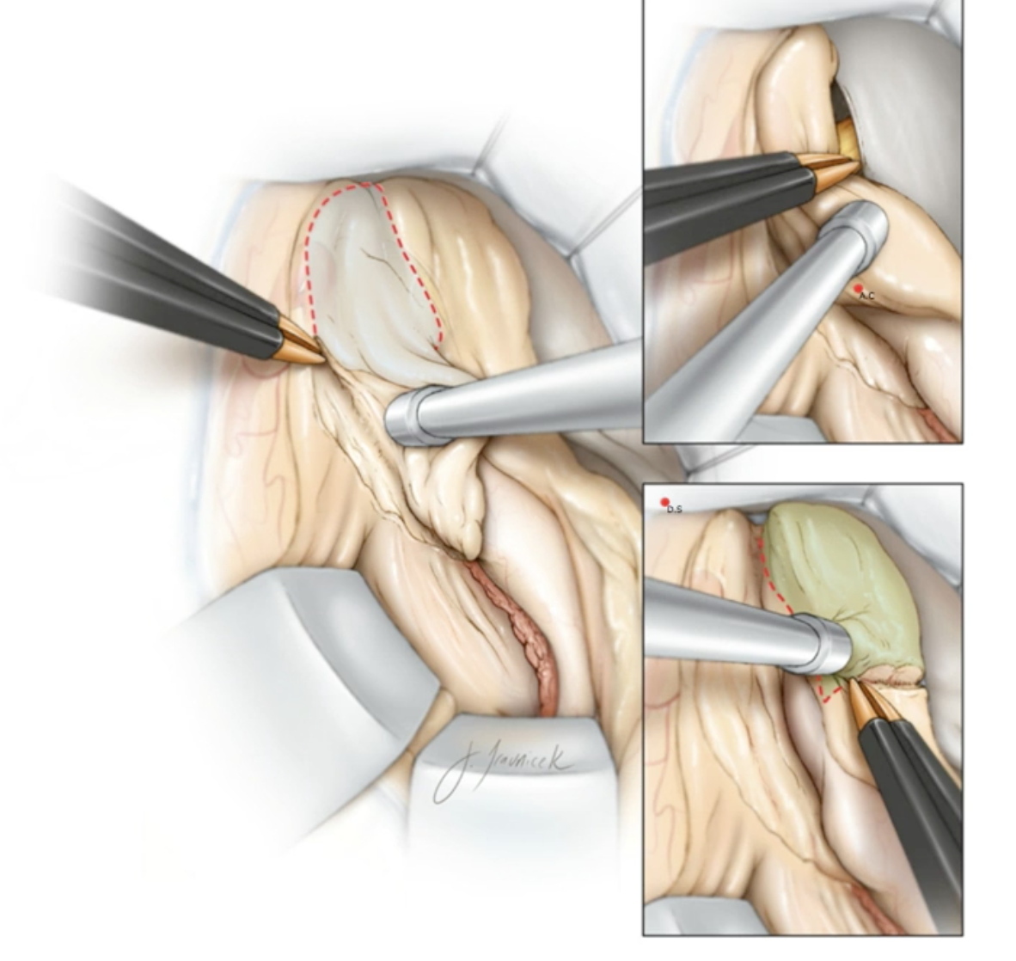
- The amygdala can then be removed (just under the M2 and above the choroidal fissure)
- Once it is removed, if the arachnoid is flipped up, you should see CN III
- Find the carotid and CN III
- Now, it is possible to gently retract the hippocampus laterally away from the choroidal point
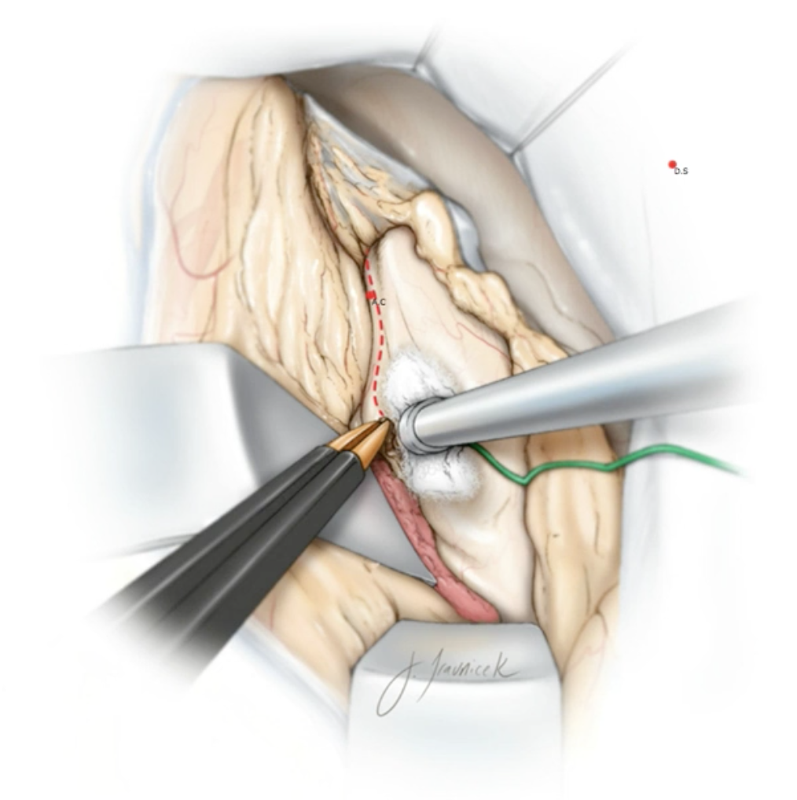

- Next, disconnect the hippocampus medially (staying lateral to the choroid plexus)

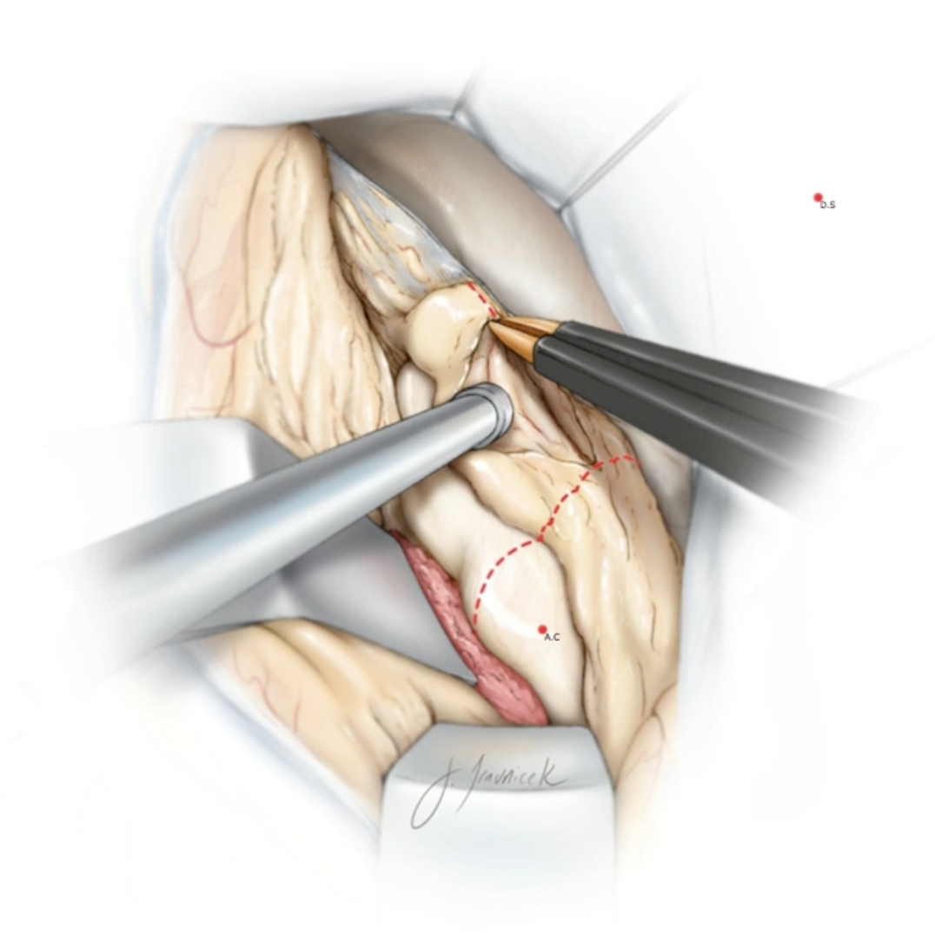
- Remove the first portion of the hippocampus (pes hippocampus)

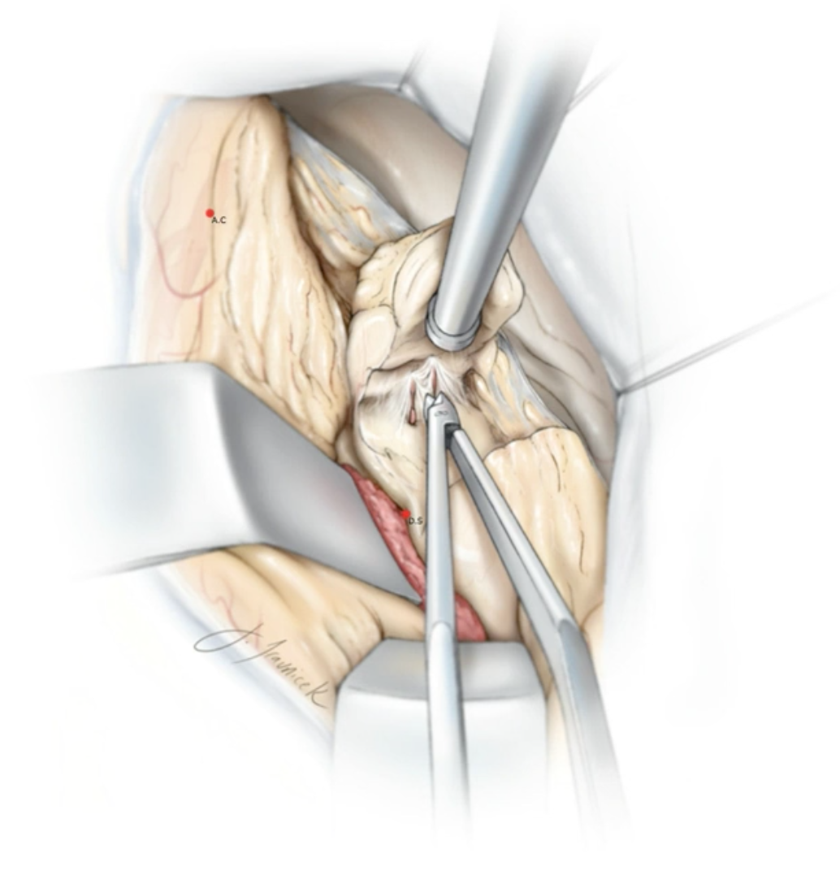
- Watch for PCA perforators

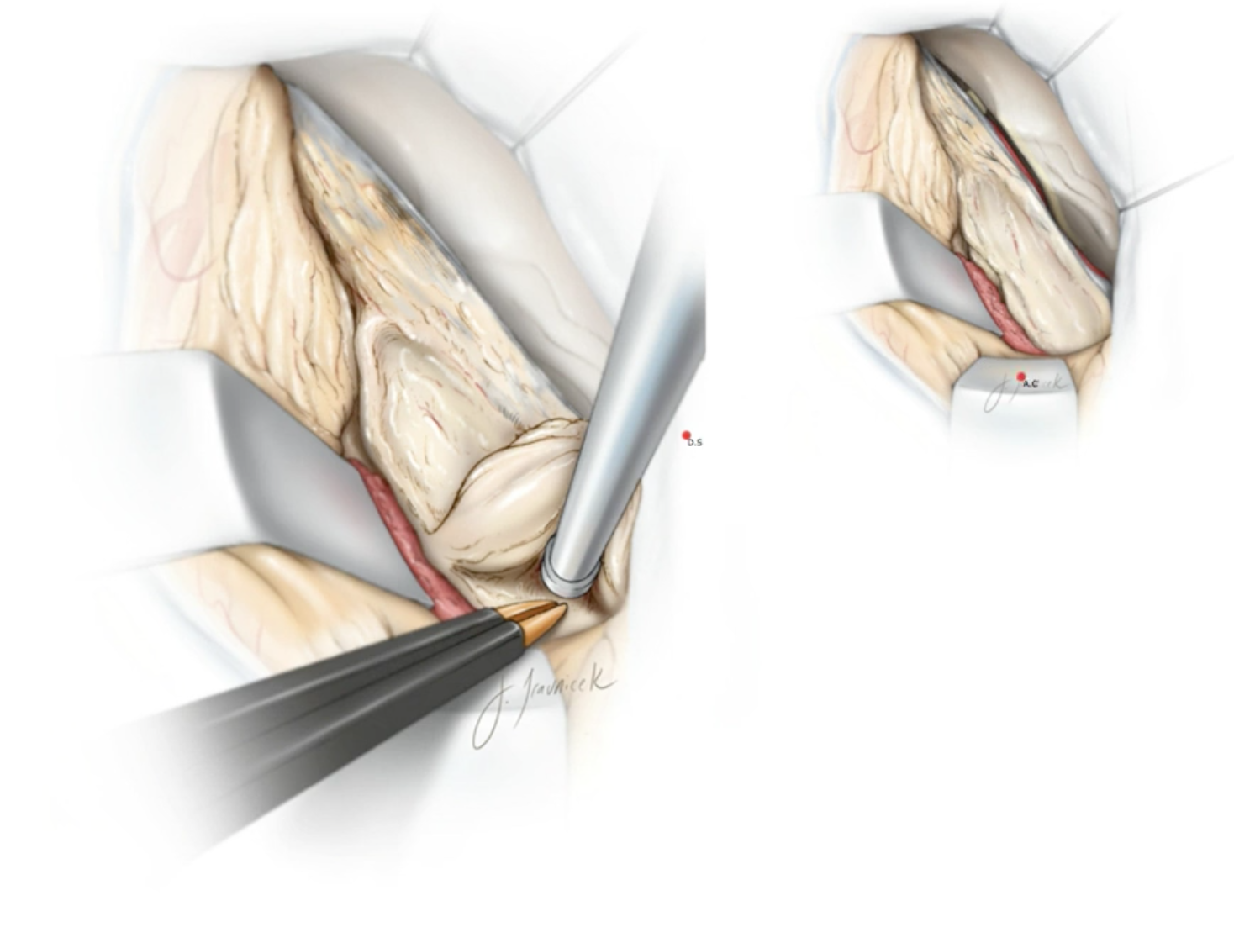
- The posterior portion of the hippocampus may then be removed (body) back to the crural cistern (posterior limit)
- The PCA runs just underneath this portion (this is why it is so important to perform subpial dissection)
- CN IV runs along the tentorium (avoid retraction or manipulation in this area to avoid injury to this nerve)
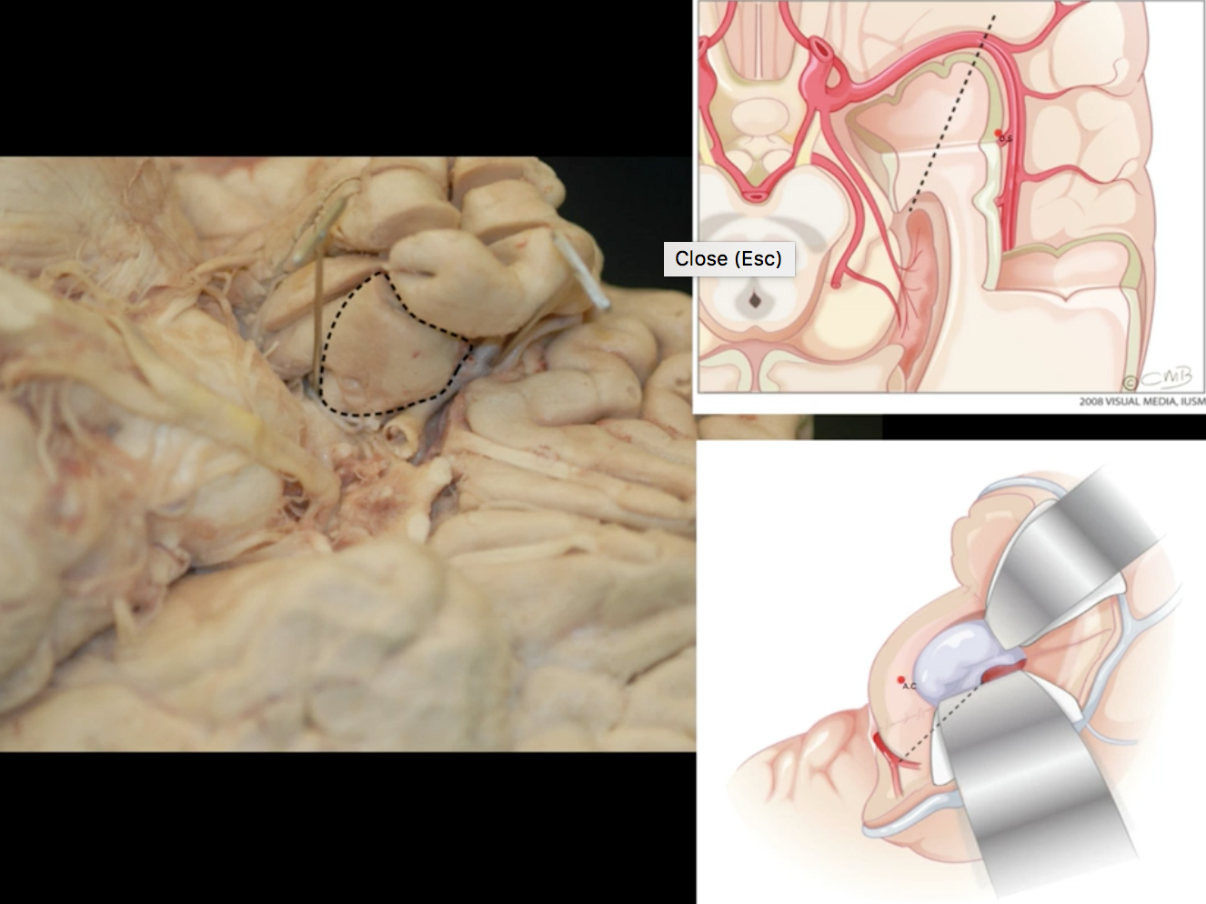
Complications in addition to any craniotomy:
- Anterior choroidal artery stroke
- CSF otorrhea
- Damage to visual pathway: superior homonymous quadrantinopia (“pie in the sky”)
- Diplopia from injury to CN III or IV
Outcome
- greatest effect is reduction of seizure frequency
- post-op MRI is done at 3 months to assess extent of resection
- continue AEDs for 2 years post-operatively; discontinue after that period if free of seizures
- after two years in patients maintained on AED: 50% are seizure free and 80% have over 50% reduction in seizure frequency
- McGill group results:
- 40-58% of patients become seizure free (Engel class I)
- 20% of patients become AED free
- 41% of patients will be on monotherapy

Modified Engel classification for seizure surgery outcome
Class | Description
I | Seizure free or residual auras
II | Rare disabling seizures (<3 complex partial seizures per year)
III | Worthwhile seizure reduction
IV | No worthwhile seizure reduction

  - Class I - Free of disabling seizures (completely seizure free; non-disabling, simple partial seizures only; some disabling seizures, but free of disabling seizures for at least 2 years; generalized convulsion with antiepileptic drug withdrawal only.)
  - Class II - Rare disabling seizures (initially free of disabling seizures, but rare seizures now; rare disabling seizures since surgery; more than rare disabling seizures, but rare seizures for at least 2 years; nocturnal seizures only.)
  - Class III - Worthwhile improvement (worthwhile seizure reduction; prolonged seizure-free intervals amounting to more than half the follow-up period, but not less than 2 years.)
  - Class IV - No worthwhile improvement (significant seizure reduction; no appreciable change; seizures worse.)

