TBI:   
 GCS 14-15 = mild  
 GCS 9-13 = moderate  
 GCS </= 8 = severe

- Avoid hypotension   
- Prophylactic hyperventilation is not recommended  
- Prophylactic AED do not prevent late seizures   
- LOC is not required for diagnosis of a concussion   
- concussion is not the same as TBI  
- most symptoms of concussion resolve within 7-10 days and do not require treatment  
- second impact syndrome  
 - sustain a second head injury while still symptomatic from an earlier one  
 - deteriorate to coma within 1-5 minutes  
 - develop malignant cerebral edema that is refractory to all treatment and progress to herniation   
 - mortality is 50-100%  
- DAI grade  
 - mild: coma 6-24 hours, mild-to-moderate memory impairment, mild-to-moderate disability  
 - moderate: coma > 24 hours, confusion and long-lasting amnesia, mild-to-moderate memory, behavioral and cognitive deficits  
 - severe: coma lasting several months with flexor/extensor posturing

Post-traumatic pseudoaneurysm  
- True aneurysm (partial injury to the vessel wall), false aneurysm (hole in the vessel wall with blood clot)  
- consider angiogram 2-3 weeks after the initial study  
- treat by trapping

In TBI, consider:  
- pseudoaneurysm  
- CCF  
- dissection  
- dAVF

**Blunt cervical vascular injury**- traumatic risk factors for BCVI  
 - high energy transfer mechanism associated with:   
 - displaced mid face fracture  
 - basilar skull fracture involving the carotid canal  
 - TBI consistent with DAI and GCS<6  
 - cervical vertebral body or transverse foramen fracture, subluxation, or ligamentous injury as any level  
 - any fracture involving C1-3  
 - near-hanging with anoxic brain injury  
 - clothesline-type injury of seat belt abrasion with significant cervical swelling, pain, or mental status change   
- grading scale for dissections (Denver grading scale)  
 - I: luminal irregularity with < 25% stenosis  
 - most resolve without treatment  
 - heparin or ASA adequate  
 - II: >25% luminal stenosis or intraluminal thrombus or raised intimal flap  
 - most resolve without treatment  
 - heparin or ASA adequate  
 - III: pseudoaneurysm  
 - repeat angio in 7-10 days post injury to assess healing  
 - IV: occlusion  
 - V: transection with free extravasation

Skull fracture leading to sinus injury requiring repair  
- consider use of a Kapp-Gielchinsky shunt to facilitate repair if primary repair is not possible

Temporal bone fractures  
- longitudinal: more common  
 - through petro-squamosal suture  
 - parallel to and through EAC  
 - usually spares CN VII and VIII  
- transverse: perpendicular to the EAC  
 - may result in CN VII and VIII injuries   
 - steroids should be considered  
 - ENT consult  
  
Basal skull fractures and open fractures should be treated with 7-10 days of ciprofloxacin

Frontal sinus  
- begins forming at age 2 and radiographically evident by age 8  
- lined with respiratory epithelium  
- mucous secretions drain through the frontonasal duct medially and inferiorly into the middle nasal meatus

LeFort fractures  
- type I: transverse aka transmaxillary  
- type II: pyramidal  
- type III: craniofacial dislocation (associated with brain injury)

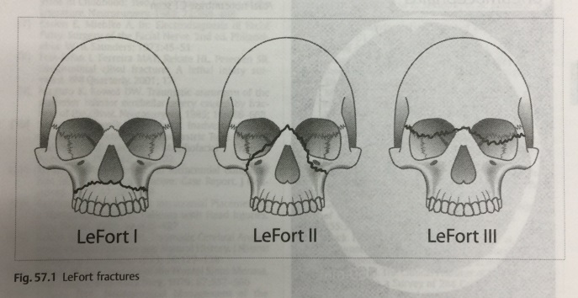

Tension pneumocephalus = Mt. Fuji sign  
 - treatment: new burr hole, or insertion of a spinal needle through a pre-existing burr hole   
Post-op pneumocephalus: 100% FiO2 can be tolerated for 24-48 hours without serious pulmonary toxicity

EDH cutoffs (Level III):   
- evacuate if > 30cm3, thickness > 1.5cm, midline shift > 5mm, GCS<8, focal neurologic deficit  
SDH cutoffs (Level III):  
- evacuate if over 10cm, midline shift > 5mm, GCS drop of >/= 2 points, anisocoria, ICP>20mm Hg  
  
- spontaneous interhemispheric SDH should be investigated for ruptured aneurysm  
- keeping a pt flat with a SDD after evacuation of a chronic SDH decreases rate of recurrence  
- hygroma: tear in arachnoid with CSF leaking into the subdural space  
  
Magnitude of impact damage is much higher with SDH than with EDH

**Gunshot wounds to the head**  
- think of traumatic aneurysms  
- bullet fragments may migrate and cause obstructive hydrocephalus  
- lead toxicity: more of an issue with bullet in the disc space  
- give tetanus   
- nafcillin for 5 days  
- patients with poor neurologic function (fixed pupils, decorticate or decerebrate posturing should not be operated on  
- debride devitalized tissue  
- cranialize injured sinuses to minimize the risk of infection  
- watertight dural closure (graft pericranium, temporalis fascia, or fascia lata – avoid dural substitute)

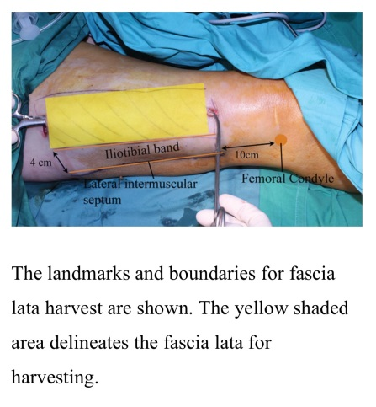

**Poor prognosis if path of bullet**:   
- crosses the midline  
- passes through the geographic center of the brain  
- enter or traverse the ventricles  
- the more lobes traversed by the bullet  
  
**Non-missile penetrating trauma**  
- knives, arrows, lawn darts  
- CTA if near named vessel  
- do not remove until direct visualization in OR  
- consider post-op angiogram to evaluate for traumatic aneurysm

**Intracerebral hemorrhage**  
- Charcot-Bouchard micro-aneurysms: aka military aneurysms; lenticulostriate aneurysms resulting in hypertensive BG ICH  
- MRI appearance of ICH on T1/T2: IB, BD, BB, DD (hyperacute, early subacute, late subacute, chronic)

**ICH score**

|  |  |  |
| --- | --- | --- |
| 1. GCS | 3-4 | 2 |
|  | 5-12 | 1 |
|  | 13-15 | 0 |
| 2. Age | >/= 80 years | 1 |
|  | < 80 | 0 |
| 3. Location | Infratentorial | 1 |
|  | supratentorial | 0 |
| 4. ICH volume | >/= 30 cc | 1 |
|  | < 30 cc | 0 |
| 5. Intraventricular blood | yes | 1 |
|  | no | 0 |
| ICH score |  | 0-6 |

30-day mortality:   
0 = 0%  
1 = 13  
2 = 26  
3 = 72  
4 = 97  
5 = 100  
6 = 100

Cerebellar ICH: surgery if GCG </= 13 or hematoma >/= 4cm

**Pediatric IVH**- germinal matrix regresses at week 36  
- subependymal hemorrhage  
- grading:   
 I – subependymal  
 II – IVH without ventricular dilation  
 III – IVH with ventricular dilation  
 IV – IVH with parenchymal hemorrhage  
- infants < 1500 g require placement of Ommaya reservoir  
- tap 8-20 cc from Ommaya and wean as appropriate  
- NB: removal of CSF may cause electrolyte disturbance (primarily hyponatremia)  
- follow HC and serial U/S  
- shunt when > 2000 g  
- beware of infants with h/o NEC  
- CSF protein < 100 mg/dL