Pearls

🞴Buy time by describing the imaging

🞴Silence is bad (think outloud)  
🞴 “I am worried about…”

🞴Don’t forget to discuss the goals of surgery (“maximal safe resection”)  
🞴Don’t forget post-op imaging  
🞴Don’t forget to take cultures when returning to the OR for infection  
🞴Always wax the mastoid cells on the way in and on the way out  
“SURVIVOR OF THE SHUNT WARS”  
🞴Don’t forget to order a shunt series when evaluating a shunt

🞴Lay out goals for any surgery recommended

General  
- VINDICATE differential diagnosis:

- VASCULAR  
 - INFECTIOUS  
 - NEOPLASTIC  
 - DEGENERATIVE, DEFICIENCY  
 - IDIOPATHIC, INTOXICATION  
 - CONGENITAL  
 - AUTOIMMUNE, ALLERGIC  
 - TRAUMATIC, TOXIC  
 - ENDOCRINE

- neurosarcoid work-up: CXR, ACE serum and CSF (also send fungal and bacterial cultures, protein, IgG, OCB)  
 - treat with steroids and immunosuppresants (methotrexate and TNF-alpha agonists)  
- Transcortical window: superior parietal lobule, parieto-occipital sulcus

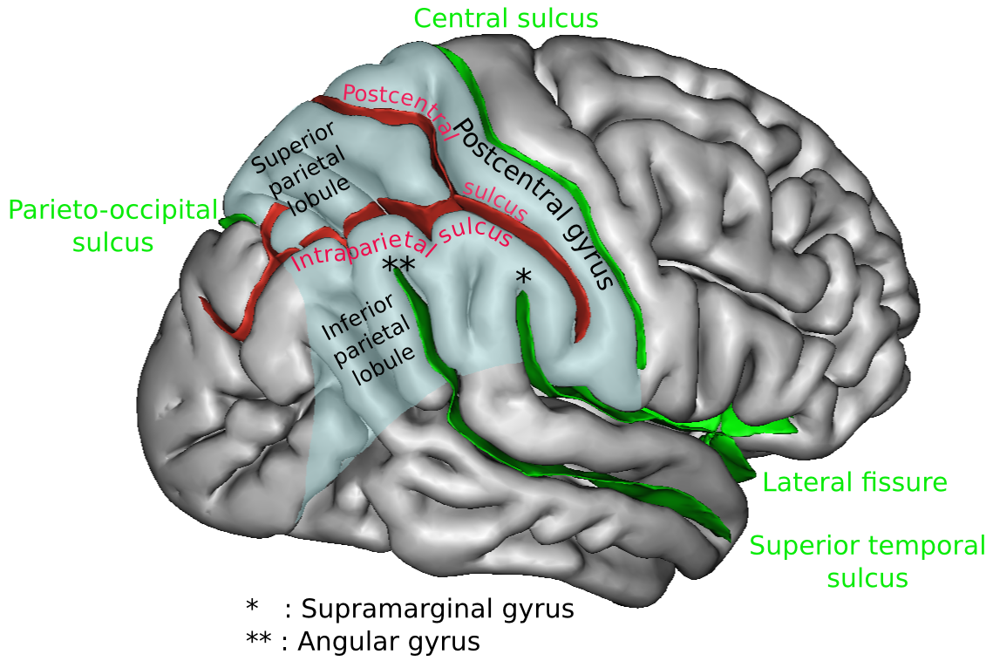

- Subtemporal approach:   
 - lateral decubitus position with right side up  
 - head parallel to the floor with a slight downward inclination  
 - horseshoe incision   
 - lumbar drain!!!

- WAX mastoid air cells  
 - expose tentorial edge  
 - sharp opening of the arachnoid of the cisterns  
 - ID CN III and IV  
 - divide and retract tentorium to enhance exposure  
 - protect the vein of Labbe

Vascular

- venous thrombosis after treatment of a type I dAVF: heparin gtt x 24 hours

- injection of IV tPA can cause severe headaches

- IJ 🡪 facial vein 🡪 SOV 🡪 cavernous sinus  
- IJ 🡪 IPS 🡪 cavernous sinus

- Types B, C, and D CCF should be treated via a transvenous route (the vessels are too small to approach via transarterial route)  
- Treatment for low-flow CCF: intermittent carotid compression   
 - compress with the contralateral hand (if circulatory compromise occurs, hand will become weak and stop compression)  
 - r/o a plaque in the carotid before recommending this treatment (carotid manipulation may disrupt plaque)  
- Cavernoma: 2.4% annual hemorrhage risk, no increased risk of bleeding during pregnancy, no role for radiosurgery, CCM1, CCM2, CCM3  
🞴Traumatic aneurysms: delayed filling on angiogram; present with CN palsies  
- AVM rupture rates: 2-4% annual hemorrhage rate, 6% annual hemorrhage rate after episode of hemorrhage

ICU/Trauma

- Cabergoline side effects: nausea, GI upset  
- If a trauma patient has refractory ICP, don’t forget to check labs (Na, serum Osm) and temperature  
- When ordering cortisol levels, order: AM cortisol, random cortisol, and 24 hour urine cortisol

Tumors  
- Choroid plexus tumors: I – papilloma, II – atypical, III – carcinoma

- Diff diagnosis for T1 hypointense/T2 hyperintense lesions: LGG, congenital, vasculitis, inflammatory, demyelinating   
- Subtypes of ependymoma: I – subependymoma, myxopapillary, II – intermediate (papillary, tanycytic, clear cell), III – anaplastic  
🞴Proximal control in tumors encasing the carotid!  
- Prognosticators for GBM: EOR, KPS, age

🞴Always prep in Frazier point in posterior fossa surgery (frontal EVD will always fall out)  
🞴If you suspect hemangioblastoma, always complete workup (pheochromocytoma)  
🞴In adults, the most common skull lesions are mets and MM  
- Chordoma: 51% 5-year survival and 35% 10-year survival  
- PCNL prognosis: age > 60, KPS, LDH, deep brain lesions

Peripheral Nerve  
🞴Always ask about PAIN, MOTOR, and SENSORY  
🞴PALSY = PERIPHERAL

🞴CHECK FOR TINEL’S

- Cervical radiculopathy: would expect to see paraspinal fibrillations on EMG (peripheral nerve injury would not show this)  
- Pure motor syndromes: AIN, PIN, deep ulnar at the wrist, ventral cord, ALS

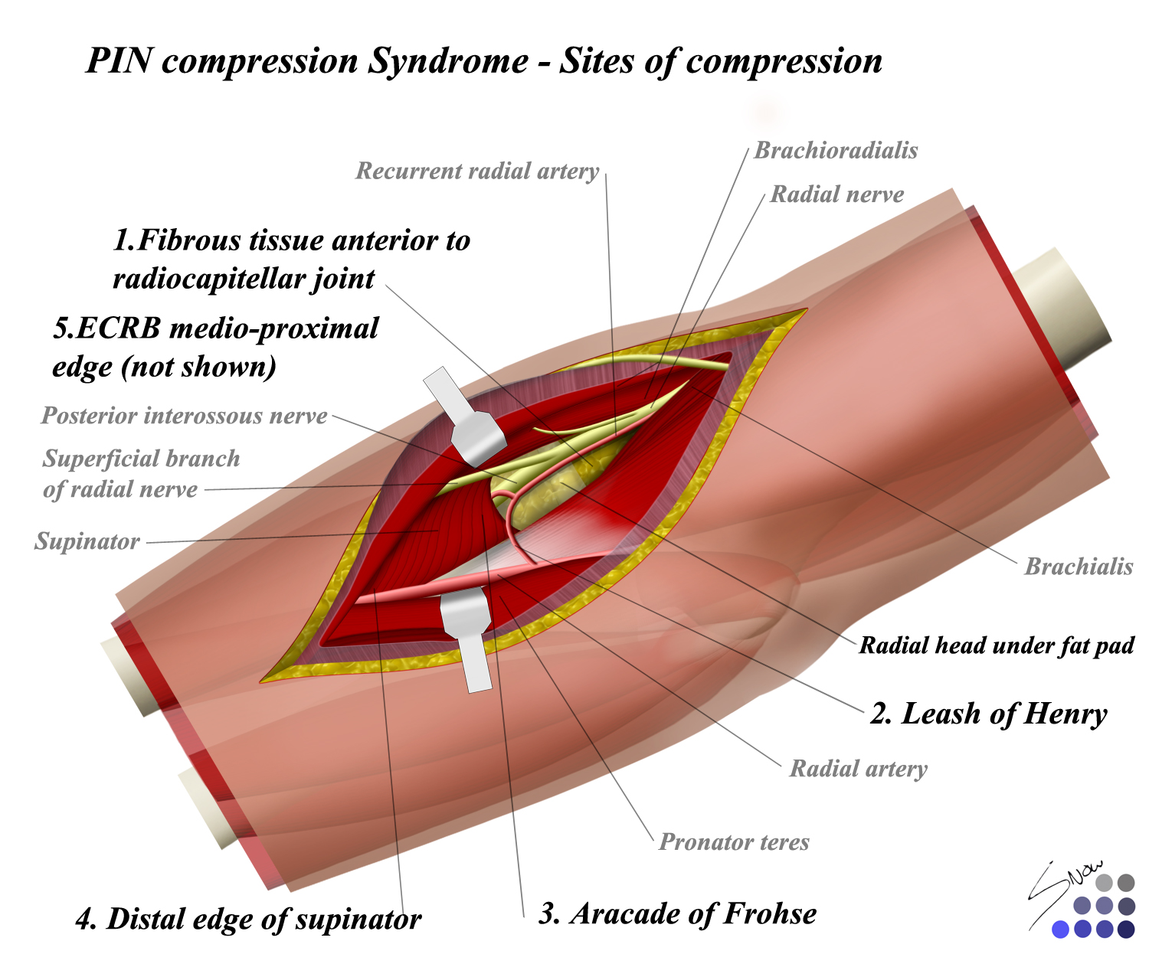  
- Leash of Henry: blood vessels surrounding the posterior interosseous nerve

Functional  
- Ziconotide (Prialt – snail venom), morphine, and baclofen are the only FDA-approved intrathecal medications  
- The thalamus has a homunculus  
🞴Don’t forget a neuropsychology evaluation before any pain procedure  
- Balloon rhizotomy may cause temporary jaw weakness  
- Stay away from brainstem for TGN SRS – may lead to anesthesia dolorosa  
- Occipital neuralgia  
 - neurectomy is not very effective  
 - temporary pain relief  
 - both the greater and the lesser occipital nerves will cause pain  
- Cervical ganglionectomy: can be performed bilaterally (look up paper from Oregon, 2012)  
- When performing an ONS, stay above the fascia  
- Baclofen withdrawal may present like sepsis

🞴If a baclofen pump patient presents with spasticity and fever, make sure to r/o UTI, other infection, or decub ulcer  
- Plegic patients have either end zone pain versus lower body pain  
- DREZ procedure targets the interneurons in layer V of rexed laminae  
 - may have ataxia post-operatively due to manipulation of the dorsal columns

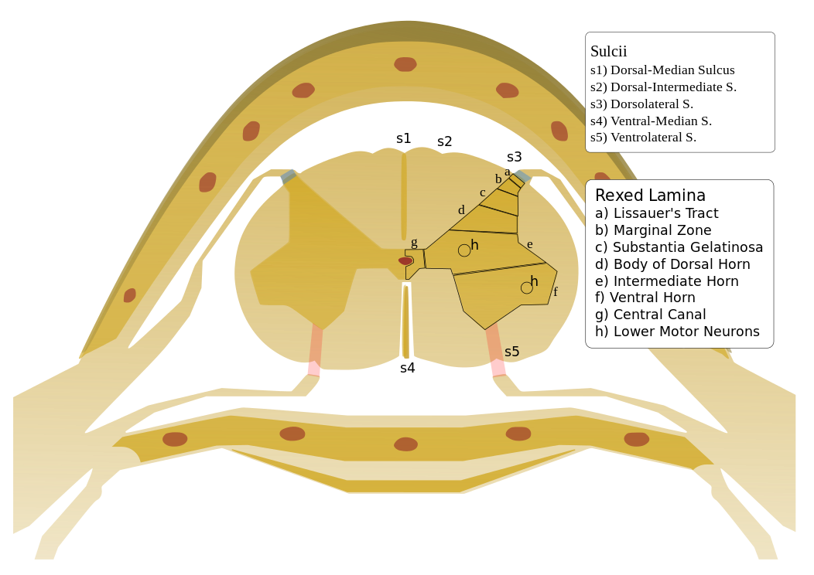

- Granulomas at a morphine pump site will resolved in 2-3 months  
- positioning for hemifacial spasm: tilt the head down a bit to bring CN VII to the top of the field   
 - for TGN, the head should be parallel to the ground

Spine  
🞴Infection following an ACDF is esophageal perforation until proven otherwise  
🞴Always place a patient in traction AWAKE (cannot examine a sedated, intubated patient)  
🞴Always make sure imaging for a disc herniation is recent before offering surgery (discs resorb and you may find nothing in the OR)  
- C2-3 ACDF considerations: takedown the digastric muscle, CN XII, submandibular gland  
- condylar vein in far lateral  
- posterior iliac graft complication: numbness from cluneal nerve injury  
 - make a straight, longitudinal incision over the posterior superior iliac spine (PSIS)

- avoid transvers oblique incisions because superior cluneal nerves (L1-L3) cross the crest 8cm lateral to the PSIS  
 - incise through the subcutaneous tissues and identify the fascia of the gluteous maximus  
 - incise the maximus subperiosteally off its origin  
 - avoid incising through the posterior ligamentous complex of the SI joint (may lead to SI instability)

  - inferiorly, the [greater sciatic](http://www.wheelessonline.com/ortho/greater_sciatic_foramen) notch should be palpated prior to instrumenting in this area

            - injury to the [superior gluteal artery](http://www.wheelessonline.com/ortho/superior_gluteal_artery) is a potential complication of posterior crest harvest

                  - in cases of superior gluteal vessel injury, also look for possible injury to the adjacent ureters

            - bone graft can be harvested to within 1 cm of the notch

    - using an osteotome, a trapezoidal outline is marked thru the cortical surface of the outer table

            - begin outlining the graft, along the farside (anterior) aspect of the graft, since this is the first area to be covered up by bleeding

            - smaller longitudinal cortical strips can also be outlined at this time

    - curved gouges are then used to remove longitudinal cancellous strips

            - this is continued down to the level of the inner table

    - currettes are used to remove additional cancellous bone from the superior and medial rim of the crest  
- Thoracic pedicle screw placement  
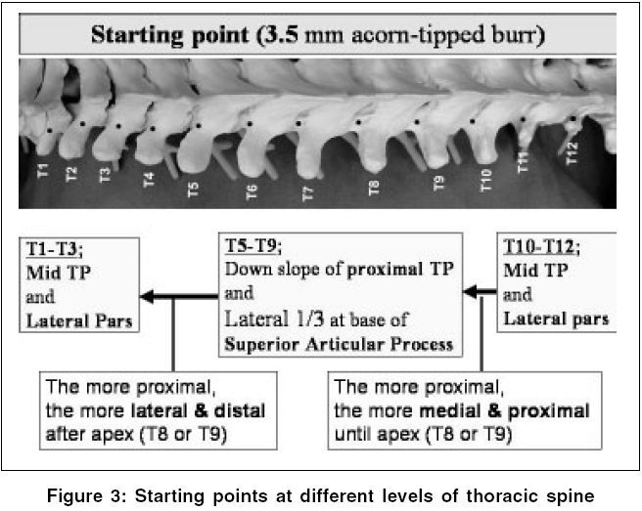

- Sounder = ball tip probe (straight or curved)

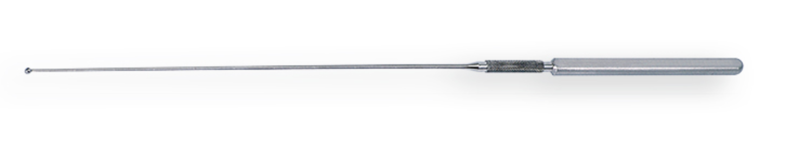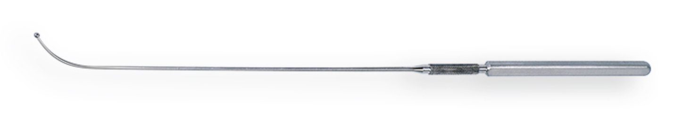

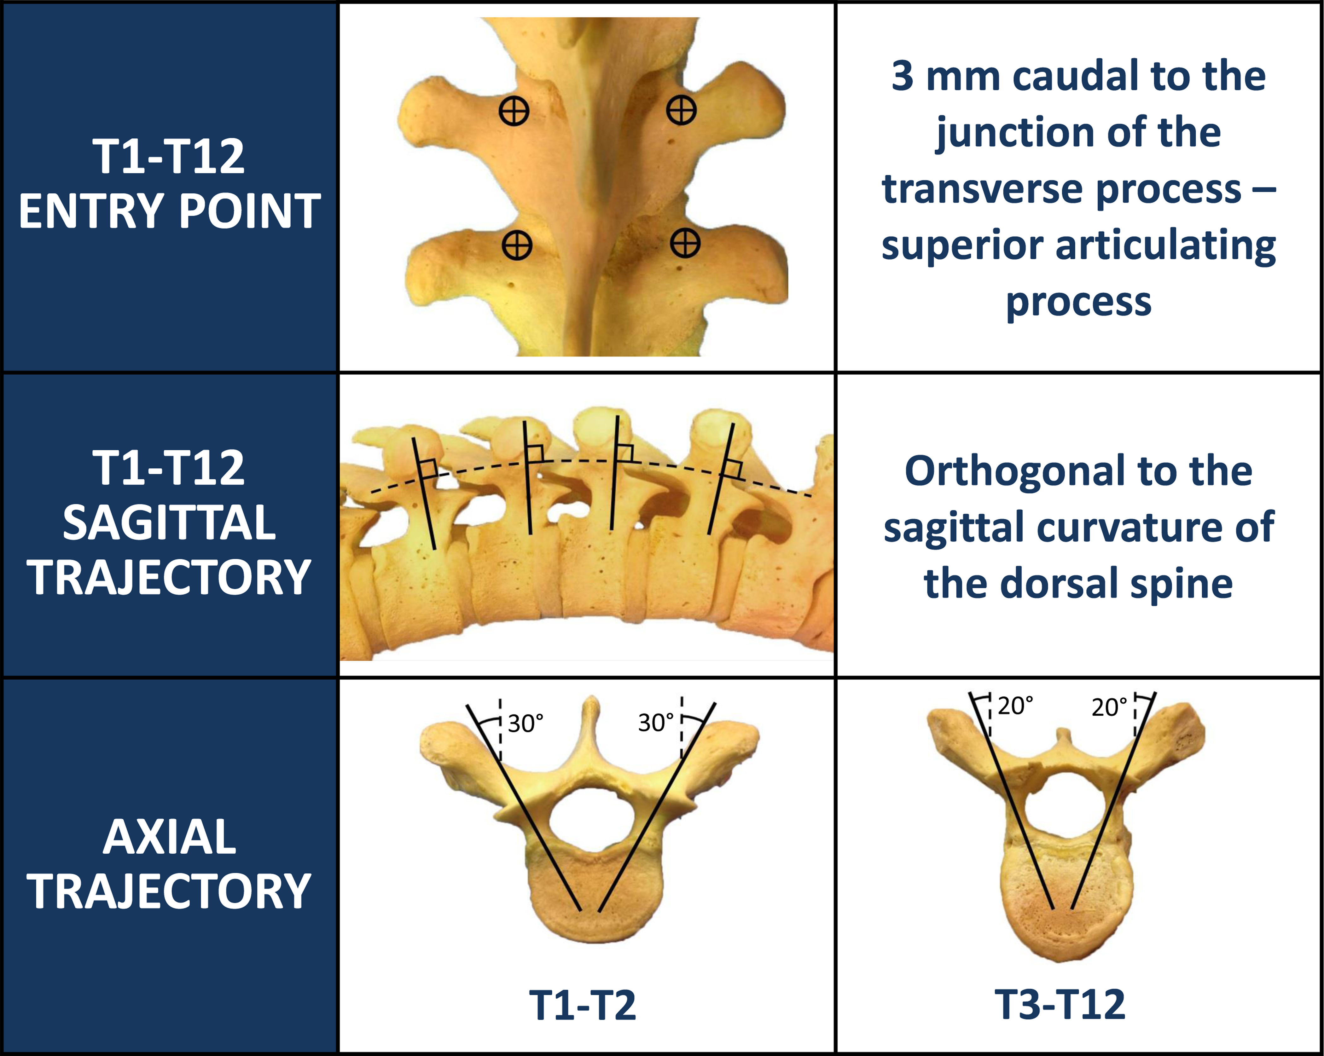

Pediatrics  
- Perform a laminoplasty, instead of laminectomy, in young children

- Placement of pediatric halo: double the number of pins and ½ the pressure (4lb instead of 8lb)  
- Anterior fontanelle tap: lateral edge of anterior fontanelle, shave and clean area  
🞴In MM, **ANY** problem should prompt evaluation of the shunt if a VPS is present (even if signs and symptoms of Chiari or tethered cord)

🞴In MM, if attempting to decompress Chiari, keep in mind that the torcula is VERY low-lying in a Chiari II malformation

- start MM patients on ampicillin and gentamicin  
- when closing MM, resect the dysplastic tissue surrounding the neural placode