**Evans ratio:** - [frontal horns / maximal biparietal diameter]  
 - if > 0.3, suggests hydrocephalus  
  
**Chronic hydrocephalus**- temporal horns are less prominent that in acute HCP  
- atrophy of the corpus callosum (best seen on sagittal MRI)

**Isolated fourth ventricle**  
- does not communicate with the 3rd ventricle (via aqueduct) or basal cisterns (via foramina of Luschka or Magendie)  
- usually seen in chronic shunting of lateral ventricles, post-infectious (esp. fungal)  
- presents with HA, lower CN palsies, pressure on the floor of the 4th ventricle may compress the facial colliculus, ataxia, lethargy, n/v  
- may be treated with a Torkildsen shunt (ventriculocisternal shunt – requires intact arachnoid granulations)

**Normal pressure hydrocephalus**  
- gait instability, urinary incontinence, dementia (“Wacky, wobbly, & wet”)  
 - gait: shuffling, wide-based, unsteadiness with turning (patients feel like they are “glued to the floor” – “magnetic gait”)  
- communicating hydrocephalus  
- LP demonstrates normal pressure  
- secondary NPH etiologies:  
 - post-SAH  
 - post-traumatic  
 - post-meningitis  
 - following p-fossa surgery  
 - tumors, including carcinomatous meningitis  
- not expected with NPH:   
 - headaches  
 - papilledema  
 - seizures  
- although some patients improve with no change in ventricles, clinical improvement most often accompanies reduction of ventricle size  
- if single LP, remove 40-50 mL of CSF  
- if continuous lumbar drainage, remove ~ 300 cc per day; average trial = 5 days (mean time to improvement = 3 days)  
- if shunt is placed, use programmable valve and start at a high pressure to reduce risk of SDH – decrease settings over several weeks  
- after shunt placement, follow patients with CT for 6-12 months  
- response to shunting is better when the symptoms have been present for a shorter time

**Ommaya reservoir**- used for administration of intrathecal chemotherapy, antibiotics, removal of CSF, fluid aspiration from a chronic tumor cyst  
- preserve surrounding pericranium so that you can anchor the reservoir to it

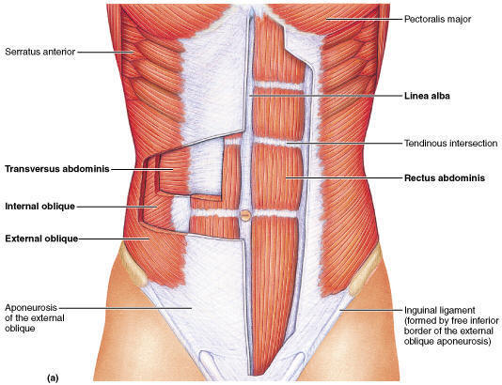**Ventriculoperitoneal shunt**- contraindications:   
 - extensive abdominal surgery  
 - peritonitis  
 - morbid obesity  
 - preemies who have h/o NEC  
- peritoneal layers:   
 - subcutaneous fat  
 - anterior sheath of the abdominis rectus muscle (anterior   
 rectus sheath)  
 - abdominis rectus muscle fibers: should be split   
 longitudinally  
 - posterior rectus sheath  
 - pre-peritoneal fat (may be very well-developed in a few   
 individuals, but is essentially non-existent in most)  
 - peritoneum (usually closely adherent to the posterior rectus   
 sheath)

**Ventriculopleural shunt**- recommended only for patients > 7 years of age to avoid hydrothorax  
- patient is positioned supine with a chest roll beneath the ipsilateral scapula to elevate and rotate the chest wall  
- 3 cm horizontal incision is made just below the level of the breast either in the mid-axillary line (typically between T4 and T6)  
- divide the subcutaneous tissue, deep fascia, and pectoralis muscle  
- external and internal intercostals are divided along the superior margin of the inferior of the two ribs exposed (to avoid neurovascular   
 bundle running along the inferior margin of each rib)  
- self-retaining retractor between the ribs aids the exposure  
- parietal pleura is visualized (visceral pleura can be seen sliding underneath with each respiration  
- pleura is not opened until the catheter is brought out subcutaneously at this incision  
- ask the anesthesiologist to hold respirations  
- use a blunt-tip hemostat to nick the parietal pleura to admit catheter (insert 8-10 cm of catheter into the pleural space)  
- allow the lung to drop away and insert 20-40 cm of tubing into the pleural cavity  
- if the pleural opening is lax around catheter, snug with a 4-0 absorbable suture  
- ask anesthesia to provide a valsalva maneuver before cinching down the pleural suture, and again before closing the deep muscle layer  
- helpful maneuver:   
 - place a red rubber catheter next to the shunt catheter (permits escape of air from the pleural space)  
 - before closing, but prior to placing the last deep suture, have the anesthesiologist perform a valsalva maneuver an allow air to   
 escape through the red rubber catheter  
 - place the end into saline to see bubles  
 - once the bubbles stop, pull the red rubber catheter and close the last stitch  
 - if the bubbles don’t stop, there is an air leak in the visceral pleura and a pigtail catheter or chest tube connected to a Pleur-evac should be used  
- a post-op X-ray may show effusion (this confirms shunt is working)  
- presence of an effusion is not a problem, but progressive effusion must be watched diligently

**Ventriculoatrial shunt**- jugular vein to superior vena cava to right cardiac atrium  
- platysma is divided  
- CFV is located as it joins the IJV at the level of the hyoid bone  
- common facial vein is located:  
 - landmark for the vein: anterior border of the SCM, 3 cm inferior and anterior to the angle of the mandible   
 - once vein is identified, proximal end is sewn off  
 - distal end is secured with a stay suture  
 - distal catheter is measured carefully, advanced to the junction of the right atrium and superior vena cava and flushed with   
 heparinized saline (1-5 units per mL of NS)  
 - the T7-8 interspace is a good target   
 - the ideal location for the catheter is the right atrium  
- if the catheter goes down the wrong vessel (eg. subclavian), a “J” guidewire may help (rotating the head to a more neutral position also   
 helps)  
- if the CFV is not suitable, a purse string suture is placed directly in the IJ, and the IJ is opened in the center of the purse string and cannulated  
- the ventricular part of the shunt is placed as in other types of shunts

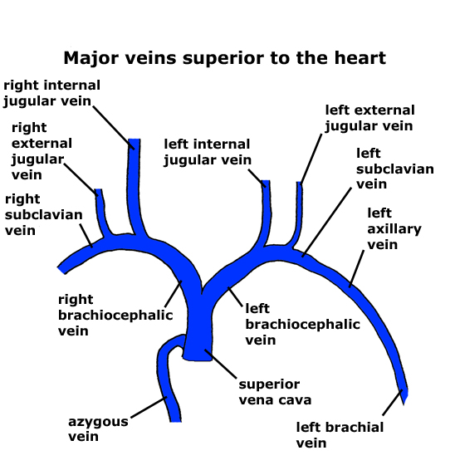

**Gallbladder**

**Lumboperitoneal shunt**  
- only for communicating hydrocephalus  
- primarily used for pseudotumor cerebri or CSF fistula  
- inserted over age 2 years  
- lateral decubitus position  
- table at 300 reverse-Trendelenberg to expand lumbar subarachnoid space  
- insert 14 gauge Tuohy needle into the subarachnoid space, with opening directed rostrally (confirm with CSF flow)  
- insert shunt tubing so that > 8 cm of catheter (L4-5) lies within the spinal canal (minimizes conus medullaris irritation)  
- needle is withdrawn over catheter  
- make flank incision and pass tunneler from flank to back  
- feed the catheter from back to flank  
- the valve may be placed at the flank  
- make abdominal incision   
- pass tunneler from abdominal incision to flank incision  
- feed catheter from flank to abdomen  
- withdraw tunneler over cathter  
- verify CSF flow   
- place catheter inside peritoneum  
- snug fitting retaining sleeve placed around catheter at all three incisions, and secured to subcutaneous tissue with non-absorbable suture  
- Integra (Cordis) horizontal-vertical lumbar valve

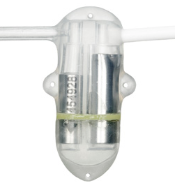  
- how to check for LP shunt malfunction:   
 - do an LP and look at opening pressure  
 - if the shunt was placed for a high-pressure pathology (pseudotumor), a low opening pressure indicates shunt is OK  
 - shunt-o-gram: inject 10 cc of omnipaque via lumbar puncture and look for presence of contrast in the peritoneum   
 - pt brought to vertical position and coughing, valsalva maneuver will accelerate the flow of contrast

**Cystoperitoneal shunt**

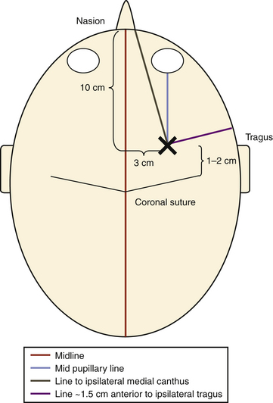**EVD/Shunt infections**- 9% EVD infection rate  
- 5-7% shunt infection rate  
- biofilm on the surface of the catheter increases resistance to antimicrobials  
- can be partly prevented by using antibiotic-coated catheters  
- early infections (first 2 weeks post-op)  
 - Staph epidermidis (coag negative staph)  
 - Staph aureus  
 - gram negative bacilli (6-20% may come from intestinal perforation)  
 - in neonates: E. coli and Strep. Hemoliticus  
- late infections (> 6 months after procedure): most are Staph. Epidermidis  
- if suspected, tap the shunt  
- LP is not recommended if pt has obstructive HCP with a possibly non-functioning shunt  
- remove infected shunt and place EVD in shunt-dependent individuals  
- if there is an abdominal pseudocyst, the fluid should be drained through the peritoneal catheter   
 before removing it  
- once the CSF is sterile for 3 days, convert the EVD to a shunt – continue abx for 14 more days

**EVD entry sites**- Kocher’s point (coronal): 2.5 cm from midline (mid-pupillary line) and 3 cm from the precentral   
 fissure / 1 cm anterior to coronal suture / 11 cm up from the nasion  
 - trajectory: medial canthus (coronal plane) + tragus (AP plane) + depth of 5-7 cm

- Frazier burr hole: placed prophylactically before p-fossa surgery for emergency ventriculostomy  
 - 3 cm from the midline, 6 cm above inion  
 - aim towards the glabella or ipsilateral medial canthus  
 - insert 6 cm with stylet and an additional 4-6 cm after removal

- Dandy’s point: 2 cm from midline, 3 cm above inion (may be more prone to damage to visual pathways than Frazier burr hole)

- Keen’s point: posterior parietal (placement in trigone)  
 - 2.5 cm posterior and 2.5 cm superior to the pinna  
 - was the usual site of occurrence of cerebral abscesses arising form otitis media, and was   
 often used to tap these  
  
- Paine’s point:   
 - creation of a 2.5 cm isosceles right triangle  
 - anterior limb abuts on the dura overlying the sphenoid ridge   
 - posterior limb touches the sylvian fissure  
 - hypotenuse overlies the sylvian fissure

