- when examining pediatric patients, always ask about milestones
- blood volume:
- children: 90 cc/kg
- adult: 70 cc/kg
- in children, transfuse 10 cc/kg
Arachnoid cysts
- congenital
- middle fossa, CPA, suprasellar, quadrigeminal plate, posterior fossa
- if found in adult: recommend one follow-up study 6-8 months later to r/o increase in size
- male: female 4:1
- most are asymptomatic
- those that become symptomatic usually do so in early childhood
- may present with seizures, headaches, n/v
- imaging: smooth border, non-calcified, extraparenchymal, density similar to CSF, non-enhancing, expansion of nearby bone,
often associated with ventriculomegaly
- may compress ipsilateral lateral ventricle and cause midline shift
- surgical treatment options: fenestration into basal cisterns, shunting (cystoperitoneal – use programmable valve)
- indications for surgery: progressive cyst enlargement, intractable HA/seizures, progressive macrocephaly
Fontanelles
- anterior fontanelle: closes by 2.5 years
- posterior fontanelle: closes by 2-3 months
- sphenoid and mastoid fontanelles: close by 2-3 months and 1 year, respectively
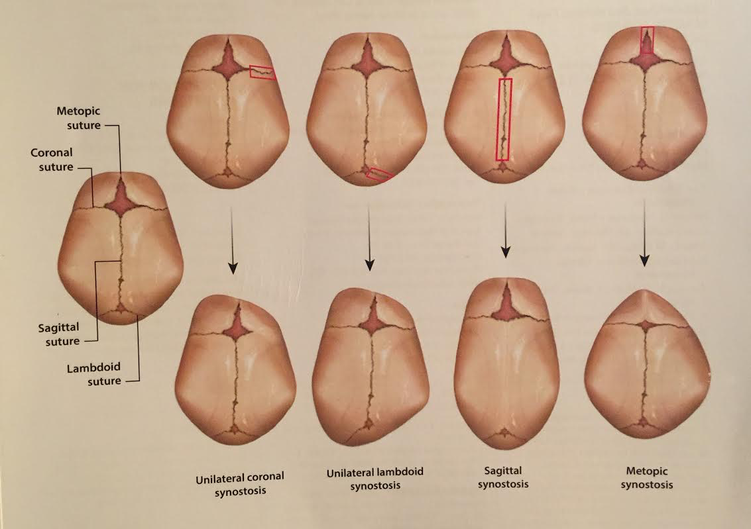
Craniosynostosis

- elevated ICP occurs in 11% with a single stenotic suture (failure of calvarial growth, papilledema, developmental delay)
- risk of surgery: blood loss, seizure, stroke
- intra-op: precordial doppler for air in sinus, BLOOD ON HAND
- if intraop air embolus: drop head and flood the field!
- positional plagiocephaly:
- ask parents to keep off flattened area for 6-8 weeks (if positional, it should improve)
- if a helmet is prescribed, it needs to be done by 6 months of age
- at 9 months of age, a helmet is very unlikely to help
- after 12 months of age, a helmet is useless
- bone scan: isotope uptake in suture (no uptake will be seen once the suture is completely fused)
- SAGITTAL
- most common CSO
- dolichocephaly or scaphocephaly (boat-shaped skull)
- frontal bossing, prominent occiput, OFC close to normal, biparietal diameter is reduced
- hydrocephalus is not common
- 44% can have elevated ICP
- surgical treatment: longitudinal incision for 3cm strip craniectomy (from coronal to lambdoid suture – from bregma
to lamda) with barrel-stave, within first 3-6 months of life
- prone position, zig-zag incision with Colorado tip, multiple IV and arterial line, precordial Doppler for air embolism
- TYPE AND CROSS FOR ALL CRANIOSYNOSTOSIS CASES
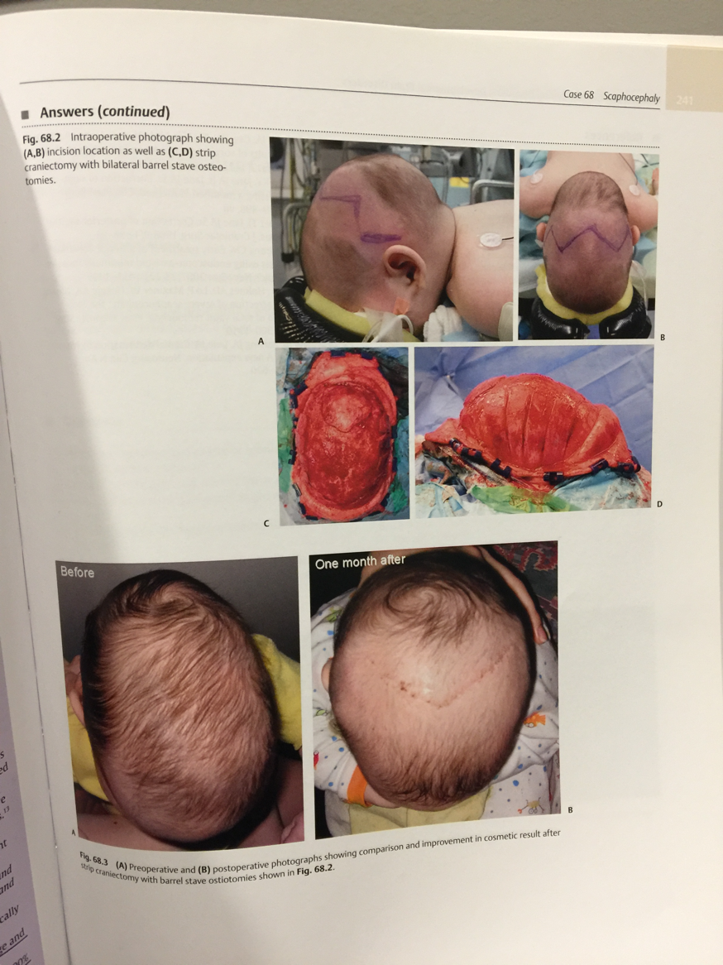
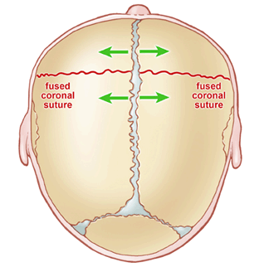
- CORONAL
- UNILATERAL: Harlequin eye sign: supra-orbital margin higher than normal side
- plagiocephaly with forehead on affected side flattened or concave above eye
- orbit rotates out on affected side (can produce amblyopia – aka lazy eye)
- BILATERAL: brachycephaly with broad flattened forehead (acrocephaly)
- surgical treatment: frontal craniotomy (uni- or bilateral) with lateral canthal advancement by taking off orbital bar
- perform with plastic surgery
- have plenty of blood available
- bicoronal incision, bifrontal craniotomy with removal of orbital bar
- use absorbable plates and screws
- 4-8 months is the best time to do surgery
- Crouzon’s syndrome (coronal + sphenoid, orbital and facial bones – hypoplasia of midface)
- Apert’s syndrome: coronal + syndactyly
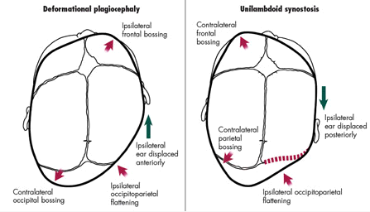
- METOPIC
- trigonocephaly
- associated with 19p abnormality and mental retardation
- hypotelorism
- bicoronal incision with bifrontal craniotomy
- plastics does interorbital expansion (as opposed to the fronto-orbital advancement in coronal CSO)
- surgery between 4-8 months
- TYPE AND CROSS – HAVE BLOOD IN THE ROOM
- LAMBDOID
- right side involved in 70% of cases
- presents between 3-18 months of age
- UNILATERAL: flattening of occipital area + bulging of contralateral forehead = ”trapezoid” skull; ipsilateral
ear is located posterior to the contralateral side
- BILATERAL: brachycephaly with both ears displaced posteriorly
- “beaten copper cranium”: indentations in the bone from underlying gyri which may be due to locally increased ICP
- conservative management: repositioning, physical therapy for torticollis
- surgical treatment: required in 20% of cases; ideal age is 6-18 months; blood transfusion is often required
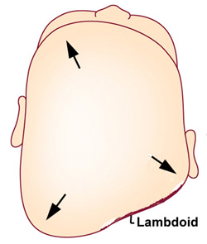
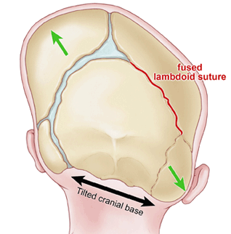
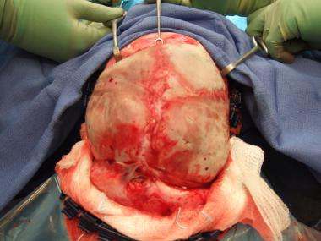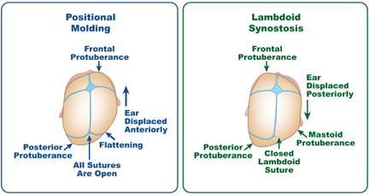
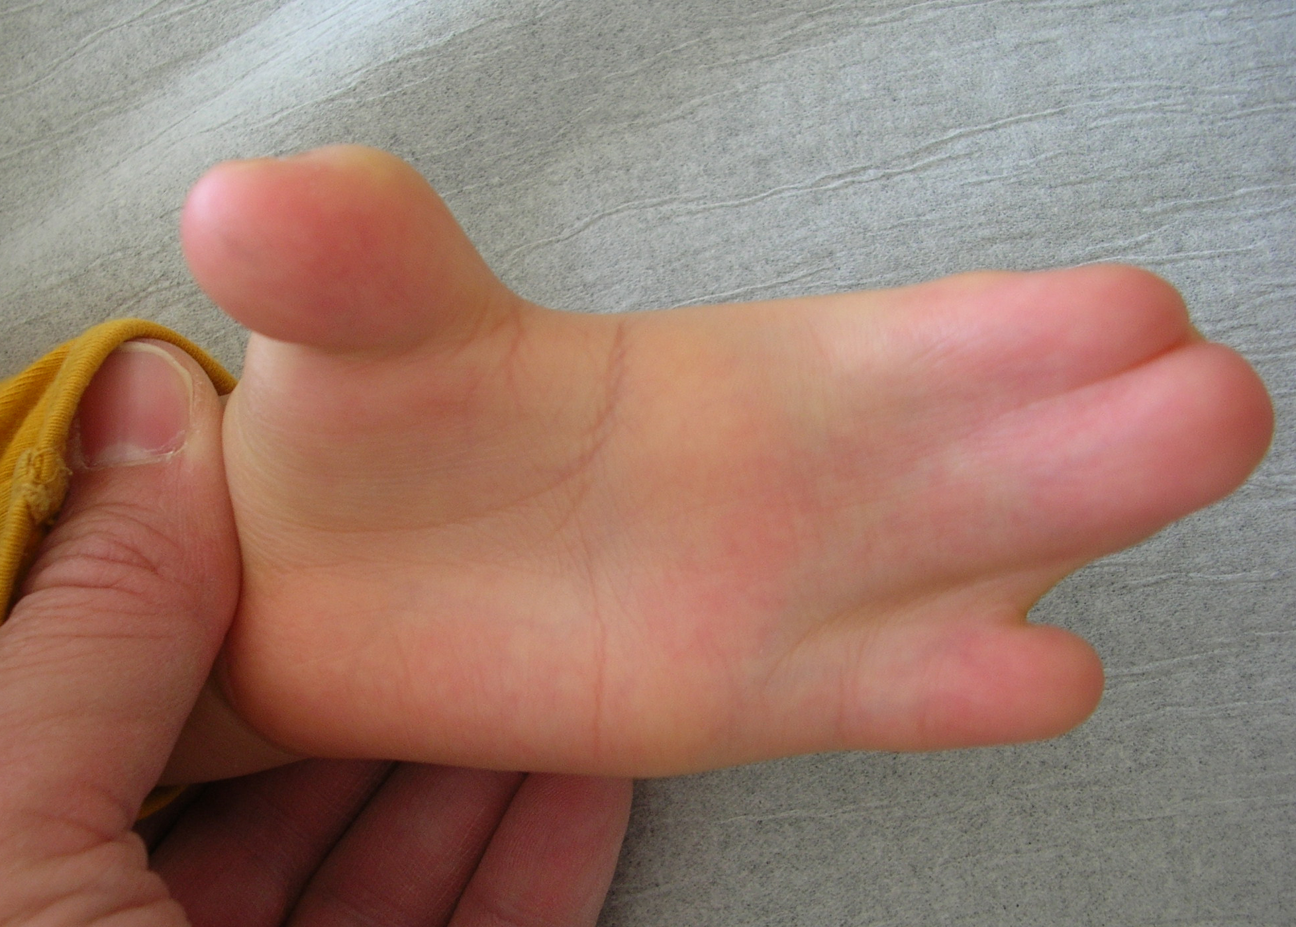
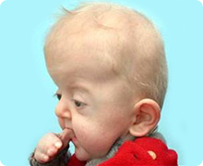
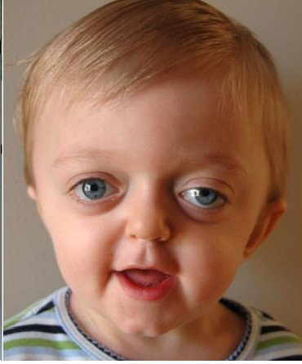
- Craniofacial dysmorphic syndromes (over 50 syndromes have been described)
- Crouzon
- craniofacial dysotosis
- AD, sporadic (25%)
- CSO of coronal, and basal skull sutures, maxillary hypoplasia, shallow orbits, proptosis
- HCP rare
- normal intelligence
- Apert
- acrocephalosyndactaly
- sporadic (95%), AD
- CSO of coronal, and basal skull sutures, maxillary hypoplasia, shallow orbits,
ptosis
- syndactyly of digits 2, 3, 4, shortened UE
- HCP common
- intelligence varies
- Kleeblattschadel (Cloverleaf)
- AD, sporadic
- CSO with trilobular skull
Atretic parietal cephalocele
- aka APC
- small subscalp lesions that consist of dura, fibrous tissue,
and dysplastic brain tissue
- palpable, midline parietal soft tissue mass
- represents an involuted true cephalocele (meningocele
or encephalocele) connected to the dura mater via a
fibrous stalk
- associated with an increased incidence of intracranial
anomalies
- prognosis: good
- differential diagnosis: sinus pericranii, dermoid or
epidermoid cyst, cephalohematoma, sebaceous cyst,
vascular lesion (hemangioma)
- radiographic features: subgaleal, soft tissue mass with
intracranial extension via a sharply demarcated calvarial
defect (cranium bifidum)
- CSF tract and vertical falcine vein point to the
subcutaneous scalp mass
- vertically oriented primitive falcine vein
- fibrous stalk connecting the cephalocele
- focal fenestration of superior sagittal sinus at the atretic
parietal cephalocele
- prominence of superior cerebellar cistern and
suprapineal recess
- superior peaking of the posterior tentorium
- spinning top configuration of the tentorial incisura
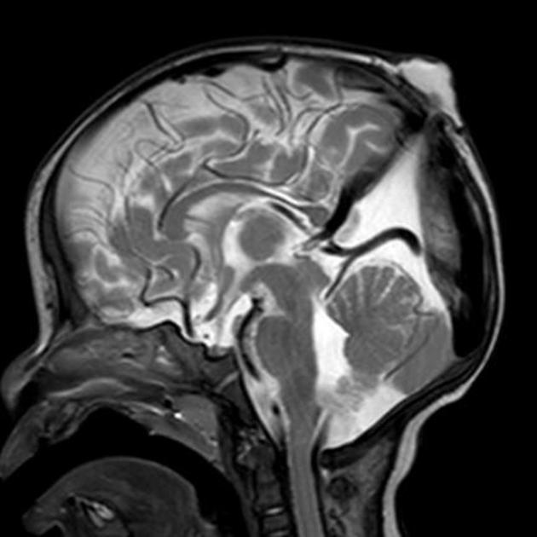

Encephalocele
- aka cranium bifidum
- meningocele: CSF and meninges herniate through a defect in the skull
- encephalocele: meninges and cerebral tissue protrude through a defect in the skull
- nasal, polypoid mass in a newborn should be considered an encephalocele until proven otherwise
- treatment: dural patch and cranioplasty
- classification:
- occipital: often involves vascular structures
- surgical excision of the sac and its contents with water-tight dural closure
- prognosis is better in meningocele than encephalocele
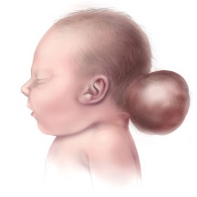
- cranial vault (80%)
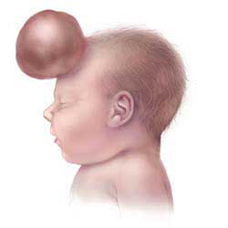
- interfrontal
- anterior fontanelle
- interparietal: often involves vascular structures
- temporal
- posterior fontanelle
- fronto-ethmoidal (AKA sincipital, 15%): external opening into face in one of 3 regions:
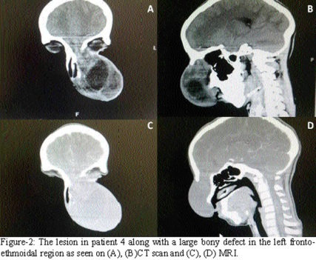
- nasofrontal: external defect in the nasion
- naso-ethmoidal: defect between the nasal bone and
nasal cartilage
- naso-orbital: defect in the antero-inferior portion of
medial orbital wall
- anterior to the crista galli
- closely associated with a defect in the foramen cecum
- basal (1.5%)
- transethmoidal: protrudes into the nasal cavity through a defect in the cribriform plate
- spheno-ethmoidal: protrudes into the posterior nasal cavity
- transsphenoidal (protrudes into sphenoid sinus or nasopharynx through patent craniopharyngeal cecum
(foramen cecum))
- fronto-sphenoidal or spheno-orbital: protrudes into orbit through SOF
- the only group that doesn’t produce a visible soft tissue mass
- may present as a CSF leak or recurrent meningitis
- transnasal approach may be fraught with ICH, meningitis, persistent CSF leak
- perform a combined intracranial approach with amputation of extracranial mass and transnasal approach
- posterior fossa (contains cerebellar and ventricular tissue)
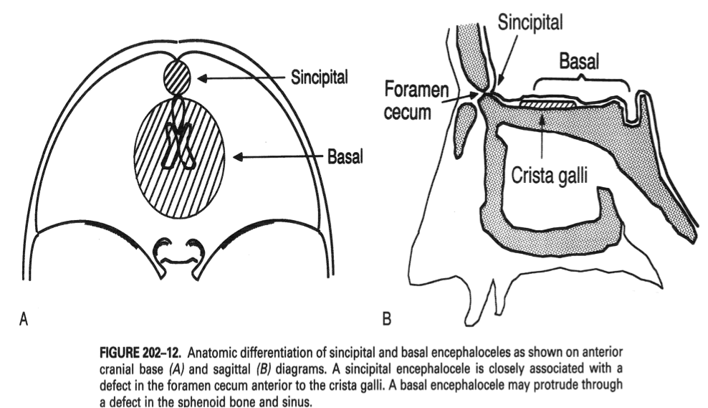
Dandy Walker malformation
- enlarged posterior fossa with complete or partial agenesis of the cerebellar vermis
- cystic dilation of the 4th ventricle which is distorted and encased in a membrane – doesn’t communicate with the ventricles
- absent choroid plexus in fourth ventricle
- mega cisterna magna: enlarged posterior fossa secondary to enlarged cisterna magna with a normal vermis and 4th ventricle
- hydrocephalus occurs in 70-90% of cases
- 50% have normal IQ
- associated findings:
- agenesis of the corpus callosum
- heterotopias
- elevation of torcula with enlarged posterior fossa (beware if attempting occipital EVD placement!!!)
- beware of cardiac abnormalities when considering surgery on these patients
- shunting of the cyst and lateral ventricles may be needed – the key is to know if aqueduct is patent!!!
- shunting the lateral ventricle alone may be dangerous due to risk of upward herniation
- a cine flow study can determine if the aqueduct is patent
- if the aqueduct is patent, both compartments don’t need to be shunted – cystoperitoneal shunt alone
Aqueductal stenosis
- produces triventricular hydrocephalus
- headache, papilledema
- treatment: ventriculoperitoneal shunt, Torkildsen shunt (lateral ventricle to cisterna magna), ETV
- follow-up for at least two years to r/o tumor
Agenesis of the corpus callosum
- forms from rostrum to splenium
- commissuration occurs 2 weeks after conception
- if posterior CC is present without the anterior portion, indicates a form of holoprosencephaly
- disconnection syndrome is more likely with an acquired CC defect
- seen in:
- Holoprosencephaly
- Schizencephaly
- simple agenesis
- Chiari type 2
- basal encephalocele
- porencephaly/hydrancephaly
- severe hydrocephalus
- septo-optic dysplasia
- incomplete morphogenesis of anterior midline structures (optic nerves, pituitary infundibulum, septum
pellucidum)
Intracranial lipomas
- failure of involution of primitive meninges
- found near or in the midsagittal plane (particularly over the corpus callosum; may also be seen in tuber cinereum and
quadrigeminal plate)
- found in isolation or part of a syndrome (trisomy 21, frontal encephalocele)
- MRI appearance characteristic of fat: high intensity on T1 and low intensity on T2
- surgery is almost never needed (except if causing CSF obstruction)
Hypothalamic hamartomas
- pedunculated (parahypothalamic) or sessile (intrahypothalamic)
- usually occur in the tuber cinerum (floor of the third ventricle between the infundibular stalk and the mammillary bodies)
- hamartoma: abnormal conglomeration of cells normally found in the same area
- presentation: precocious puberty (GnRH release from hamartoma cells), seizures (gelastic), developmental delay
- most common CNS tumor to cause precocious puberty
- imaging: non-enhancing, isointense on T1, slightly hyperintense or isointense on T2
- indications for surgery: precocious puberty that fails to respond to GnRH analogs, intractable seizures, mass effect
- can be treated endoscopically, with craniotomy (orbitozygomatic, transcallosal/interforniceal), or radiosurgery (17 Gy)
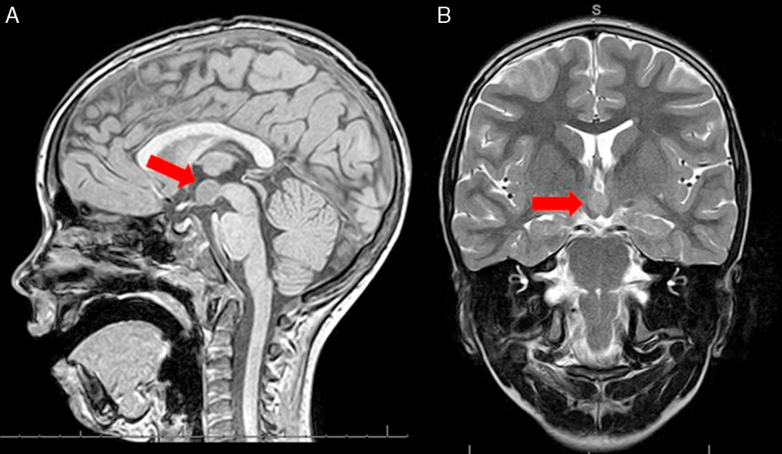
Spinal arachnoid cysts
- almost always dorsal and in thoracic spine
- if ventral, consider neurenteric cyst
SPINAL DYSRAPHISM (spina bifida)
- spina bifida occulta: congenital absence of the spinous process and part of the lamina
- no visible exposure of meninges or neural tissue
- group of developmental disorders resulting from defects in neural tube closure
- closure of the spinal canal begins at the cephalad end approximately 20 days after fertilization and proceeds caudally
- closure is complete at approximately day 28
- associated with folic acid deficiency, valproic acid, carbamazepine
- folic acid supplementation:
- 0.4 mg per day
- 4 mg per day if MM in pt or previous child
- involvement above L3 precludes ambulation
- involvement below S1 allows for unaided ambulation
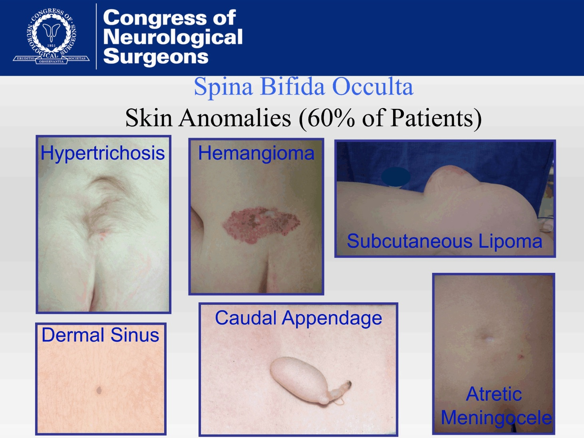
Myelomeningocele
- anterior neuropore closes at gestation day 25
- posterior neuropore closes at gestation day 28
- risk increases to 2-3% if previous birth with MM
- prenatal folate lowers risk (400 µg QD)
- HCP in 65-85%
- 5-10% have overt HCP at birth
- most have Chiari type 2 malformation
- closure of the MM can convert a latent HCP to active HCP by eliminating the route of CSF egress
- 73% have latex allergy (proteins in latex – milky sap from the rubber tree)
- intrauterine closure does not improve distal neurologic function
- initial management:
- measure size of defect
- assess if lesion is ruptured or unruptured
- if ruptured: start antibiotics (nafcillin or gentamicin) – d/c after closure or continue if shunt is anticipated
- unruptured: no antibiotics necessary
- cover lesion with telfa
- then sponges soaked in lactated ringers or normal saline (form a sterile gauze ring around lesion if it is protruding)
- Trendelenburg position with patient on stomach (keep pressure off lesion)
- perform surgical closure within24- 36 hours (unless contraindication)
- simultaneous shunt is not placed unless there is overt hydrocephalus at birth
- neurologic assessment
- watch for spontaneous movement in LE
- need L3, at least, to lock knees straight to be ambulatory (can walk with AFOs)
- assess lowest level of neurologic function
- measure OFC
- monitor for abnormal rate of growth of HC (> 1cm/day)
- head U/S within 24 hours
- check for inspiratory stridor, apneic episodes
- ancillary assessment
- neonatologist to assess pulmonary function (pulmonary immaturity may affect ability to perform closure)
- urology consultation (non-emergent) – start regular urinary catheterization
- AP/lateral spine films (assess scoliosis)
- orthopedic consultation: for hip or knee deformities
- surgical management
- closure within 24-36 hours reduces risk of infection, but does not change neurologic function
- unless there is overt hydrocephalus, wait at least 3 days before shunting
- surgical goals
- free placode from dura to avoid tethering, water-tight dural closure, skin closure
- start at normal dura, open as wide as the defect, trim placode if necessary to close dura, undermine skin to achieve
closure (avoid trapping skin as this can lead to formation of a dermoid tumor)
- post-op CSF leak means a shunt is needed
- general principles
- keep the exposed neural tissue moist (avoid dessication)
- maintain and latex-free environment
- do not allow scrub solutions (iodine) or chemical antimicrobials to contact neural placode
- do not use monopolar cautery
- at every point in the closure, avoid placing tension on the neural placode
- 5-layer closure is ideal and may make future tethering easier to untether
- the five layers:
1. placode
2. dura (comes up to the skin – junctional zone)
3. fascia (cut circumferentially around skin – very important)
4. dermis
5. epidermis
- divide abnormal epithelial covering from the normal skin
- pia-arachnoid may be separated from the neural tissue
- placode is folded into a tube
- pia-arachnoid is approximated around it with 7-0 suture (absorbable suture)
- helps to start with normal dura above and work down
- isolate dura around periphery and follow deep to the spinal canal superiorly
- dura is then formed into a tube and approximated in a water-tight fashion
- if dura cannot be closed, judiciously trim placode
- filum terminale should be divided if it can be located
- the skin is then mobilized and closed (make sure there is no tension) – ask plastics for help
- dermoid tumors may form from retained skin during the closure
- post-operative management
- keep patient off incision
- bladder catheterization regimen
- daily OFC measurements
- avoid narcotics
- if not shunted: head U/S twice a week and keep patient flat to decrease CSF pressure on the incision
- if there is a CSF leak from a MM incision, always evaluate for hydrocephalus!!!
- ALWAYS R/O SHUNT MALFUNCTION WHEN A MM PATIENT DETERIORATES
- almost all have Chiari 2 malformations (do not address unless symptomatic) – address in a patient with apneic spells
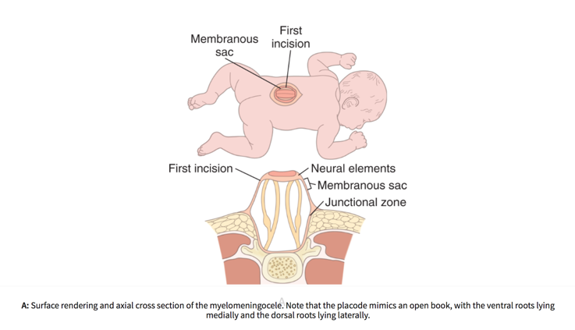
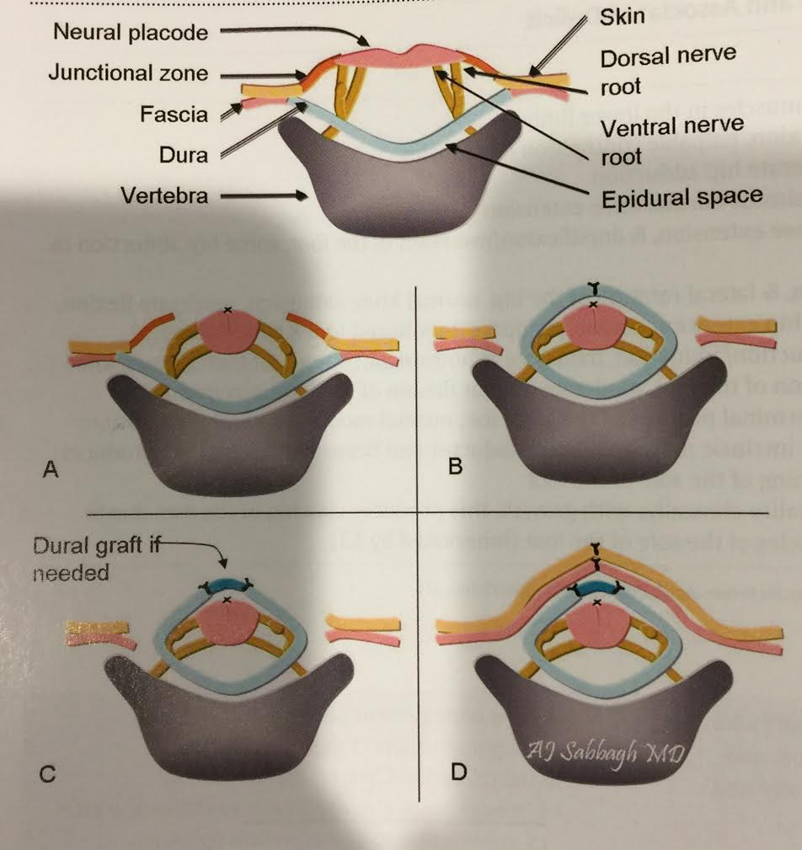
- the first cut in surgery is to free the arachnoid and placode from the surrounding skin (this is the junctional zone)
- junctional zone = the area where the dura had fused with the subcutaneous tissue
- to minimize the risk for later development of a dermoid or lipoma, any residual epidermal or dermal elements are resected
from the periphery of the neural placode
- using monofilament suture, the pia is closed if possible to re-form the neural placode into a tube because pial closure is
thought to lower the incidence of retethering
- the dura is mobilized and closed by identifying normal dura below the last intact lamina
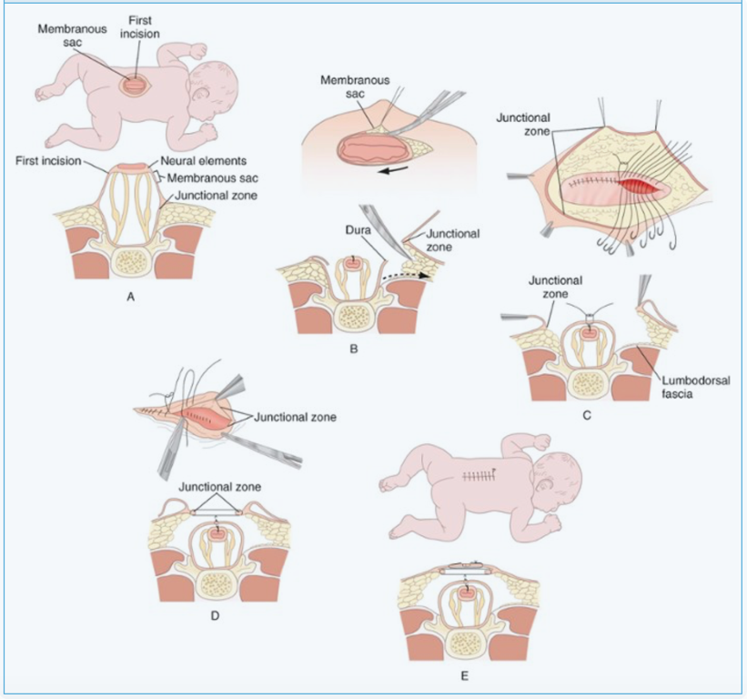
Lipomyeloschisis
- dorsal spinal dysraphism with lipoma
- three types
- intradural lipoma
- lipomyelomeningocele:
- skin-covered subcutaneous lipoma
- subcutaneous lipoma passes through a midline defect in the lumbodorsal fascia, vertebral
neural arch, and dura, and pia
- merges with an abnormally low tethered cord
- may extend superiorly under intact spinal arches
- presentation: back pain, back mass, bladder problem, foot deformities, paralysis or leg pain
- almost all patients have cutaneous stigmata: subcutaneous fat pad, dimple, hair, dermal sinus opening
- MRI shows lipomatous mass (high T1, low T2 signal)
- early prophylactic untethering is recommended
- all patients should have pre-op urology eval
- surgical technique:
- mobilize the subcutaneous mass (it funnels down through the deep fascia)
- open last intact vertebral arch and ID/cut fibrovascular band that crosses the most cephalad
bifid lamina
- open dura
- cord and placode are untethered (use monitoring)
- subtotal removal of the lipoma (leave some behind to avoid injury to the dorsal surface of
placode)
- placode is reformed into a closed neural tube
- pial margins are closed
- dura is closed primarily or with fascia lata graft if too much tension
- fibrolipoma of the filum terminale
Dermal sinus
- tract beginning at the skin surface, lined with epithelium
- usually located at either end of the neural tube (cephalic
or caudal)
- most common location: lumbosacral
- in the region of the inion, present as tiny pits with one or
few dark, dysplastic hairs (often missed on casual
physical exam)
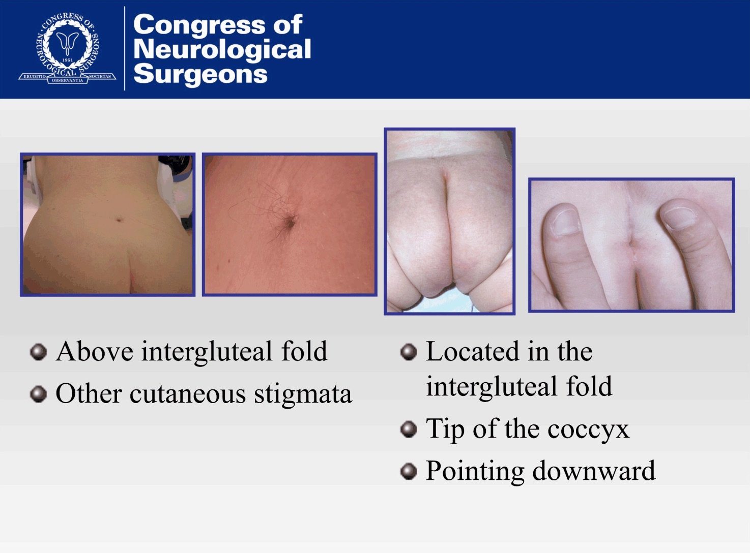
Spinal dermal sinus
- appears as dimple or sinus
- in the gluteal cleft: benign
- above the gluteal cleft: needs investigation
- usually associated with tuft of hair, capillary hemangioma, lipoma
- image with MRI at 3 months of age (obtain MRI of the entire spine)
- ask about signs and symptoms of meningitis
- obtain renal and bladder ultrasound and consult urology
- c/s hair, close to midline
- 1-2mm opening
- may widen at any point to form a cyst
- may present with recurrent meningitis
- tract always courses cephalad as it dives inward from the surface
- eclipse is cut around the opening; sinus is followed deep until the termination of the tract is encountered
- if the tract penetrates the spine, laminectomy must be performed and the tract followed to its full extent (extradural cyst
may be present)
- if it enters the dura, it is usually in the midline
- dura should be opened and inspected
- extreme care to prevent spilling the contents into the subdural space
- in OR: EMG is a must!
- do not cut anything that stimulates at 1 mA or below
- SSEP and MEP are difficult to obtain in newborns
- section filum to untether cord while there
Cranial dermal sinus
- stalk begins with a dimple in the occipital or nasal region
- cutaneous stigmata may be present
- occipital sinuses extend caudally
Klippel-Feil syndrome
- congenital fusion of 2 or more cervical vertebrae
- may occur in conjunction with other congenital cervical spine anomalies: basilar impression and atlanto-occipital fusion
- clinical presentation:
- low posterior hairline
- shortened neck (brevicolis)
- limitation of neck motion
- associated with other congenital abnormalities:
- genitourinary (unilateral absence of a kidney)
- cardiopulmonary
- deafness
Tethered cord syndrome
- abnormally low conus medullaris
- before 3 months of age, all infants have a low-lying conus which then ascends
- may present with sacral dimple
- natural history: progressive neuro deterioration with deficits in sensory, motor, bowel/bladder during rapid periods of growth
- associated with a short, thickened filum or intradural lipoma (fatty filum)
- most common in MM (diagnosis needs to be made clinically, as almost all these patients have tethering radiographically)
- presentation in MM: increasing scoliosis, increasing spasticity, worsening gait, deteriorating urodynamics (r/o VPSM)
- if painful, consider tethered cord
- if painless, consider syringomyelia
- r/o brainstem compression from Chiari II
- may require multiple untethering procedures
- scoliosis in tethered cord
- if < 10⁰ with untethering: neurologic improvement
- if > 50⁰ with untethering: possible deterioration
- in adults:
- conus below L2
- thickened filum terminale (diameter > 2mm)
- may be a congenitally low-lying conus
- untethering is good for pain control, but poor for return of bladder function
- pre-operative evaluation:
- cystometrogram/urodynamic studies
- intra-op: find filum at L4-5, L5-S1 and stimulate; cauterize and cut; monitor anal sphincter
- filum is differentiated from nerve roots by presence of characteristic squiggly vessel on the surface (
- filum also has a whiter appearance than nerve roots under the microscope and ligamentous-like strands can be seen running
through it
- NB: intra-op electrical stimulation and recording of anal sphincter EMG are more definitive
- should untether is young children even if asymptomatic due to progressive nature of the disease
Split cord malformation
- obtain pre-op urodynamic studies, renal & bladder ultrasound
- image entire neural axis in any closed neural tube defect
- more than one spur may be present (5%)!
- can occur anywhere in the spine, but most commonly low thoracic/upper lumbar
- intra-op:
- maintain MAP
- IOM with rectal probe
- localize based on CT (bony septum)
- ID bony septum
- for Type I: remove bony septum first, then untether spinal cord, finally recreate dural sac
- for Type II: remove fibrous septum, then cut filum terminale
Type I SCM
- two hemicords, each with its own central canal and surrounding pia
- each cord has a central canal and one dorsal horn and one ventral horn
- each within a separate dural tube
- separated by a dural-sheathed rigid osseocartilaginous (bony) median septum
- diastematomyelia
- at the level of the split: absent disc often
- overlying skin abnormality: nevi, hypertrichosis, lipoma, dimples, hemangiomas
- often have orthopedic high arches
- limb length discrepancy often
- untether cord only once bony septum is removed
- use drill and bone wax to remove septum
- open the dura and inspect because there are often aberrant roots – sacrifice medial roots as they may be tethering the cord
- often, there may be two filum terminale that need to be cut
- if you see asymmetry of the LE in an adult that was told he had polio, check for split cord
- he may have been misdiagnosed and will improve with surgery!
Type II SCM
- two hemicords within a single dural tube
- separated by a nonrigid fibrous median septum
- diplomyelia
- each hemicord has nerve roots arising from it
- usually no spine abnormality at the level of the split
- usually spina bifida occulta in the lumbosacral region
Chiari Malformation
- congenital or acquired
- obtain MRI brain and cervical spine to r/o syringomyelia (30-70%)
- cerebellar tonsils > 5 mm below the foramen magnum
- beware of bleeding from the occipital sinus
- CHIARI TYPE 0: syringomyelia present without tonsillar descent (respond to p-fossa decompression)
- potentially more significant than the tonsillar herniation is the amount of compression of the brainstem
- CHIARI TYPE 2: caudal dislocation of the medulla, small posterior fossa, tectal beaking, myelomeningocele, hydrocephalus,
medullary kink, upper cervical nerves course cranially, present with progressive hydrocephalus and respiratory distress,
difficulty swallowing, apnea, downbeat nystagmus
- if a Chiari 2 with MM and shunt presents with new symptoms, ALWAYS CHECK THE SHUNT FIRST!
- if present with fatigue, bladder changes with tethered cord, ALWAYS CHECK THE SHUNT FIRST!
- CHIARI TYPE 3: cerebellar and other posterior fossa tissue herniating through an enlarged foramen magnum and into a
congenital cervical meningocele
- prognosis poor; incompatible with life
- symptoms: pain (suboccipital headache), headaches caused by valsalva maneuver or neck extension, grasp weakness, Lhermitte’s sign, bilateral LE spasticity, cape sensory loss
- patients respond best when operated on within 2 years of symptom onset
- when there is a Chiari, tethered cord, and scoliosis: decompress Chiari first, then untether cord, then deal with scoliosis
Syringomyelia
- patients present with progressive difficulty with ambulation and spasticity
- image neural axis to r/o Chiari or lesion causing CSF obstruction leading to syrinx
- should be treated if symptomatic
- syringo-subarachnoid shunt (avoid if a lot of adhesions)
- syringo-pleural shunt
- syringo-peritoneal shunt
Lemire classification of neural tube defects (high maternal serum AFP present between 15-20 weeks of gestation)
- neurulation defects (non-closure of the neural tube results in open lesions)
- craniorachischisis: total dysraphism
- anencephaly (failure of fusion of the anterior neuropore)
- myelomeningocele
- postneurulation defects (produces skin-covered, closed lesions)
- cranial
- microcephaly
- hydranencephaly (loss of most of the cerebral hemispheres, replaced by CSF)
- intact cranial vault and meninges
- most common cause is bilateral ICA infarct
- another cause is infection
- how to differentiate from maximal hydrocephalus:
- EEG: no cortical activity in hydranencephaly (background activity present with HCP)
- CT, MRI: some cortical mantle is present in HCP
- angiography: no flow through supraclinoid ICA, but normal posterior circulation
- shunting may be needed to normalize head size
- holoprosencephaly
- lissencephaly
- neuronal migration abnormality
- arrest of cortical development at an early fetal age
- infants severely retarded and don’t survive > 2 years
- agyria, pachygyria, polymicrogyria
- porencephaly
- agenesis of the corpus callosum
- Dandy Walker syndrome
- macroencephaly
- spinal
- diastematomyelia, diplomyelia
- hydromyelia/syringomyelia
Migration abnormalities
- lissencephaly
- heterotopia: abnl foci (non-enhancing grey matter) located in an abnormal location; almost always presents with seizures
- cortical dysplasia: a cleft that does not communicate with the ventricle
- schizencephaly:
- cleft that communicates with the ventricle
- cleft lined with grey matter (distinguishes it from porencephaly)
- holoprosencephaly
- failure of the telencephalic vesicle to cleave into two hemispheres
- degree of failure ranges from severe alobar to semilobar and lobar
- associated with trisomy 13 and 18
- microcephaly
- HC more than 2 SD below mean
- macroencephaly
Neurenteric cysts
- CNS cyst lined by endothelium primarily resembling the GI tract (or respiratory tract)
- congenital
- usually affect the upper thoracic and lower cervical spine
- present with pain
- surgical removal usually reverses the symptoms
- recurrence is uncommon with complete removal of the cyst wall
Intracranial neurenteric cysts
- most common in posterior fossa
- capsule adherent to brainstem may prevent complete resection
- incomplete removal requires long-term follow-up
PEDIATRIC HEAD INJURY
- use rapid sequence MRI to evaluate, if possible (to avoid radiation)
- cephalhematoma
- subgaleal hematoma: may cause significant drop in Hgb, can cross sutures, do not calcify
- subperiosteal hematoma: aka cephalhematoma, blood elevates periosteum and is limited by sutures, may calcify
- if persists > 6 weeks, obtain a skull film (if calcified, surgically remove for cosmetic reasons)
- resist the urge to percutaneously aspirate these as risk of infection exceeds the risk of following them expectantly
Pediatric skull fractures
- Post-traumatic leptomeningeal cysts (growing skull fractures)
- not to be confused with leptomeningeal cysts that are not post-traumatic (aka arachnoid cysts)
- aka traumatic meningoencephalocele
- PTLMC consists of a fracture line that widens with time
- usually asymptomatic, but may cause mass effect with neurologic deficit
- require a widely separated fracture and a dural tear
- radiographic marker of underlying dural tear is diastasis of the edges of the fracture < 4mm
- rarely occur > 6 months out from injury
- present as a subgaleal scalp mass
- treatment of a true PTLMC is surgical
- dural defect is usually larger than the bony defect
- perform a craniotomy around the fracture side, repair the dura, and replace the bone
- not a concern in the setting of the ordinary, linear, non-displaced, parietal skull fracture of infancy
Pediatric depressed skull fractures
- remodeling of the skull as a result of brain growth tends to smooth out the deformity
- “ping-pong ball” fracture
- no treatment is necessary when these occur in the temporoparietal region in the absence of underlying brain injury
as the deformity will usually correct as the skull grows
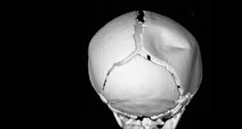
Non-accidental trauma
- suspect in children < 3 years
- suspect in bilateral chronic SDH in a child < 2 years of age
- perform eye exam to r/o retinal hemorrhage and skeletal survey to r/o other fractures
- shaken baby syndrome
Post-traumatic hydrocephalus
- seen in 40% of patients with severe head injury (GCS 3-8)
- seen in 70% by 2 months
- in the chronic setting, how to differentiate between true hydrocephalus v. ex vacuo secondary to axonal injury
- symptoms: headache
- elevated pressure on LP
- funduscopic exam showing papilledema
- transependymal absorption on CT or MRI
- patient with neurologic recovery seems worse than expected
Outcome prognosticators
- persistent ICP > 20 mm Hg after hyperventilation
- increasing age
- impaired or absent pupillary response
- hypotension (SBP<90)
- hypercarbia
- hypoxia
- anemia
- compression or absence of basal cisterns (ambient, quadrigeminal)
- presence of midline shift
Glasgow outcome scale
1: death
2: persistent vegetative state
3. severe disability (conscious but disabled/dependent)
4. moderate disability (disabled but independent)
5. good recovery (normal life despite minor deficits)
Late complications to r/o in all patients presenting with “post-concussive syndrome”
- seizures
- delayed hydrocephalus
- CSF leak
Chronic traumatic encephalopathy
- aka dementia pugilistica
- retired boxers
- present with motor, cognitive, and psychiatric changes
- dysarthria, tremors, incoordination, decreased complex attention, emotional lability, euphoria/hypomania, …
- pyramidal signs, parkinsonism
- develop amyloid angiopathy (increased risk of ICH)
- EEG changes (diffuse slowing or low-voltage records)
- neurofibrillary tangles
- cerebral atrophy on imaging
SYNDROMES INVOLVING TUMORS
NEUROCUTANEOUS SYNDROMES
- aka phakomatoses
- NB: both skin and CNS derive embryologically from ectoderm
- dysplasia of other organ systems (including the eyes)
- all exhibit autosomal dominant inheritance pattern except ataxia telangiectasia
- neurocutaneous disorders (NCD) are a group of conditions, each with unique neurologic findings and benign cutaneous
lesions
1. neurofibromatosis
2. tuberous sclerosis
3. von Hippel-Lindau disease
- chromosome 3
- retinal angiomas
- cystic posterior fossa lesion with mural nodule
- spinal cord hemangioblastomas
- pancreatic lesion
- renal cell carcinoma
- pheochromocytoma
4. Sturge Weber syndrome
5. racemose angioma (Wyburn-Mason syndrome): midbrain and retinal AVMs
6. ataxia telangiectasia
Neurofibromatosis
- One of the phakomatoses
- Both skin and CNS lesions derive embryologically from ectoderm
- The most common of the NCDs
- Schwannomas (neurilemmomas) arise from schwann cells which produce myelin.
  - Displace axons (CENTRIFUGAL)
- Neurofibromas consist of neurites (axons or dendrites of immature or developing neurons), schwann cells, and fibroblasts within a collagenous or myxoid matrix
  - Unencapsulated and engulf the nerve of origin (CENTRIPETAL)
  - May occur as solitary lesions or may be multiple as part of NF1 in the setting of which there is potential for malignant transformation (1%)
- Schwannomas and neurofibromas have Antoni A (compact) and Antoni B (loose) fibers
- Neurofibromas have more Antoni B fibers
- A patient ≤ 30 years age with a vestibular schwannoma is at increased risk of having NF2
 | NF1 | NF2
AKA | von Recklinghausen’s | MISME – multiple inherited schwannomas, meningiomas, and ependymomas
Inheritance/incidence | AD/1 in 3,000 births | AD/1 in 40,000 births
Sporadic occurrence | 30-50% | >50%
% of total neurofibromatoses | 90% of all NF is NF1
Gene locus | 17 (17q11.2) | 22(22q12.2)
Gene product | Neurofibromin  Neurofibromin 1 | Schwannomin (Merlin)  Neurofibromin 2
Vestibular schwannoma | Almost never bilateral | Bilateral VS are the hallmark
Neurofibromas | - Yes – multiple PN and skin neurofibromas  - 20% develop plexiform neurofibromas  (almost pathognomonic!) | No
Cutaneous schwannomas | No | 70%
Cutaneous manifestations | - café au lait spots  - axillary/inguinal freckling
Lisch nodules | Very common (melanocytic iris hamartoma)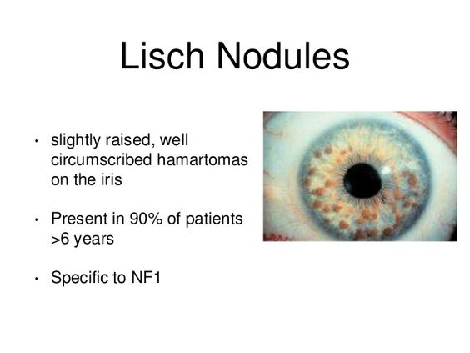 | Not associated
Cataracts | Not associated | 60-80%
Skeletal anomalies | Common  - kyphoscoliosis  - sphenoid wing dysplasia  - superior orbital defect pulsatile exophthalmos | Not associated
Pheochromocytoma | Occasional | Not associated
Associated lesions | - IC meningiomas, pilocytic astrocytomas  - optic glioma (most are non-progressive and  can be followed with serial imaging) | - No Lisch nodules  - retinal hemartomas  - patients will become deaf
MPNST (malignant peripheral nerve sheath tumor) | 2% (plexiform neurofibromas may transform) | Not associated
Associated intramedullary spinal cord tumors | - astrocytoma  - syringomyelia | - ependymoma
Associated malignant tumors | - neuroblastoma  - ganglioglioma  - sarcoma  - leukemia  - Wilm’s tumor  - breast cancer
Intellectual impairment | Associated | Not associated
NF-1 diagnostic criteria (two or more of the following)
- six or more café-au-lait spots
- two or more neurofibromas, or one plexiform neurofibroma
- axillary or inguinal freckling
- optic glioma
- two or more Lisch nodules (iris hamartomas)
- osseous lesions (sphenoid dysplasia, thinning of long bone cortex)
- first-degree relative with above criteria
NF-1 associated conditions
- acqueductal stenosis
- macrocephaly
- unilateral superior orbital defect (pulsatile exophthalmos)
- cognitive impairment and learning disabilities
- kyphoscoliosis
- syringomyelia
- intracranial tumors
- astrocytoma, hemispheric
- meningioma, solitary or multicentric
- extracranial tumors
- schwann cell tumors
- neuroblastoma
- sarcoma
- leukemia
- pheochromocytoma
- Wilm’s tumor
- moyamoya disease
NF-1 associated lesions
- neurofibroma
- astrocytoma
NF-2 diagnostic criteria
- bilateral vestibular schwannomas
- first-degree relative with NF-2
- unilateral vestibular schwannoma before age 30
Schwannoma
- arise from schwann cells (produce myelin)
- displace axons (centrifugal)
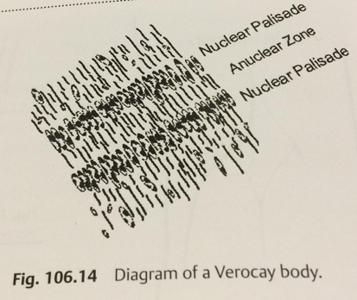
Neurofibroma
- consist of neurites (axons or dendrites of immature neurons)
- engulf the nerve of origin (centripetal)
- may occur as solitary lesions, or part of NF-1
- have more Antoni B fibers
Tuberous sclerosis complex
- aka Bourneville’s disease
- most are sporadic, but can be AD
- clinical triad: seizures, mental retardation, sebaceous adenomas
- typical CNS findings: subependymal nodules (“tubers”) – a hamartoma, looks calcified on CT head
- associated with: subependymal giant cell astrocytoma (SEGA)
- intense enhancement
- almost always at the foramen of Monro
- develop in 5-15% of cases
- remove if symptomatic (transcallosal approach)
- patients > 3 years of age with increasing size of SEGA lesions have had sustained reduction on everolimus
- chromosome 9q (hamartin) and 16p (tuberlin)
- hamartomas of: skin (sebaceous adenoma), brain (tubers), eyes (retinal hamartoma), kidneys (renal cysts)
- ash leaf macules (hypomelanotic, leaf shaped)
- intracerebral, subependymal calcifications that protrude into the ventricle (“candle guttering”) are the most common and
characteristic finding along the walls of the lateral ventricles or near the foramina of Monro
- shagreen patches, ungal fibromas, retinal astrocytomas, cardiac rhabdomyoma, renal cysts
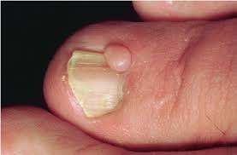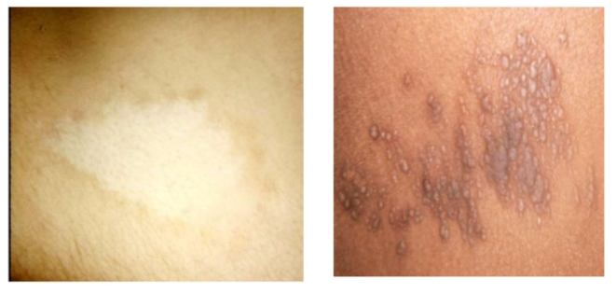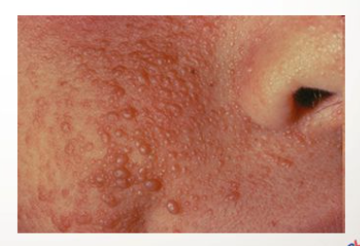
Sturge-Weber syndrome
- aka encephalotrigeminal angiomatosis
- localized cerebral atrophy and calcifications
- usually causes contralateral hemiparesis, hemiatrophy, homonymous hemianopsia (if occipital lobe involved)
- mental retardation
- ipsilateral port-wine facial nevus (usually in V1 distribution of the trigeminal nerve)
- contralateral seizures
- plain skull films show “tram-tracking” (double parallel lines of calcification)
- retinal angiomas
- most cases are sporadic
- some speculation about AR inheritance pattern with chromosome 3 implicated
- treatment is supportive
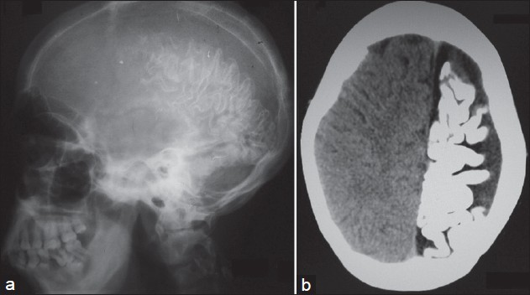
Wyburn-Mason syndrome
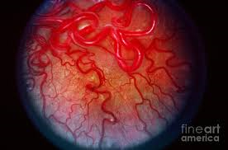
- aka retinoencephalofacial angiomatosis
- non-hereditary, sporadic, congenital phakomatosis
- unilateral retinocephalic vascular malformations
- cutaneous vascular nevi
- retinal or optic nerve vascular malformation
- ipsilateral cerebral AVM involving the visual pathways
and midbrain
- typically unilateral
- does not typically cause cutaneous manifestations

Neurocutaneous melanosis (NCM)
- rare, congenital, sporadic phakomatosis
- large or numerous congenital melanocytic nevi are associated with benign or malignant melanocytic tumors of the leptomeninges
- nevi are large, hairy, or both
- may have multiple lesions as opposed to one large
- neurologic manifestations before age 2: intracranial hypertension (hydrocephalus in over 60%)
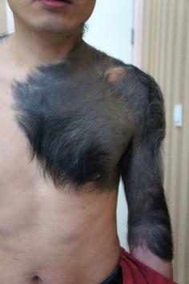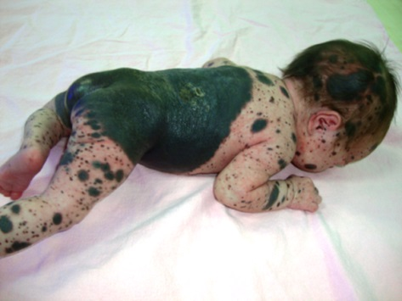
Endoscopic third ventriculostomy
- successful in obstructive hydrocephalus
- if ETV and pineal biopsy are planned, do the ETV first (if there is hemorrhage from biopsy, at least HCP has been treated)
- make sure there is adequate space in the prepontine cistern
- works best if > 2 years old
- make sure to penetrate the membrane of Liliequist (otherwise, high failure rate)
- must use a rigid endoscope (does not work well with flexible)
- pierce the tuber cinereum (gray matter; part of the hypothalamus), in front of the mammillary bodies
- patient is supine with head midline and slightly flexed to maintain proper cerebral venous drainage
- incision is 2.5 cm off midline and 1 cm in front of the coronal suture (usually on the right side)
- burr hole can be made larger for ultrasound-guidance or navigation can be used
- ventricular anatomy (important to know which ventricle you are in):
- thalamostriate vein is lateral and converges with the anterior septal vein before converging and entering the
foramen of Monro as the internal cerebral vein
- choroid plexus runs along the floor of the lateral ventricle

- endoscopic view into the right lateral ventricle
- thalamostriate vein (white arrow) runs along the lateral wall and converges with the anterior septal vein (short black arrow) before converging and entering the foramen of Monro as the internal cerebral vein
- superior choroidal vein (long black arrow) is also seen coursing through the choroid plexus
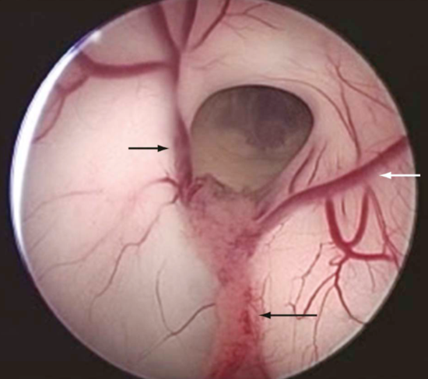
- the foramen of Monro is entered without placing traction along the margins
- anterior and medial circumference of the foramen of Monro is the fornix
- posterior and lateral circumference is the thalamus and choroid plexus
- the floor of the third ventricle is thin and translucent
- once the third ventricle is entered, the mamillary bodies should be evident midway along the floor with the basilar complex
just anterior to them in the midline (if these structures cannot be visualized, then the procedure should be aborted)
- the infundibular recess looks like a pinkish orange spot on the anterior midline floor
- slightly posterior to it is a white rectangular transverse band of the dorsum sellae
- the ideal spot for fenestration is midway between the basilar complex and the dorsum sellae in the midline
- CN III and CN VI can sometimes be visualized laterally along the floor

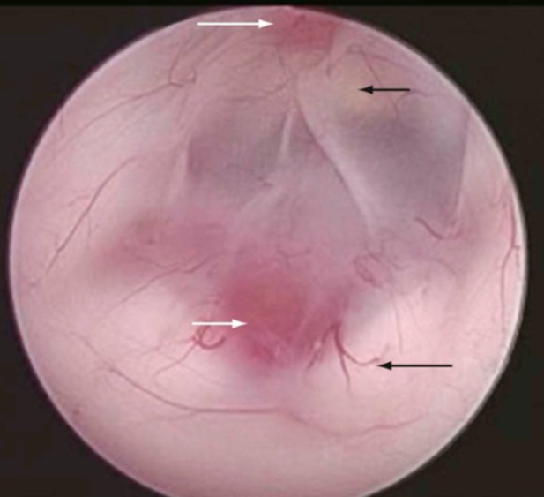
- endoscopic view of the floor of the third ventricle
- ideal spot for fenestration is in the midline, midway between the dorsum sellae (short black arrow) and the basilar artery (short white arrow)
- paired mamillary bodies (long black arrow) and the infundibular recess (long white arrow) are also seen

- fenestration through the floor of the ventricle is made bluntly with a blunt trocar, closed forceps, or a laser wire
- if floor of third ventricle is opaque, use a small doppler probe to locate the basilar complex definitively before fenestration -
- fenestration is then dilated to 4 to 6 mm in diameter by using a Fogarty balloon, spreaders, or forceps
- endoscope is perched atop the ostomy to inspect the subarachnoid spaces for membrane of Liliequist
- must be carefully fenestrated or the operation will be at risk for failure
- rule of thumb: if the endoscope can fit within the fenestration, it is large enough
- after the fenestration, the floor of the third ventricle should pulsate and flap with the respiration and heart rates
- endoscope is withdrawn slowly to inspect for hemorrhage
- NB: ventriculomegaly decreases more slowly in pts with ETV versus patient with shunts
- leaving an EVD behind is a good idea in sick patients, but may promote post-op CSF leak in healthy individuals
- complications: CSF leak, meningitis, cranial neuropathies (CN III, VI) , seizures, vascular injury (basilar, PComm),
hemorrhage, later need for VPS, hypothalamic injury, pituitary injury, traumatic basilar aneurysm
- ETV score: age, etiology of HCP, and shunt history (predicts chances of ETV lasting 6 months without failure)
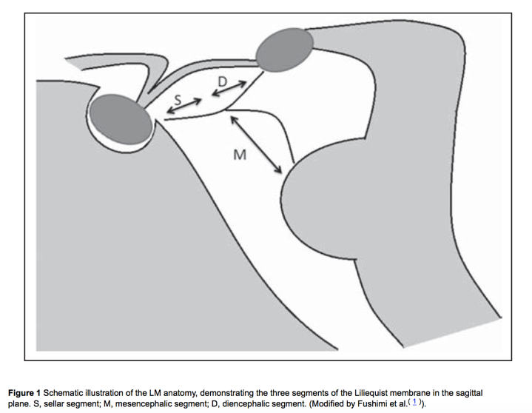 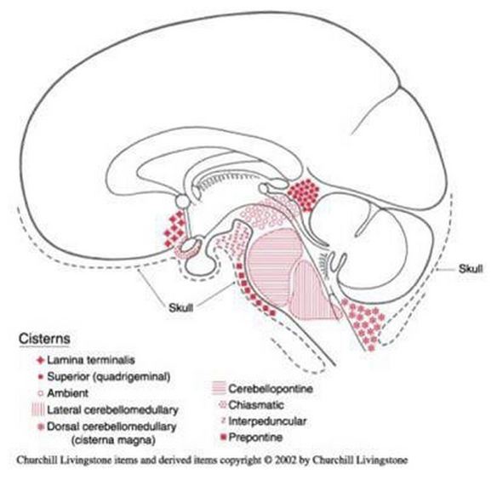
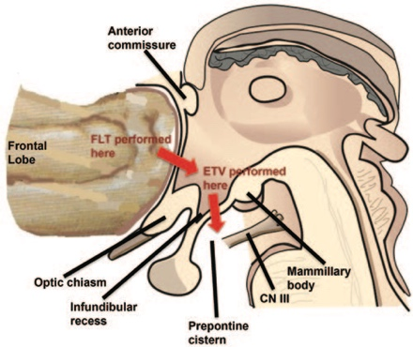
VP shunt evaluation
- always order a shunt series
- a disconnected shunt may over drain and cause slit ventricles and headaches
- alternative sites for shunt placement
- ventriculopleural
- ventriculoatrial
- gall bladder
- lumboperitoneal
Moya moya
- pediatric patients present with ischemic stroke (baseline ischemia and lack of cerebral auto-regulatory reserve), seizures, TIA
- do not wait for the patient to have a stroke before performing surgery
- surgical intervention should be performed upon discovery of illness
- if bilateral disease, do most symptomatic side first
- 25-50% of children with unilateral disease will develop contralateral disease
- obtain cerebral angiogram in pediatric stroke (include external runs, as well)
- there is no medical treatment
- keep well-hydrated and on aspirin
- definitive treatment is surgical
- EDAS/EDAMS
- find STA
- in OR:
- no hyperventilation or hypotension during surgery
- both can exacerbate hypoperfusion
- hyperventilation will blow off CO₂ (vasoconstriction will occur)
- permissive hypertension, A-line, ASA
Pial synangiosis for pediatric patients:
- mark STA with a Doppler
- open scalp over STA
- dissect out STA with galeal cuff
- make craniotomy
- open dura in a stelate fashion
- use microscope to open up the arachnoid
- transpose STA; lay vessel down on the surface of the brain
- suture cuff of galea onto pia
- lay dura down, but do not close
- replace bone flap
- doppler during closure to make sure that the STA is still patent
- if the patient wakes up with deficit, r/o stroke and seizure
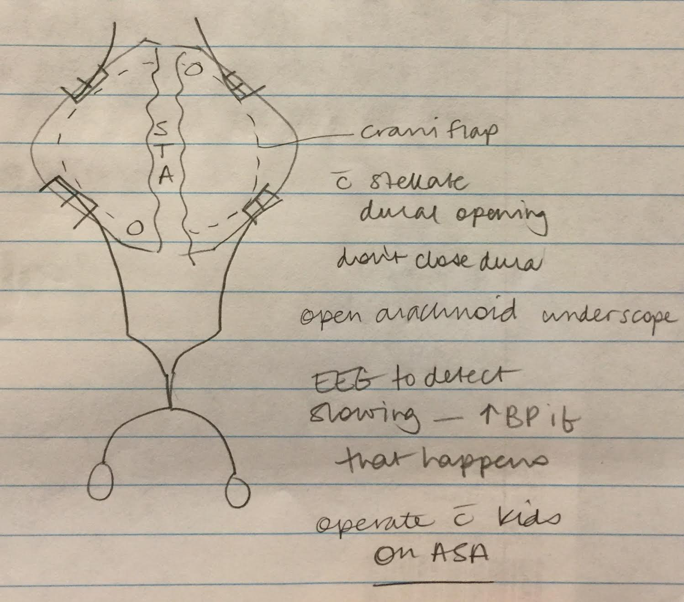
Vein of Galen malformation
- The term vein of Galen malformation involves a persistent fetal vessel known as the median prosencephalic vein (of Markowitz). This vein is present during the 3rd to 11th weeks of gestation and drains the majority of the diencephalic structures.
- As the brain develops, the anterior portion of the vein regresses with internal cerebral vein development. In healthy term infants, the internal cerebral veins drain into the posterior portion of the median prosencephalic vein, now called the “vein of Galen”.
- In vein of Galen malformations, the anterior portion of the vein does not regress appropriately.
- A vein of Galen malformation therefore represents a true arteriovenous fistula.
- Vein of Galen malformations pose several problems to the newborn.
- High output cardiac failure is the strongest indication for neonatal intervention.
- The fistula acts as a venous sump, pulling a significant portion of the infant’s circulating blood volume through the fistula.
- A second devastating presentation is “melting brain syndrome”.
- High venous pressures can cause secondary leukomalacia and severe mental retardation.
- Seizures and hydrocephalus may also develop as in the presented case.
- Treatment may be delayed in stable infants to prevent complications from blood loss and contrast load.
- Delayed treatment also allows easier arterial access for endovascular treatment.
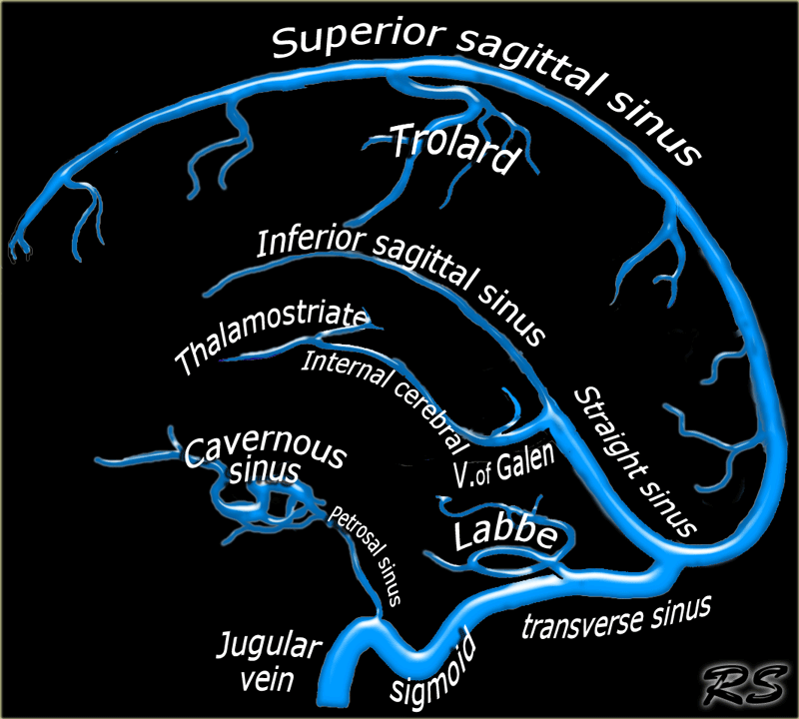
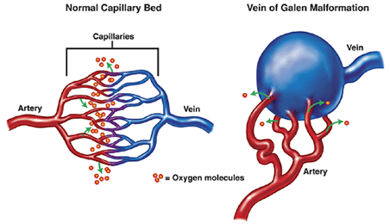
- Treatment of complex lesions should be staged to allow a more controlled devascularization and can help prevent complications such as perfusion breakthrough and/or venous thrombosis.

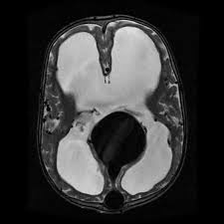
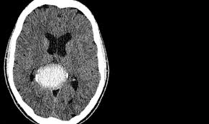
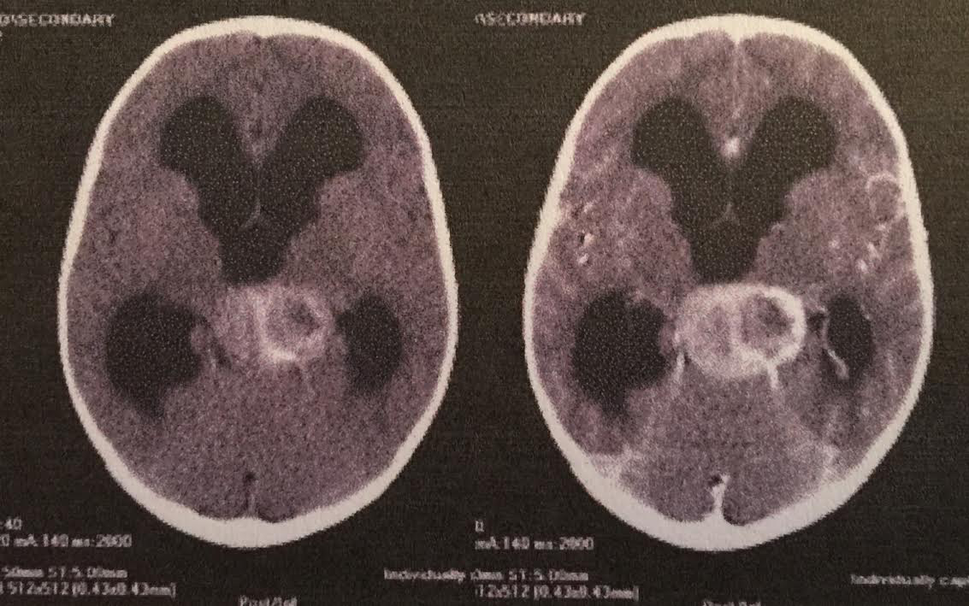

- beware of pineal lesions that are vascular (biopsy attempt would be disastrous)
- newborn children present with macrocephaly and severe congestive heart failure due to high flow shunting through
malformation
- older children present with hydrocephalus and, usually, a slow flow lesion
- Yasargil classification
- evaluate for heart conditions
- do not treat hydrocephalus with EVD/shunt
- treat HCP by treating malformation
- 75% risk of ICH with EVD or shunt placement
- when to intervene (the longer you can wait, the better):
- cardiac failure
- pulmonary edema
- HCP
- developmental delay
Intraventricular hemorrhage
- Grading scale for IVH:
- 1: germinal matrix hemorrhage only
- 2: blood in ventricle, no dilation
- 3: dilation
- 4: parenchymal blood, as well
- place Ommaya reservoir until the baby is big enough for placement of a shunt
- babies under 1500-1800 grams do not have subcutaneous tissue
- another temporizing method is daily fontanelle taps (22 guage styleted needle)
- this is not good as it can lead to “needle porencephaly”
Benign extra-axial fluid of infancy
- enlarged subarachnoid spaces over the frontal poles in the first year of life
- ventricles are normal or minimally enlarged
- may be distinguished from subdural hematoma by the “cortical vein sign”
- usually resolves spontaneously by 2 years of age
PEDIATRIC SPINE
- in ages < 9, 67% of cervical spine injuries occur in the upper 3 segments of the cervical spine (occiput – C2)
- pseudosubluxation: up to age 10, C2 normally moves on C3 up to 2-3 mm with neck flexion
CASES
Newborn in NICU with open myelomeningocele and ventriculomegaly
- measure head circumference, evaluate fontanelle, obtain head ultrasound
- consult renal, cardiology, urology, orthopedics
- prior to repair:
- broad spectrum antibiotics
- wet, sterile gauze (change Q6H)
- complete neuro exam to assess level
- U/S head (if HCP, shunt first – protect lesion with donut)
- operate within first 24 hours
- latex precautions, avoid iodine at placode
- 5-layer closure:
1. Placode
2. Dura
3. Fascia (bring fascia together medially and leave defects medially)
4. Dermis
5. Epidermis
- if there is a CSF leak postoperatively, make sure that the shunt is working and that there isn’t infection
8F with HA, vomiting, rapidly worsening vision in the ED
- after ABCs, take history and abbreviated physical examination
- drowsy, but arousable with bitemporal hemianopsia
- HCT with HCP and hyperdensity in the third ventricle (suprasellar lesion c/w craniopharyngioma)
- this is an acutely ill patient – needs a ventriculostomy STAT (work-up for the cause can happen later)
8M with several months of worsening HA. In ED with HA and vomiting. Check ABC. If patient is stable, obtain HCT. Neuro intact but has papilledema. MRI brain from OSH has tectal lesion with HCP [hypo on T1WI and hyper on T2WI – consistent with tectal glioma (minimal enhancement)]
- NO biopsy!!! Just treat HCP.
6F with new onset of unsteady gait and diplopia. On exam, B CN VI and L CN III palsy. Pontine lesion seen on MRI brain [hyper on T2 and hypo on T1, heterogeneous enhancement]
- Do not biopsy a diffuse pontine glioma
- treat HCP
- external beam radiation, no chemotherapy is effective
3M with tuft of hair on his back, impaired gait with asymmetry on LE muscular exam
- obtain full spine MRI
- obtain CT spine to look for bony septum
- renal ultrasound and urodynamic studies
- SPLIT CORD MALFORMATION
15M with headache, nausea, and vomiting
- upward gaze palsy and papilledema
- MRI brain shows HCP and pineal lesion [cyst, pineal parenchymal tumor, epidermoid, germ cell tumor]
- obtain a MRI of the spine preop is the patient is stable (if not crashing from the HCP)
- HCP with pineal tumor → no LP for CSF markers; serum markers
- no HCP with pineal tumor → LP for CSF markers + serum markers
- markers: serum beta-hCG and AFP, CSF beta-hCG, AFP, OCT-4, c-kit, CEA, cytology
5M with mid-thoracic back pain of increasing severity over one year. PMHx is unremarkable. No B/B difficulties. No difficulty with ambulation. Increased LE reflexes. Normal strength and reflexes in UE.
- MRI T spine with contrast shows intramedullary, homogeneously enhancing lesion
- IOM (SSEP/MEP) and ultrasound are useful in these cases
- give steroids
- demyelinating lesions do not expand the cord
- perform a laminoplasty in a child
- if GBM, stop and close.
- enter the cord in the midline or near the DREZ
- if ependymoma, gross total resection en bloc
- if astrocytoma, CUSA and stop if monitoring changes [stop if MEP<50% baseline – make sure BP is normal]
10M with one month of HA, especially in the morning. MRI brain c/s contrast shows a large posterior fossa lesion (cystic with mural nodule)
- pilocytic astrocytoma
- MRI total spine with gadolinium
- ICU, decadron
- EVD is not necessary if patient does not have evidence of HCP
- only the mural nodule needs to be resected, not the cyst wall in a JPA
- no adjuvant therapy is needed
- any new neurologic deficit warrants a HCT
consult from NICU for follow-up on a baby with IVH born at 25 weeks
- HUS shows enlarged ventricles
- full fontanelle with enlarging HC
- options: reservoir, ventriculosubgaleal shunt, serial LP, serial ventricular taps (reservoir is the best choice)
- in cases of loculated hydrocephalus, endoscopic fenestration and additional shunt catheters, if necessary
9M with polyuria, polydipsia, progressive weight loss and upward gaze palsy
- MRI brain with pineal mass
- pineal mass + empty sella is very suggestive of a GERMINOMA (usually with posterior pituitary dysfunction)
- treatment for germinoma: CHEMO + RT
15F with h/o MM repair and VPS placement, presents with new scoliosis and back pain
- differential diagnosis: tethered cord, syringomyelia, Chiari, shunt malfunction, split cord
15M with intracranial impalement
- ABC evaluation
- labs/HCT/type and cross
- CTA/cerebral angiogram
Unresponsive patient
- examine
- check labs (Na, Hgb, glucose, …)
- order blood products
- imaging when stable
- OR plan: confident, but conservative
When to pull the knife: wait as long as possible
6M with increasing headaches over several months
- mild papilledema on exam
- congenital aqueductal stenosis
- OR for ETV
18F with one week history of RUE numbness and weakness; RUE with diminished sensation and RLE with 4/5 dorsiflexion
- MRI brain with L F ring-enhancing lesion
- stereotactic biopsy showed a demyelinating process
- in youger females, ALWAYS CONSIDER MS!!!
2F with a midline lumbar mass
- presents with arching of feet and urinary issues
- lipomyelomeningocele
- pre-op urodynamics
- use neuromonitoring in the OR!
Chiasmal hypothalamic glioma: chemo, no surgery!!!
McCune-Albright syndrome
- sporadic syndrome
- multiostotic fibrous dysplasia
- café-au-lait spots
- precocious puberty
- endocrinopathies

