Intracranial neoplasms during the first year of life  
- different subset of tumors than those presenting later in childhood  
- 90% are of neuroectodermal origin  
 - teratoma is the most common

Pediatric steroid dose = 0.5 mg/kg/day divided Q6H (avoid prolonged treatment due to growth suppressant effect in children)  
AED: prophylactic AED use is discouraged; give AED for one week in craniotomy patients

**CRANIAL**- image entire neuraxis  
- if placing patient in prone position, use horseshoe or pediatric pins (tighten to 40 lbs)

**POSTERIOR FOSSA:**- if the patient has hydrocephalus, place a ventriculostomy but do not aggressively drain to avoid upward herniation  
- neural axis should be scanned to r/o drop mets

|  |
| --- |
| **\*The top 3 tumors in the posterior fossa in children are: JPA, Ependymoma, and Medulloblastoma**  **JPA: surgery (no chemotherapy or radiation)  Ependymoma: surgery + radiation (no chemotherapy)  Medulloblastoma: surgery + radiation + chemotherapy** |

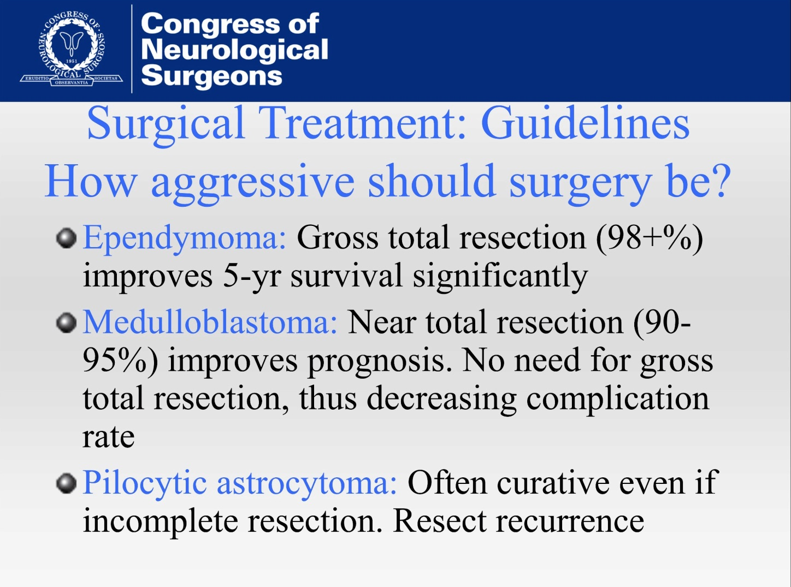 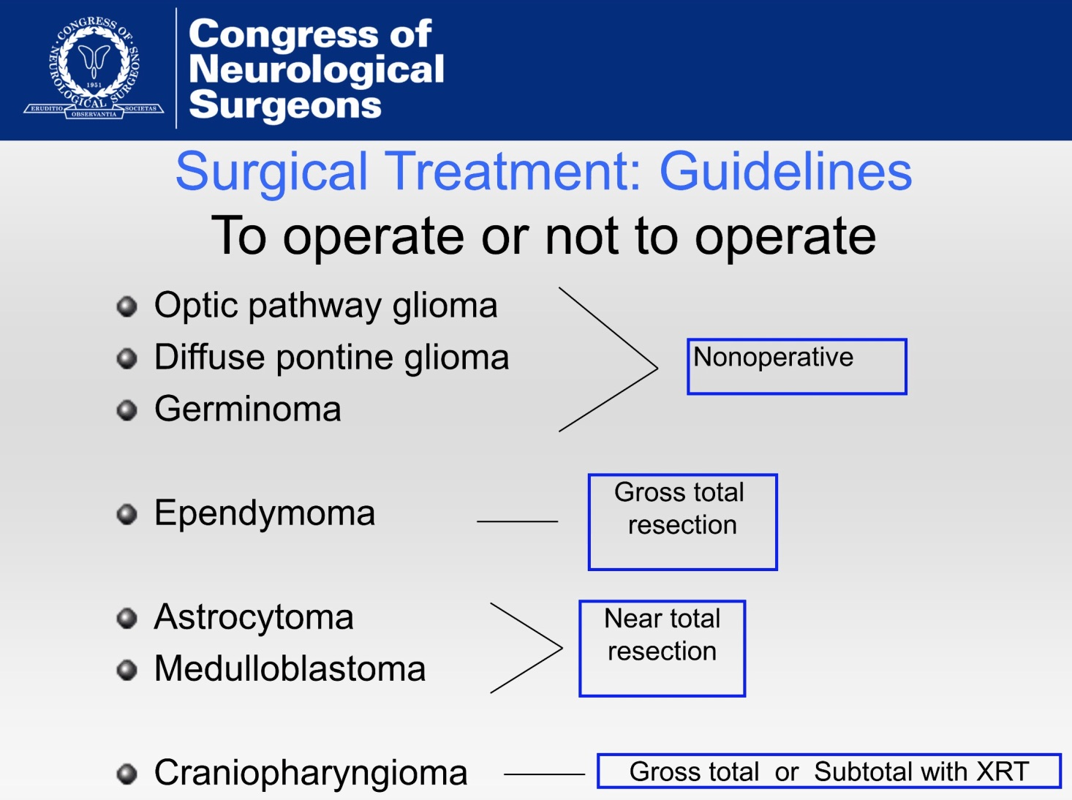

**Juvenile pilocytic astrocytoma**- remove enhancing nodule

- only remove cyst wall if strongly enhancing

- no adjuvant therapy needed   
- resect recurrence  
- extent of resection is the most important prognostic factor   
- Rosenthal fibers  
- subarachnoid metastases are uncommon (but associated with suprasellar JPA)

**Medulloblastoma (PNET)**

- image entire neural axis (most likely p-fossa tumor to have drop mets)  
- resection followed by chemotherapy, total neuraxis radiation with a boost to the posterior fossa  
 - CNS radiotherapy has been associated with growth hormone deficiency  
 - endocrine dysfunction, short stature and developmental delay caused by early childhood radiation preclude use of cranial   
 radiotherapy in children less than 3 years old  
- near total resection improves prognosis – no need for GTR, thus decreasing complication rate  
- molecular markers: wnt, shh, c-myc

**Ependymoma**

- image entire neural axis (10% have drop mets – less than medulloblastoma)  
- from where does it arise in the fourth ventricle?  
 - roof: best for complete resection  
 - floor: do not violate  
 - laterally at foramen of Luschka  
- no chemotherapy effective  
- radiate following resection  
- if supratentorial ependymoma: gross total resection without radiation  
- if < 1 cm2 residual: 80% 10-year survival  
- if > 1 cm2 residual: 0% 10-year survival

**Hemangioblastoma**  
- associated with von-Hipple Lindau syndrome (chromosome 3)  
- cystic with mural nodule  
- image neural axis to look for spinal cord hemangioblastomas  
- must treat pheochromocytoma first to avoid anesthesia complications  
- r/o retinal, abdominal (pancreas and renal) lesions

**SUPRASELLAR:**

**Juvenile pilocytic astrocytoma**- typically cannot be excised because of high visual, hypothalamic, and endocrine morbidity  
- subarachnoid metastasis should be ruled out (image neuraxis)  
- treated with chemotherapy (carboplatinum and vincristine) and radiation

**Rathke’s cleft cyst  
  
Craniopharyngioma**- benign tumor with malignant behavior  
- develops from nests of epithelium derived from Rathke's pouch (Rathke's pouch is an embryonic precursor of the anterior pituitary)  
- most common non-glial intracranial tumors in children  
- may appear calcified on CT  
- present with elevated ICP (headache, HCP), visual loss, endocrine dysfunction (hypopituitarism and DI), hypothalamic dysfunction  
- spontaneous cyst rupture (rare) may result in aseptic chemical meningitis

- subtypes:   
 - **adamantinomatous** (most common in pediatric patients)  
 - mostly cystic lesions  
 - squamous papillary  
 - mostly solid lesions  
- pre-operative workup: endocrinologic evaluation and visual field assessment  
- surgical resection is primary treatment  
- give steroids intraop  
- approaches: pterional, subfrontal, transventricular   
- safest is subtotal resection with proton beam XRT (side effects: optic neuritis, endocrine dysfunction, cognitive delays)  
- DI very common postoperatively   
 - do not fluid restrict

- give IV ddAVP [0.0005 units/kg/hr to a max of 0.01 units/kg/hr], followed by oral ddAVP 100µg BID  
- SRS can be used for recurrence  
- chemotherapy is ineffective  
- for recurrent cystic component: intracavitary radiation or bleomycin  
- morbidity is high in reoperations

**Germ cell tumor**- *see pineal region tumors* **Optic/hypothalamic glioma**- non-operative treatment  
 **Vascular lesion  
  
Lymphocytic hypophisitis**- treatment is steroids

- an enlarged stalk is NOT an adenoma

**Dermoid**

**SKULL:**

**Langerhans cell histiocytosis**- aka histiocytosis X, eosinophilic granuloma, Hand-Schuller-Christian disease (multiostotic, systemic form)  
- may occur in bone, skin, lungs, or stomach  
- presents with a tender, enlarging, skull mass  
- may also present with recurrent infections (chronic draining ear infections, chronic candidiasis)  
- may be asymptomatic and incidentally found  
- parietal bone is the most common site  
- blood tests are normal  
- round, or oval non-sclerotic punched out skull lesion with sharply-defined margins, involving both inner and outer tables  
- differentiate from hemangioma by absence of sunburst appearance  
- differentiate from epidermoid which has dense surrounding sclerosis  
- CT scan with soft tissue mass within area of bony destruction having a central density  
- gross appearance: pinkish gray to purple lesion, involving pericranium with possible dural penetration  
- single lesions treated with curettage (remove 1cm of pericranium around lesion, remove bone surrounding it, resect underlying dura)  
- multiple lesions associated with extracalvarial bony involvement (treated with chemotherapy and radiation – very radiosensitive)  
- work-up: obtain a bone scan and skeletal survey to r/o multi-ostotic disease, also LFT and coags to r/o liver disease  
- generally a benign, local disease

- may spontaneously regress, but single lesions are typically removed  
- may also occur in the hypothalamus and present with growth delay and DI

**Epidermoid/Dermoid cyst**- similar appearance, derivation, pathogenesis, clinical outcome

- produced by the inward displacement of cutaneous epithelial tissue (ectoderm)

- congenital lesions  
- increase in size secondary to desquamation of keratin, cholesterol, and acellular debris

- differentiated by patient age at clinical onset, rate of progression, preferential location, frequency of associated lesions

- ratio of epidermoid to dermoid is 10 to 1.5

- most common congenital lesion of the scalp and calvarium in children  
- ectodermal rests get trapped in developing skull (arise in the diploe and expand inner and outer tables)  
- non-neoplastic  
- present as palpable, enlarging masses  
- can rupture and cause chemical meningitis (from irritating properties of fat and keratin) or bacterial meningitis, if infected  
- on X-ray: well-defined, sclerotic margins  
- MRI demonstrates DWI restriction

- nasal and midline sub-occipital (inion) cysts are more likely to have intracranial extension  
- treatment is surgical  
- radiation and chemotherapy are not indicated  
- bone margins are curetted  
- search for tract and disconnect if found  
- tract may occur over dural sinus  
- dermoid cysts most commonly become symptomatic in the 1st or 2nd decade of life and tend to occur in the midline  
- dermoids are usually well-demarcated and contain greasy material that may contain hair and adnexal appendages such as sebaceous glands  
  
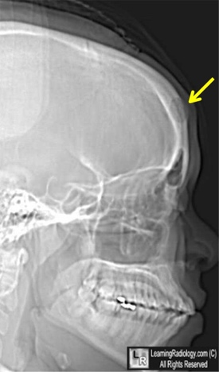 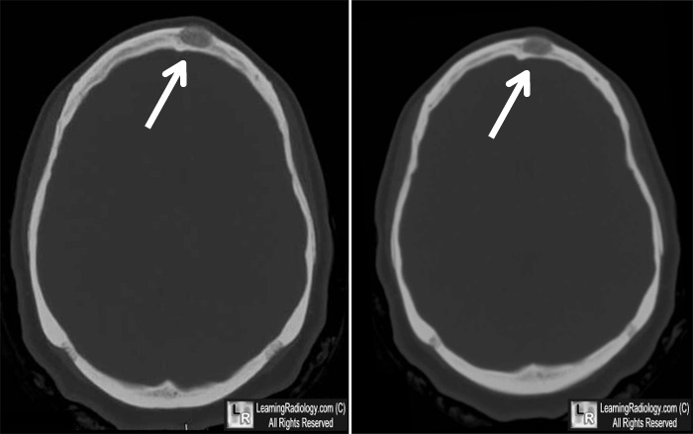

**Epidermoid**

* Expand and conform to subarachnoid spaced (dermoids do not)
* Represent less than 2% of all intracranial tumors
* Most commonly diagnosed in the 3rd to 5th decade of life
* Have an affinity for the subarachnoid cisterns at the base of the brain (parachiasmal suprasellar cistern and the CPA)
* Account for 7% of all CPA tumors
* Grow more slowly than dermoid cysts
* Grow by desquamation of epithelium and accumulation of cellular debris
* Enlargement of the tumor produces a lytic effect on the bone, resulting in a delicate, scalloped margin
* Symptoms are due to compression of surrounding neurovascular structures

**SUPRATENTORIAL:  
  
Astrocytoma**  
- most common supratentorial tumor in pediatrics

**Choroid plexus papilloma**- WHO I

**BRAINSTEM:**  
- if lesion involves midbrain, or partial pons – biopsy as this could be PNET (better therapies and prognosis than DIPG)  
- upper brainstem: lower grade  
- lower brainstem: higher grade  
- dorsally exophytic: may be low-grade  
- classification of pontine tumors:   
 - diffuse pontine tumor: usually malignant, enhancing  
 - focal pontine tumors: well-demarcated  
 - exophytic pontine tumors: almost always dorsally exophytic into the 4th ventricle (benign or malignant)

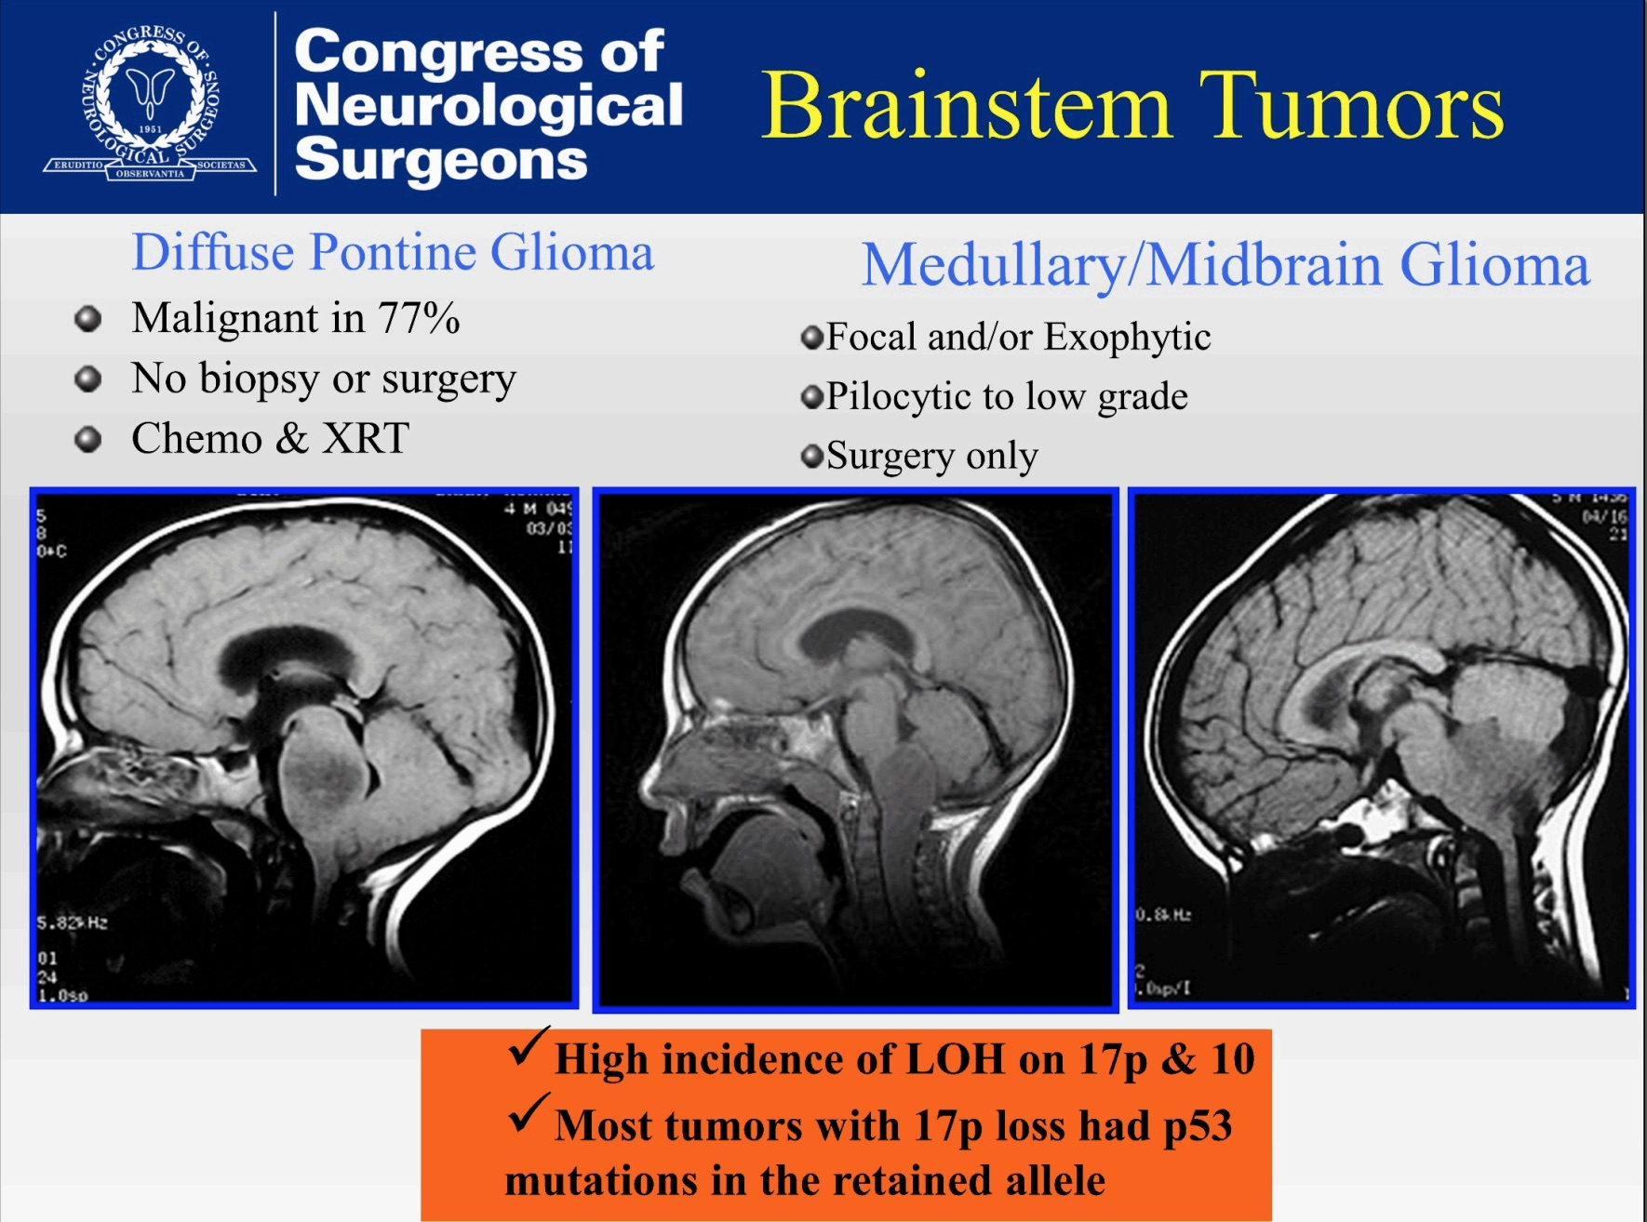

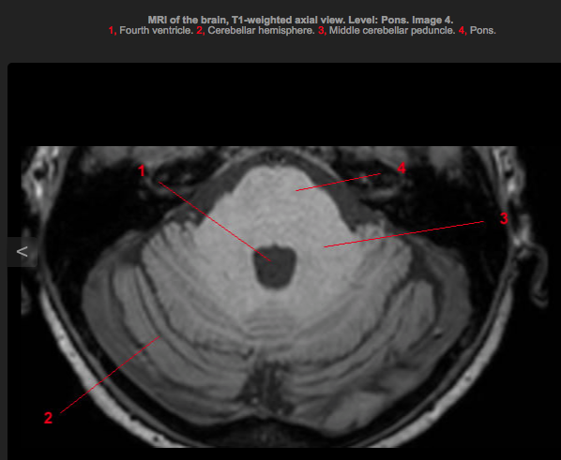 **Diffuse intrinsic pontine glioma**  
- present with long-tract signs and cranial nerve dysfunction (eg. hemiparesis and difficulty swallowing)  
- minimal enhancement  
- consult neuro-oncology  
- biopsy is not necessary  
- no chemo is effective  
- external beam radiation  
- surgical therapy is limited to treatment of hydrocephalus

- if biopsy is needed, via middle cerebellar peduncle

**PINEAL:**- diff dx:   
 - cyst  
 - germ cell tumors:   
 - germinoma  
 - choriocarcinoma  
 - embryonal carcinoma  
 - mixed tumor  
 - teratoma   
 - pineoblastoma (PNET)  
 - pineocytoma  
 - atypical teratoid rhabdoid tumor (ATRT)  
- CSF markers to send: hCG, PLAP, AFP, CEA  
 - beta-hCG: choriocarcinoma (>50), germinoma (positive, but <50)  
 - AFP: embryonal carcinoma, yolk sac tumor  
 - PLAP: germinoma  
 - CEA: teratoma, metastasis  
- image neuraxis if the patient is stable (subarachnoid metastasis is not uncommon)  
- address hydrocephalus if presenting sign (upward gaze palsy, papilledema, lethargy)  
- coronal suture burr hole for ETV, burr hole more anterior for biopsy (can create one burr hole in between)  
- consider leaving a clamped EVD for a few days following ETV

- parenchymal tumor → surgery  
- germ cell tumor → chemo + radiation  
- approaches: infratentorial/supracerebellar, interhemispheric/transoccipital, transventricular/endoscopic  
- perform ETV for HCP instead of VP shunt to avoid intraperitoneal metastasis

**Germinoma**- germ cell tumor  
- highly radiosensitive  
- negative serum markers **Embryonal carcinoma**- germ cell tumor  
- elevated AFP

**Endodermal sinus (yolk sac tumor)**- germ cell tumor  
- elevated AFP

**Choriocarcinoma**- germ cell tumor  
- elevated beta-hCG

**Mixed germ cell tumor**  
- elevated beta-hCG

**Teratoma**

- germ cell tumor  
- elevated AFP in immature form

- elevated CEA

**Pineocytoma  
  
Pineoblasoma  
  
Teratoma**  
  
**Glioblastoma**

**Tectal glioma**

**SPINAL**- Image entire neural axis  
  
**Myxopapillary ependymoma**- WHO I  
- rare, slow growing tumor  
- most have exophytic growth patterns

- pts commonly present with LBP, bowel and bladder symptoms  
- gross total resection is the goal  
- GTR v subtotal resection and XRT are comparable   
- use intra-op MEP, SSEP, anal sphincter EMG and microscope

**Ependymoma**- goal is gross total resection  
- good plane available