MOTOR INNERVATION OF THE MEDIAN NERVE
- DOES NOT innervate muscles of the upper arm - innervates muscles of the forearm and hand - muscles can be separated into 4 groups:
Group | Muscle | Roots | Action(s)
1. Proximal Forearm | Pronator teres | C6, C7 | - Main pronator of the forearm  - First muscle innervated by median nerve  - Branches to muscle exit median nerve prior to the nerve passing between the two heads of the muscle  - The elbow needs to be extended for the pronator teres to have mechanical advantage
 | Flexor carpi radialis (FCR) | C6, C7 | - One of the two major wrist flexors  - The more important one
 | Flexor digitorum superficialis (FDS) | C8, T1 | - Known as the sublimis muscle  - Flexes the 2nd-5th digits (all except the thumb) at their proximal interphalangeal joints
 | Palmaris longus | C7, C8 | - Attached to the palmar aponeurosis  - Corrugates the palmar skin  - Not readily examinable  - Absent in 15% of the population
2. Anterior Interosseous | Flexor digitorum profundus  (FDP) | C8, T1 | - As a whole, is innervated by the MEDIAN N. and the ULNAR N.  - Flexion of the distal interphalangeal joint of the 2nd and partly the 3rd digits  - ULNAR N. controls the flexion of the DIP joints of the 3rd (partly), 4th, and 5th digits  - Therefore, to test, concentrate on the index finger
 | Flexor pollicis longus (FPL) | C8, T1 | - Flexes the distal phalanx of the thumb at the interphalangeal joint
 | Pronator quadratus | C7, C8 | - Significantly weaker forearm pronator  - Weakness of this muscle is not readily apparent if the pronator teres is strong  - This muscle can be tested with the forearm flexed at the elbow, which takes away the mechanical advantage of the pronator teres
3. Thenar | Abductor pollicis brevis (ABP) | C8, T1 | - Abducts the thumb in the palmar plane  - There are two types of thumb abduction:  palmar abduction: away from the plane of the palm (mediated by the abductor pollicis brevis)  radial abduction: away from the line of the forearm (mediated by abductor pollicis longus)
 | Flexor pollicis brevis (FPB) | C8, T1 | - Innervated by both the MEDIAN and ULNAR nerves  - Superficial head: MEDIAN N.  - Deep head: ULNAR N.  - Flexes the thumb at the metacarpal-phalangeal joint
 | Opponens pollicis | C8, T1 | - Have the patient forcibly maintain contact between the volar pads of the distal thumb and fifth digit while you try to pull the distal first metacarpal away from the fifth digit  - Although the median nerve independently controls thumb opposition, a combination of thumb adduction (adductor pollicis; ulnar nerve) and thumb flexion (flexor pollicis brevis; deep head, ulnar nerve) may mimic thumb opposition when a complete median nerve palsy is present
4. Terminal | First and second lumbricals  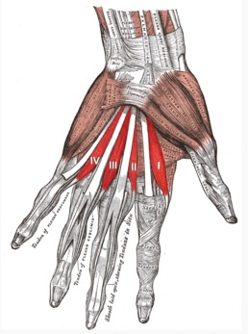 | C8, T1 | - Innervated by the terminal radial and ulnar divisions of the median nerve, respectively  - Intrinsic muscles of the hand that flex the metacarpo-phalangeal joints and extend the interphalangeal joints

Picture | Sign | Nerve involved | Cause/Location of Injury | Details
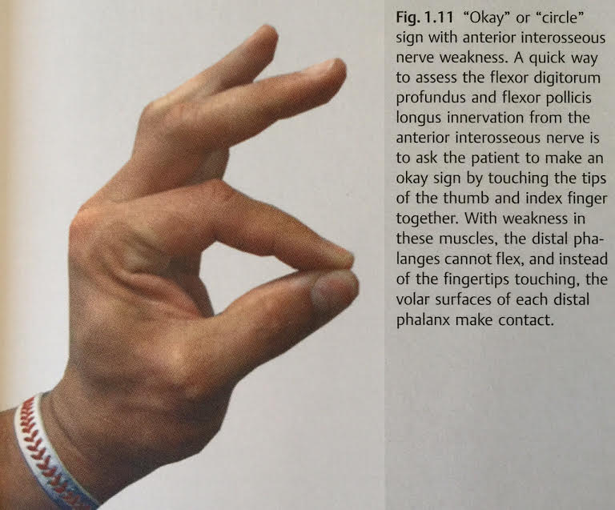 | “OKAY” | Anterior Interosseous Nerve  (AIN) |  | Ask the patient to make an okay sign by touching the tips of the thumb and index finger together (this tests the flexor digitorum profundus and flexor pollicis longus). When the muscles are weak, the distal phalanges of the thumb and index finger cannot flex, and instead of the fingertips touching, the volar surfaces of each distal phalanx make contact.
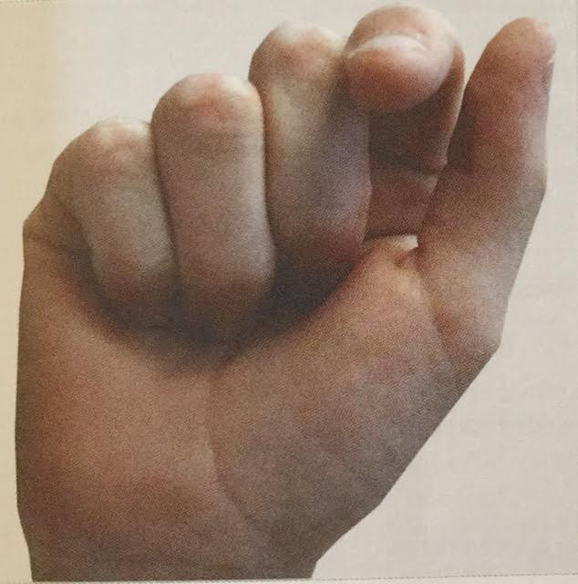 | Benedictine  or  Orator’s hand | Complete Median Nerve  palsy | UPPER ARM  Trauma: lacerations, gunshots, blunt contusions | When asked to make a fist, the 1st digit (thumb) barely flexes, the 2nd digit partially flexes (substitution from non-median innervated muscles), the 3rd digit flexes but is weak, the 4th and 5th digit flex normally.
 |  | Complete Median Nerve injury (UPPER ARM) | When examining a complete median nerve palsy, beware of the following: the brachioradialis (radial nerve), with the help of gravity, may pronate the forearm; you may observe thumb opposition by the indirect actions of the FPB (deep muscle head) and the adductor pollicis | 1. Numbness on the volar surfaces of the first 3 ½ digits  2. Numbness on the radial two thirds of the palm  3. Forearm cannot pronate against gravity or resistance  4. Hand can only weakly flex at the wrist in an ulnar direction  5. Thumb cannot be opposed or abducted in palmar direction  6. Lumbrical weakness in the index and long fingers  7. When asked to make a fist Benedictine sign
 |  |  | In the proximal upper arm, the MEDIAN, ULNAR, and RADIAL nerves are in close proximity and may all be injured | Triad neuropathy
 | Honeymooner’s palsy | Median nerve | UPPER ARM | A type of pressure palsy  Occurs when your arm is under the neck of your partner sleeping next to you for a length of time
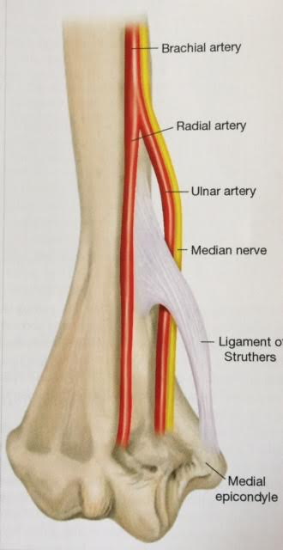 | Supracondylar spur (Ligament of Struthers)  NOT the arcade of Struthers | Median nerve | UPPER ARM  Supracondylar spur on the medial side of the humerus, 5cm proximal to the medial epicondyle  Ligament of Struthers bridges the spur to the medial epicondyle  This ligament may cause entrapment of the nerve  1% of population have a supracondylar spur | Causes insidious onset of forearm and hand weakness, with variable sensory loss in a median distribution; deep aching pain in the proximal forearm which worsens with repetitive pronation/supination or during testing of the pronator teres or FCR  Examination may reveal weakness and possible atrophy of any median nerve-innervated muscle  In some cases, the branches to the pronator teres may arise proximal to where the median nerve passes under the ligament and the pronator teres is spared  In cases of carpal tunnel, test wrist and finger flexors, including AIN muscles to exclude this more proximal entrapment  Check for Tinel’s sign in the distal, medial upper arm  X-ray can diagnose supracondylar spur
 | Pronator teres syndrome | Median nerve | FOREARM  Compressed where it passes between the two head of the pronator teres | Occurs frequently in people who perform repetitive, forceful pronation of their forearm  The only median-innervated muscle not affected is the pronator teres  Tenderness to palpation of the pronator teres is common  Tinel sign at the anticubital fossa  In contradistinction to CTS, patients do not complain of nocturnal pain or numbness
 |  | Median nerve | FOREARM  Fibrotic arch between the two head of the flexor digitorum superficialis (sublimis arch) | Forceful flexion of the proximal interphalangeal joints of the 2nd-5th digits (causes contraction of the flexor digitorum superficialis muscle may precipitate symptoms
 | Supracondylar fracture | Anterior interosseous nerve | UPPER ARM  Occurs mostly in children | Delayed median palsies can also occur due to callus formation  Pseudo-anterior interosseous neuropathy  Often, patients may have some thumb and index finger numbness, which can help differentiate this from a true anterior interosseous nerve palsy
 | Musculotendinous Median Neuropathies | Median nerve | FOREARM | Bicipital aponeurosis  Presentation is similar to Ligament of Struthers entrapment  Resisted forearm flexion in the supinated position for 30 seconds may precipitate symptoms
 | Saturday night palsy | Radial nerve |  | A type of pressure palsy  Occurs from hanging the arm over the back of a chair and passing out (eg. when intoxicated)

Surgical treatment of median nerve entrapment at the elbow, all three possible compression points – bicipital aponeurosis, pronator teres, and sublimis arch – are each inspected and decompressed

