**UPPER EXTREMITY**

|  |  |  |  |
| --- | --- | --- | --- |
| ROOTS | NERVE | MUSCLE INNERVATED | ACTION |
|  | Spinal accessory nerve (CN XI) | * Trapezius * Sternocleidomastoid | * Elevates shoulder Abducts arm > 900 |
| C3, 4, 5 | Phrenic nerve | * Diaphragm | * Inspiration |
| C3, 4, 5, 6 | Dorsal scapular nerve | * Rhomboids * Levator scapulae | * Adduct and elevate the scapula * Elevate scapula |
| C4, 5,6 | Suprascapular nerve (upper trunk) | * Supraspinatus * infraspinatus | * Shoulder abduction (first 200, 150-300) * External rotation of shoulder/shoulder stability |
| C5, 6, 7 | Long thoracic nerve | * Serratus anterior | * Forward shoulder thrust |
| C6, 7, 8 | Thoracodorsal nerve (post cord) | * Latissimus dorsi | * Extends, adducts, and medially rotates humerus |
| C5, 6 | Musculocutaneous  (superior trunk & lateral cord) | * Coracobrachialis * Brachialis * Biceps brachii | * Flexion and adduction of the arm * Major flexor of the forearm * Forearm flexion (with supinated hand) Forearm supination |
| C5, 6 | Axillary (posterior cord) | * Deltoid * Teres minor | * Arm abduction (30-900), medial & lateral rotation of arm |
| C5, 6, 7, 8, T1 | Radial (posterior cord) | * Triceps * Anconeous * Brachioradialis * Extensor carpi radialis longus * Extensor carpi radialis brevis * Supinator | * Major extensor of the forearm * Forearm flexor * Extends and abducts the hand at the wrist * Extends and abducts the hand at the wrist * Supinates the forearm |
| Radial nerve | Posterior Interosseous nerve | * Extensor carpi ulnaris * Extensor digitorum * Extensor digiti minimi * Extensor indices * Extensor pollicis longus * Extensor pollicis brevis * Abductor pollicis longus | * Extends and adducts the hand at the wrist * Extends the medial four digits at the metacarpophalangeal joint, extends the hand at the wrist * Extends the fifth digit at the MCP and IP joints * Extends the second digit and helps extend hand * Extends the thumb at the CMC and IP joints * Extends the thumb at the carpometacarpal joint * Abducts the thumb and extends at CMC joint |
| C5, 6, 7, 8, T1 | Median | * Pronator teres * Flexor carpi radialis * Palmaris longus * Flexor digitorum superficialis * Abductor pollicis brevis (LOAF) * Opponens pollicis (LOAF) * Flexor pollicis brevis (LOAF) *(partly innervated by the ulnar n.)* * Lumbricals I & II (LOAF) *(supply digits II & III)* | * Pronates and flexes the forearm at the elbow * Flexes and abducts the hand at the wrist * Flexes hand at the wrist * Flexes middle phalanges at the PIP joint of II-V Flexes proximal phalanges at MCP joint * Abducts thumb metacarpal bone * Opposes thumb to the index finger * Flexes the thumb * Flex the proximal phalanges and extend distal phalanges of digits II & III |
| Median | Anterior interosseous nerve | * Flexor pollicis longus * Flexor digitorum profundus I & II * Pronator quadratus | * Flexes the DIP of the thumb * Flexes the DIP joint of digits 2 & 3 (4 & 5 are ulnar-innervated) * Pronates the forearm |
| Median | Palmar cutaneous branch | * *Palmar sensation* | * (comes off proximal to the carpal tunnel) |
| Median | Digital cutaneous branch | * *Digit sensation* | * (travels in carpal tunnel) |
| C7, 8, T1 | Ulnar | * Flexor carpi ulnaris * Flexor digitorum profundus III & IV (ulnar part) * Flexor digiti minimi brevis (Hypothenar) * Abductor digiti minimi (Hypothenar) * Opponens digiti minimi (Hypothenar) * Lumbricals III & IV (digits IV & V) * Palmar interossei * Dorsal interossei * Adductor pollicis (Thenar) * Flexor pollicis brevis (Thenar) *(partly median-innervated)* | * Flexes and adducts the hand at the wrist * Flexes the distal phalanges at the DIP joints (digits IV-V) Assists with flexion of the hand * Flexes the proximal phalanx of digit V * Abducts the little finger * Opposes the fifth finger * Flex the proximal phalanges and extend the two distal phalanges of digits IV & V * Adduct the fingers toward the middle finger * Abduct the fingers away from the middle finger * Adducts thumb * Flexes the thumb |
| Ulnar | Dorsal cutaneous branch |  |  |
| Ulnar | Palmar cutaneous branch |  |  |
| Ulnar | Digital sensory branch |  | * *(In Guyon’s canal)* |

Thumb innervation & movement

|  |  |  |
| --- | --- | --- |
| Action | Nerve | Muscle(s) |
| Abduction Flexion  Opposition | Median | Abductor pollicis brevis  Flexor pollicis brevis (also partly by ulnar)  Opponens pollicis |
| Flexion at DIP joint | Anterior interosseous nerve (Median) | Flexor pollicis longus |
| Adduction | Ulnar | Adductor pollicis |
| Extension  Abduction | Posterior interosseous nerve (Radial) | Extensor pollicis brevis & longus  Abducts the thumb at CMC joint |

Flexion/extension: occur in the plane of the palm  
Abduction/adduction: occur in the plane at a right angle to the palm

Opposition: bringing the thumb across the hand

|  |  |
| --- | --- |
| Dorsal scapular nerve | Hypertrophy of the scalene muscles with weightlifting |
| Long thoracic nerve | “back-pack palsy” |
| Axillary nerve | Weakness during shoulder abduction (>200) and external rotation of the arm |

[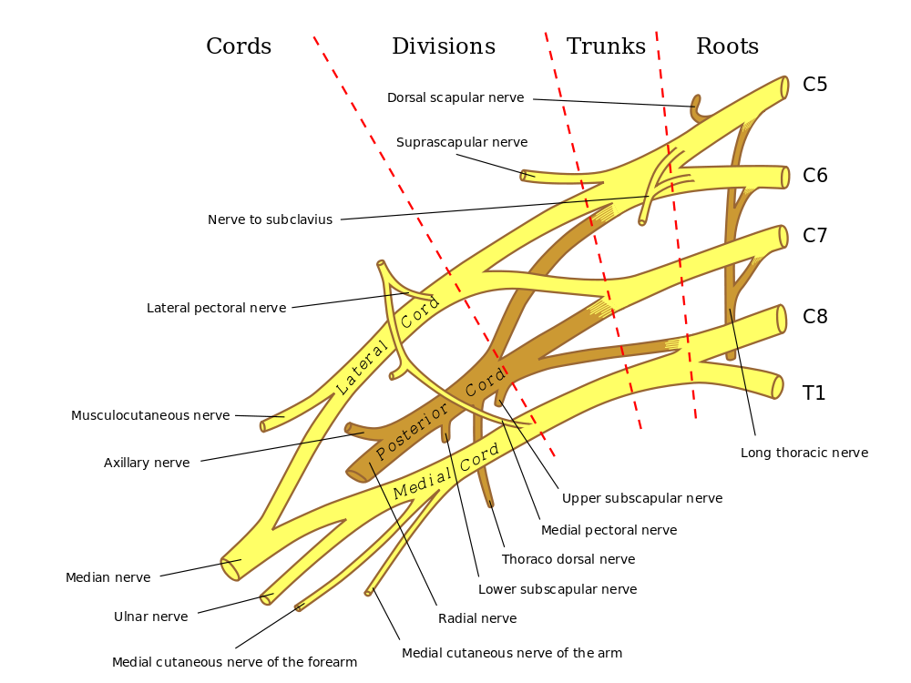](https://www.google.com/url?sa=i&rct=j&q=&esrc=s&source=images&cd=&cad=rja&uact=8&ved=0ahUKEwj7hIz4tLrYAhXC7YMKHfpuAtIQjRwIBw&url=https%3A%2F%2Fcommons.wikimedia.org%2Fwiki%2FFile%3ABrachial_plexus_2.svg&psig=AOvVaw3acGfQquVjmov6w493wLKH&ust=1515021471083423)

LOWER EXTREMITY

|  |  |  |  |
| --- | --- | --- | --- |
| ROOTS | NERVE | MUSCLE INNERVATED | ACTION |
| L1, 2, 3 | Lumbar nerves | * Psoas major | * Flexion of the hip joint |
| L2, 3, 4 | Obturator | * Obturator externus * Adductor longus * Adductor brevis * Adductor magnus * Gracilis * Pectineus | * Thigh adduction & lateral rotation * Thigh adduction |
| L2, 3, 4 | Femoral | * Iliopsoas (Iliacus) * Sartorius * Quadriceps femoris * Rectus femoris * Vastus medialis * Vastus intermedius * Vastus lateralis | * Hip flexion * Flexion and abduction of the hip * Knee extension |
| L5, S1 | Superior gluteal | * Gluteus medius * Gluteus minimus * Tensor fasciae latae * Piriformis | * Tenses iliotibial tract * Lateral thigh rotation |
| L5, S1, S2 | Inferior gluteal nerve | * Gluteus maximus | * Thigh extension and lateral rotation |
| S1, S2  L5, S1  L5, S1  L5, S1 | (direct branches from the plexus) | * Obturator internus * Gemelli * Quadratus femoris | * Hip joint stabilizers |
| L5, S1, S2  L5, S1, S2  L5, S1, S2  L5, S1, S2 | Peroneal (sciatic nerve)  Tibial (sciatic nerve)  Tibial (sciatic nerve)  Tibial (sciatic nerve) | * Biceps femoris, short head (hamstring) * Biceps femoris, long head (hamstring) * Semitendinous (hamstring) * Semimembranous (hamstring) | * Knee flexion |
| L5, S1, S2 | Superficial peroneal nerve | * Peroneus longus * Peroneus brevis | * Plantar flexion  Eversion of the foot |
| L4, 5 | Deep peroneal nerve | * Tibialis anterior | * Dorsiflexion of ankle |
| L5, S1 | Deep peroneal nerve | * Extensor digitorum longus | * Dorsiflexion of ankle Extension of metatarsophalangeal joints of the 2nd to 5th toes |
| L5, S1 | Deep peroneal nerve | * Extensor Hallucis longus | * Dorsiflexion of ankle Extension of metatarsophalangeal joint of big toe |
| L5, S1 | Deep peroneal nerve | * Extensor digitorum brevis | * Extension of MTP joints of 2nd to 5th toes |
| S1, 2 | Tibial nerve | * Soleus * Gastrocnemius | * Plantar flexion of ankle joint |
| S1, 2 | Tibial nerve | * Tibialis posterior | * Plantar flexion Inversion |
| L1 | Iliohypogastric |  | * sensory to skin of buttocks and hypogastric region |
| L1 | Ilioinguinal |  | * sensory to skin of groin and external genitalia |
| L1, 2 | Genitofemoral |  | * sensory to skin of genitalia |
| S2-4 |  |  |  |

