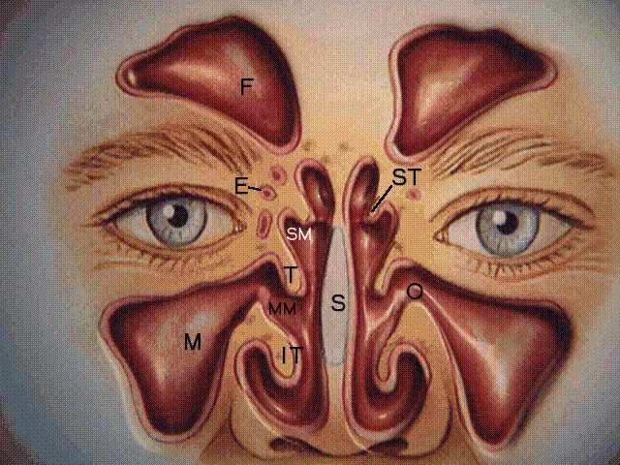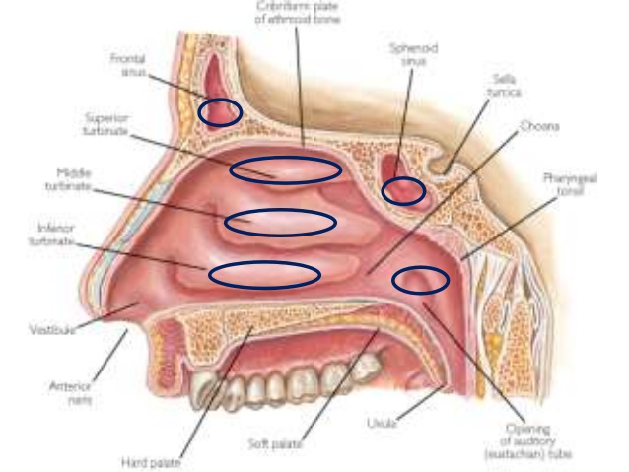Room setup:  
Microscope on surgeon’s side  
C-Arm around head for lateral film  
Firm donut for head – no Mayfield

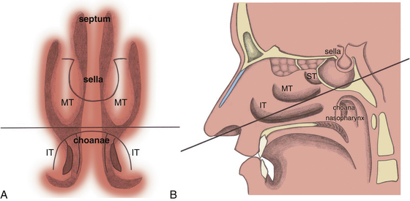Preoperative medications:   
Vancomycin/Gentamycin/Flagyl  
Dexamethasone

Afrin in both nostrils  
Vaginal packing in mouth  
Tegaderm over eyes  
Head in slight flexion

1. The approach is via the LEFT nostril with the surgeon on the patient’s RIGHT side
2. Insert the short nasal speculum into the left nostril to locate the middle turbinate
3. Switch to the long nasal speculum to find the posterior portion of the nasal septum
4. Inject the nasal mucosa with 1% Lidocaine with epinephrine (one shot)
5. Open the mucosa using monopolar cautery
6. Insert the Hardy speculum to retract nasal mucosa and expose keel of the sphenoid bone
7. Check the position with fluoroscopy
8. Use an osteotome to crack the posterior portion of the septum
9. Drill sphenoid sinus face – keep the superior and inferior margins of the keel as a midline reminder
10. Take down the sphenoid mucosa
11. Identify the bilateral carotid protuberances laterally, optic protuberance superiorly, and the clivus inferiorly
12. Drill the anterior wall of the sella to expose the dura
13. Open dura – sickle (apex) knife
14. Hemostasis
15. Remove tumor with ring curettes in the following order: inferior, lateral, superior
16. Visualize diaphragm
17. Fat harvest from belly
18. Pack sella with fat
19. Buttress with mesh
20. Use duraseal
21. Place nasal trumpet in right nostril and merocel packing in the left nostril